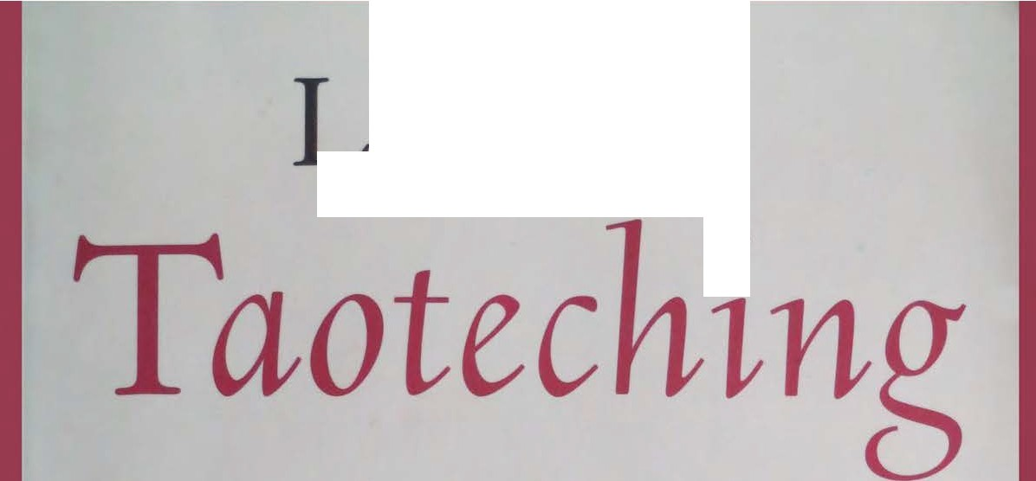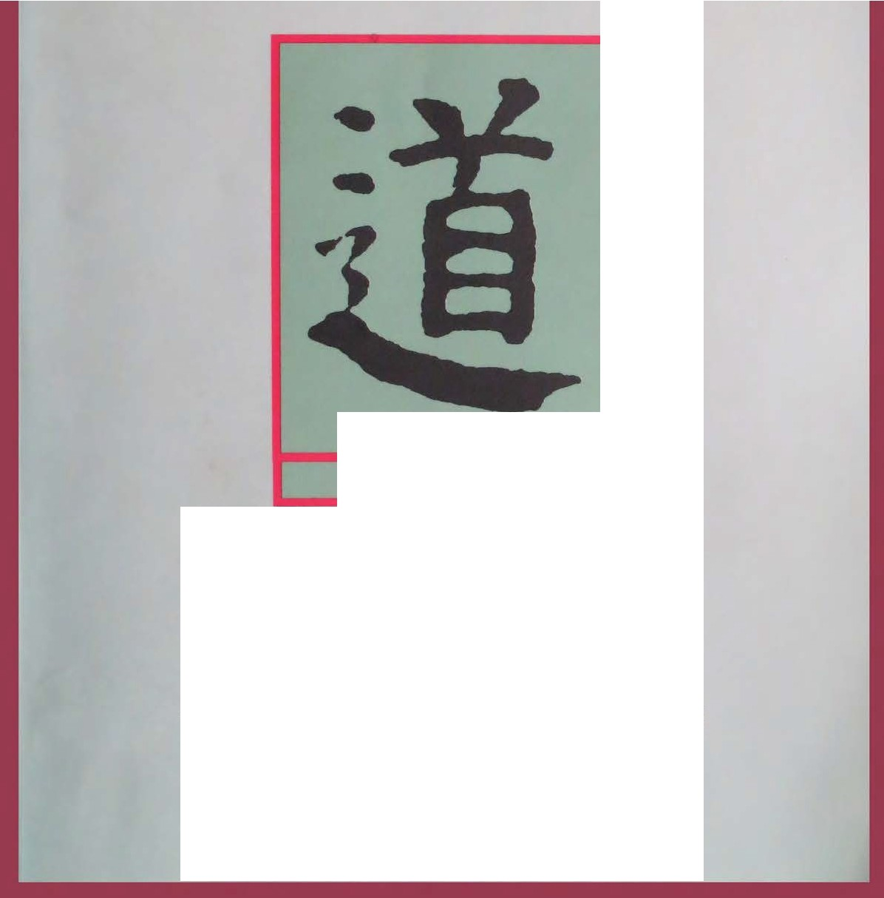---lao- zu 's
•

THE WAY

translated by Red Pine with selected commentaries of the past 2000 years

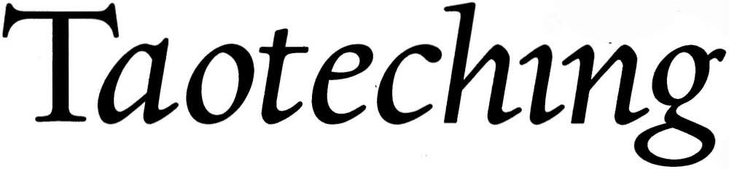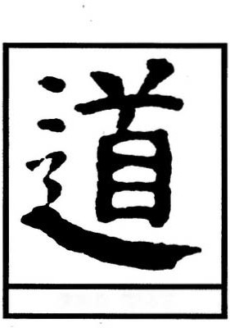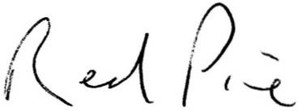

Lao-tzus

•

THE WAY

translated by Red Pine with selected commentaries of the past2000 years

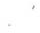

Copyright © 1996 by Red Pine (Bil Porter).

Published in the United States of America by Mercury House, San Francisco, California, a nonprofit publishing company devoted to the free exchange of ideas and
guided by a dedication to literary values.

Al rights reserved. No part of this book may be reproduced in any form or by any electronic or mechanical means without permission in writing from the publisher,
except by a reviewer who may quote brief passages In a review.

UNITED STATES CONSTITU TION, PIRST AMBNDMBNT:
Congress shall make no law respecting an establishment of religion. or prohibiting the free exercise thereof; or abridg­ ing the freedom of speech, or of the press; or the right of the people peaceably to assemble, and to petition
the Government for a redress of grievances.

Manufactured in the United States of America.

LIBRARY OF CO NGRB S S
CATAL OGU ING- IN - PU B LICATION DATA
Lao-tzu.
[Tao te ching. English]
Lao-tzu's Taoteching I translated by Red Pine, with selected commentaries of the past 2000 years.
p. cm.
ISBN 1-56279 -085-4 (pbk.)
I. Pine, Red. II. Title.
,
BLI900.L26s513 1996
299' ·SI482-DC20 96-18579
CIP

FIRST EDITION
10 12 14 16 18 20 19 17 15 13 II
2 4 6 8 975 3



for
Ku Lien-chang



Contents

Introduction
IX

Lao-tzu's Taoteching 1

Glossary 165

-- yell,owlf,vep
J
Central China
6TH CENTURI BC

:toO DL

1. .. •.
'\ ,-;:,;....:.
FqJ

'Wei
I

' '!At-(
-t>ohai

ch'in
/( Chin
- a l - -
Ü. lt iauluui

lo , ez.!fJle,, ,_- • . · . _- L ti.
l .ir""1ztziiA Hu "11SS ·h. o .:Jlt
ch'en·
Urz

0

yellow

. J.
I "•n
Cl]zll,i .- afo'll \-t.ci:
91+ . - .A-\n-r.,_
ltq>z,. .
C - ·_
U Jq,,,.
HuhJien
y. "1,.',, rj
Sea,

l>J z,..e,.
5hu

-
. ,u,
'--)

Chf shan A

- \i
ls-J! - {

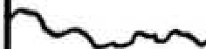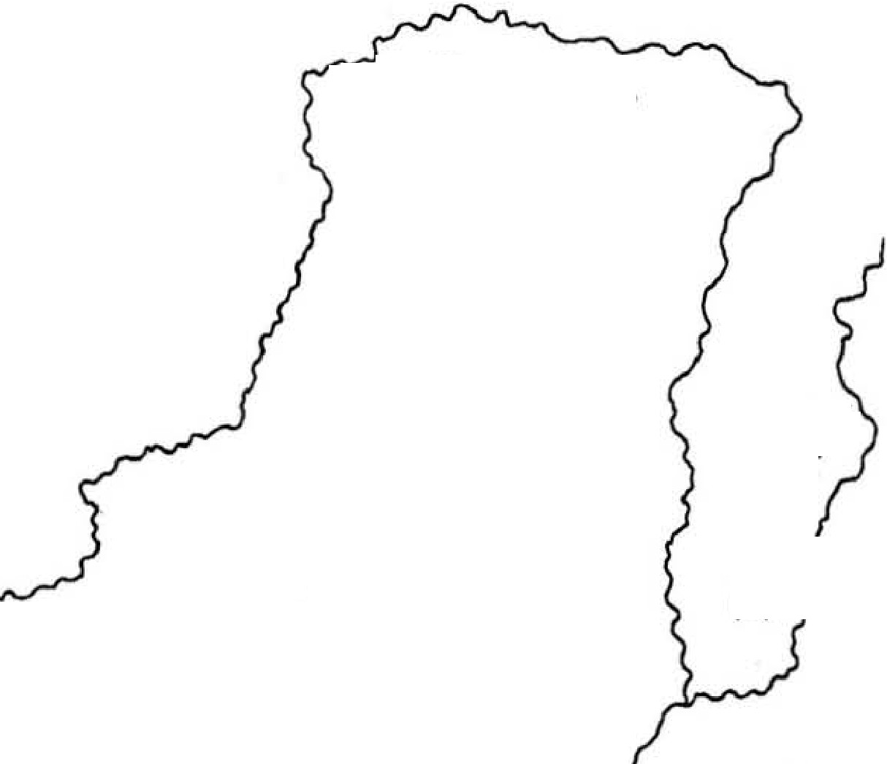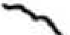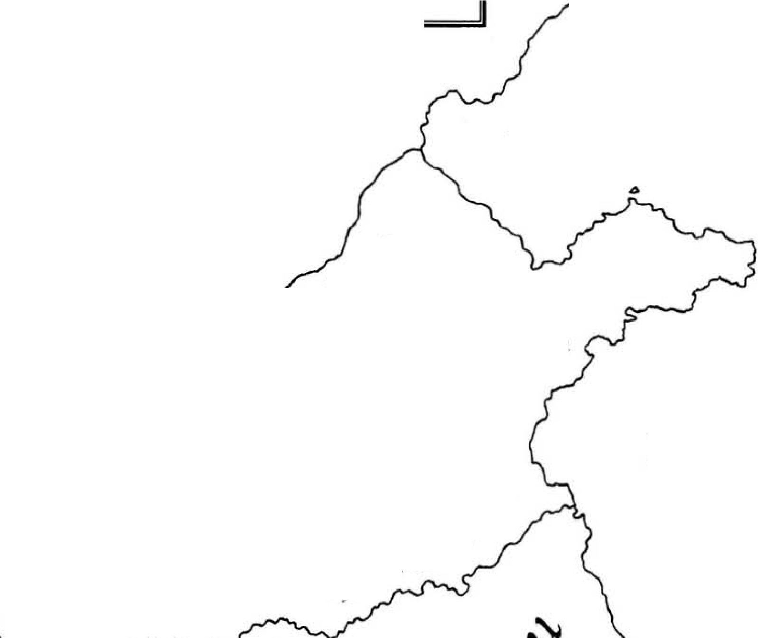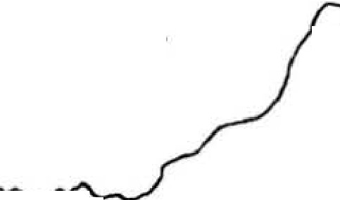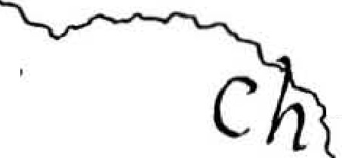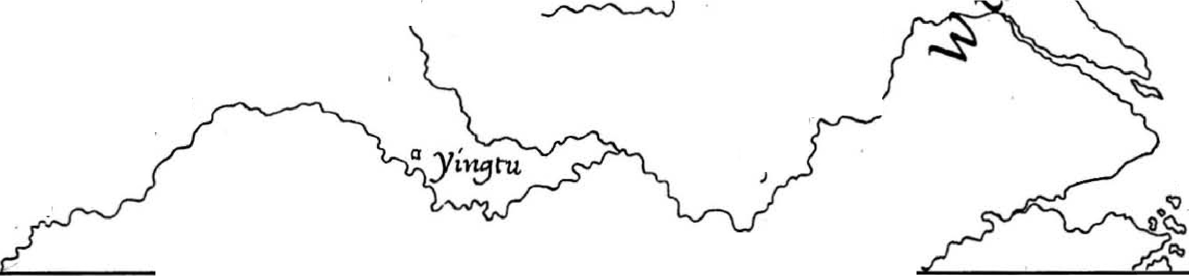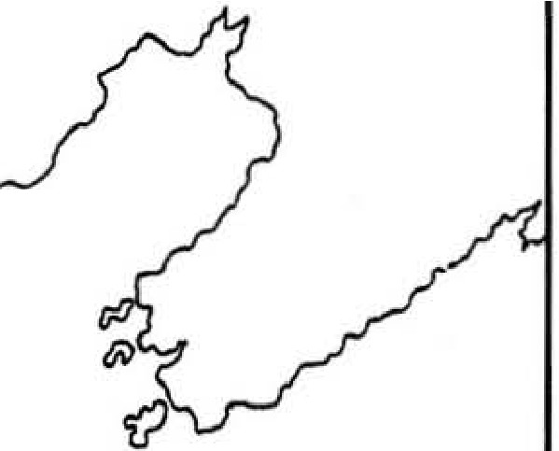J # · 4 -
•
Central China in the sixth century Be.
Map by Paul Hansen.
} - - J
••

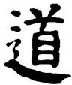Introduction

The Taotechingis at heart a simple book. Written at the end of the sixth century Be by a man called Lao-tzu, it is a vision of what our lives would be like if we were more like the dark, new moon.
Lao-tzu teaches us that the dark can always become light and contains within itself the potential for growth and long life, while the light can only be­ come dark and brings with it decay and early death. Lao-tzu chose long life. Thus he chose the dark.
�.
The word that Lao-tzu chose to represent this vision was Tao But Tao
means "road" or "way" and doesn't appear to have anything to do with dark­ ness. The character is made up of two graphs: "i§": head" and "L: go." To make sense of how the character came to be constructed, early Chinese philologists concluded that "head" must mean the start of something and that the two graphs together show someone starting on a trip. But a Chinese scholar in Taiwan has recently presented a novel, and more convincing, interpretation of the word's origins. According to Tu Er-wei, the 'bead" in the character tao is the face of the moon. And the meaning of "road" comes from watching this disembodied face as it moves across the sky.
1\1 also notes that tao shares a common linguistic heritage with words that
mean "moon" in other cultures: Tibetans call the moon da-ua; the Miao, who now live in southwest China but who lived in the same state as Lao-tzu when he was alive, call it tao-tie; the ancient Egyptians called itthoth. Tu Er-wei could
. have also added dar-sha, which means "new moon" in Sanskrit.
However, the heart of Tu's thesis is not linguistic, but textual and based on references within the Taoteching. Lao-tzu says the Tao is between Heaven and Earth, it's Heaven's Gate, it's empty but inexhaustible, it doesn't die, it waxes and wanes, it's distant and dark, it doesn't try to be it's the light that doesn't blind, it has thirty spokes and two thirteen-day (visible) phases, it can be strung like a bow or expand and contract like a bellows, it moves the other way (in
full,

relation to the sun), it's the great image, the hidden immortal, the crescent soul, the dark union, the dark womb, the dark beyond dark. If this isn't the moon, what is it?
Th Er-wei has, I think, uncovered a deep and primitive layer of the Taote­ ching that has escaped the attention of other scholars. of course, we cannot say for certain that Lao-tzu was consciously aware of the Tao's association with the moon. But we have his images, and they are too often lunar to dismiss as acci­ dental.
In associating the Tao with the moon, Lao-tzu was not alone. The symbol Taoists have used since ancient times to represent the Tao shows the two conjoined phases of the moon. And how could they ignore such an obvious connection between its cycle of change and our own? Every month we watch the moon grow ftom nothing to a luminous disc that scatters the stars and pulls the tides within us all. The oceans feel it. The earth feels it. Plants and animals feel it. Humans also feel it, though it is women who seem to be most aware of it. In the Huangti Neiching, or Yellow Emperor's Internal Book of Medicine, Ch'i Po explained to the Yellow Emperor: 'When the moon begins to grow, blood and breath begin to surge. When the moon is com­ pletely full, blood and breath are at their fullest, tendons and muscles are at their strongest. When the moon is completely empty; tendons and muscles are at their weakest"
(j
(8.26).
The advance of civilization has separated us ftom this easy lunar awareness. We call people affected by the moon "lunatics," making clear our disdain for its power. Lao-tzu redirects our vision to this ancient mirror. But instead of point­ ing to its light, he points to its darkness. Every month the moon effortlessly shows us that something comes ftom nothing. Lao-tzu asks us to emulate this aspect of the moon, not the full moon, which is destined to wane, but the new moon, which holds the promise of rebirth. And while he has us gazing at the moon's dark mirror, he asks why we don't we live longer than we do. After all, don't we share the same nature as the moon, and isn't the moon immortal?'
Scholars tend to ignore Lao-tzu's emphasis on darkness and immortality;
for it takes the book beyond the reach of academic analysis. For them, darkness is just a more poetic way of describing the mysterious. And immortality is a euphemism for long life. Over the years, they have distilled what they call Lao­ tzu's "Taoist philosophy" ftom the later developments of "Taoist religion." T hey call the Taoteching a treatise on political or military strategy. or they see it as primitive scientific naturalism or utopianism-or just a bunch of sayings.
But trying to force the Taoteching into the categories of modern discourse
not only distorts the Taoteching, it also treats the traditions that later Taoists

have associated with the text as irrelevant and misguided. Meanwhile, the Taoteching continues to inspire millions of Chinese as a spiritual text, and I have tried to present it in that dark light. The words of philosophers fail here. If words are of any use at all, they are the words of the poet. For poetry has the ability to point us toward the truth and then stand aside, while prose stands in the doorway relating all the wonders on the other side but rarely lets us pass. In this respect, the Taoteching is unique among the great literary works of the Chou dynasty. Aside from the anonymous poems and folksongs of the Shihching, or Book of Odes, we have no other poetic work from this early period of Chinese history; the wisdom of other sages was conveyed in prose. Al­ though I haven't attempted to reproduce Lao-tzu's poetic devices (Hsu Yung­ chang identifies twenty-eight different kinds of rhyme), I have tried to convey the poetic feel with which he strings together images for our breath and spirit, but not necessarily our minds. For the Taoteching is one long poem written in
praise of something we cannot name, much less imagine.
Despite the elusiveness and namelessness of the Tao, Lao-tzu tells us we can approach it through Te. Te means "virtue," both in the sense of "moral charac­ ter" as well as "power to act." Yen Ling-feng says, "Virtue is the manifestation of the Way. The Way is what Virtue contains. Without the Way. Virtue would have no power. Without Virtue, the Way would have no appearance" (Taoteching, Han Fei put it more simply: "Te is the Tao at work" (Taoteching, 38). Te is our entrance to the Tao. Te is what we cultivate. Lao-tzu's Virtue, however, isn't the virtue of adhering to a moral code but action that involves no moral code, no self, no other-no action.
21).
These are the two poles around which the Taoteching turns: the Tao, the
dark, the body. the essence, the Way; and Te, the light, the function, the spirit, Virtue. In terms of origin, the Tao comes first. In terms of practice, Te comes first. The dark gives the light a place to shine. The light allows us to see the dark. But too much light blinds. Lao-tzu saw everyone chasing the light and hastening their own destruction. He encouraged people to choose the dark in­ stead of the light, less instead of more, weakness instead of strength, inaction instead of action. What could be simpler?
Lao-tzu's preference for darkness extended to himself as well. For the past
2,500 years, the Chinese have revered the Taoteching as they have no other book, and yet they know next to nothing about its author. What they do know, or think they know, is contained in a brief biographical sketch included by Ssu-ma Ch'ien in a history of ancient China that he completed around 100 Be. Al­ though we don't know what Ssu-ma Ch'ien's sources of information were, we do know he was considered the most widely travelled man of his age, and he

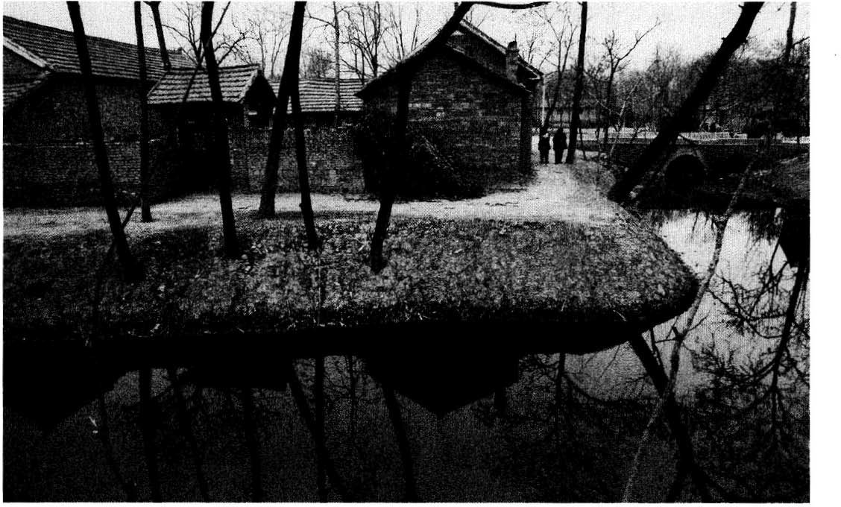

Village ofChujen east ofHuhsien. Lao-tzu's old home was located on this, thefifth ofnine bends ofa canal that once enabled small boats to travel via adjoining waterways to the Yellow River to the north or the Huai River to
the south. Photo by Bill Porter.

went to great lengths to verify the information he used. Of late it has become popular, if not de rigueur, to debunk his account of Lao-tzu, but it remains the earliest account we have and is worth repeating.
According to Ssu-ma Ch'ien, Lao-tzu was a native of Huhsien Prefecture in
the state of Ch'u. Nowadays, the former prefectural town of Huhsien is called Luyi. If you are travelling in China, or simply want to find it on a map, look for the town of Shangchiu on the train line that runs between the city of Cheng­ chou on the Yellow River and the Grand Canal town of Hsuchou. Luyi is about 70 kilometers south of Shangchiu. The shrine that marks the site of Lao-tzu's former village is just east of town.
. The region is known as the Huang-Huai Plain. As its name suggests, it is
the result of the regular flooding of the Huangho, or Yellow River, to the north and the Huaiho, or Huai River, to the south. The Chinese have been growing wheat and millet here since neolithic times, and more recently cotton and to­ bacco. It remains one of the most productive agricultural areas in all of China, and it was a rich prize over which many states fought in ancient times.
Lao-tzu was born on this plain in 604 BC, or 57t BC, depending on which


account of later historians we accept. Ssu-ma Ch'ien doesn't give us a date, but he does say that Huhsien was part of the great state of Ch'u. Officially; Huhsien belonged to the small state of Ch'en until 479 Be, when Ch'u eliminated Ch'en as a state once and for all. Some scholars have interpreted this to mean that either Huhsien did not belong to Ch'u when Lao-tzu was alive or that he must have been born there after 479 Be. But we need not accept either conclusion. Ssu-ma Ch'ien would have been aware that Ch'u controlled the forrunes of Ch'en as early as 598 Be, when Ch'u briefly annexed the entire state and then changed its mind, allowing Ch'en to exist as a "neighbor state."
Whether or not Huhsien was acrually part of Ch'u is not important. What is important is that during the sixth cenrury Ch'u controlled the region of
Be
which Huhsien was a part. This is significant not for verifYing the accuracy
of Ssu-ma Ch'ien's account but for directing our attention to the culrural
influence that Ch'u represented. Ch'u was not like the other states in the central plainS.
Although the rulers of Ch'u traced their ancestry to a grandson of the Yel­ low Emperor, the patriarch of Chinese culrure, they represented its shamanis­ tic periphery. From their ancestral home in the Sungshan area, just south of the Yellow River, they moved, or were pushed, steadily southwest, evenrually ending up in the Chingshan area, just north of the Yangtze. Over the cenruries they mixed with other tribal groups, such as the Miao, and incorporated elements of their shamanistic culrures. The Ch'u rulers took for their surname the word hsiung, meaning 'bear," and they called themselves Man or Yi, which the Chinese in the central states interpreted to mean 'barbarians."
The influence of Ch'u's culrure on Lao-tzu is impossible to determine, but it does help us better understand the Taoteching knowing that it was written by a man who was no stranger to shamanistic conceptions of the sacred world. Certainly as Taoism developed in later cenruries, it remained heavily indebted to shamanism, and some scholars see evidence of the Ch'u dialect in the Taoteching itself.
T his, then, was the region where Lao-rzu grew up. But his name was not Lao-tzu (which means "Old Master"). Ssu-ma Ch'ien says his family name was his personal name was Erh (meaning "ear," and hence, learned), and his posthumous name was Tan (meaning "long-eared," and hence, wise). In addi­ tion to providing us with a complete set of names, Ssu-ma Ch'ien also tells us
ti,
that Lao-tzu, or Li Erh, served as Keeper of the Royal Archives.
Before continuing, I should note that some scholars reject Ssu-ma Ch'ien's Li Erh or Li Tan and suggest instead a man named Lao Tan, who also served as Keeper of the Royal Archives, but in the fourth century Be rather than the sixth

century. Some find this later date more acceptable in explaining Lao-tzu's in­ novative literary style as well as in explaining why Chuang-tzu attributes pas­ sages of the Taoteching to Lao Tan but not Li Tan. For his part, Ssu-ma Ch'ien was certainly familiar with Chuang-tzu's writings, and he was not unaware of the fourth-century historian Lao Tan. In fact, he admits that some people thought that Lao Tan was Lao-�zu. But Ssu-ma Ch'ien was not convinced that the two were the same man. After all, if Tan was Lao-tzu's posthumous name, why shouldn't Chuang-tzu and other later writers call him "Old Tan"? And why couldn't there be two record keepers with the same name in the course of two centuries? If China's Grand Historian was not convinced that the fourth­ century historian was the author of the Taoteching--certainly he had more documents at his disposal than we now possess-I see no reason to decide in favor of a man whose only claim to fame was to prophesy the ascendency of the state of Ch'in, which was to bring the Chou dynasty to an end in 221 Be. Meanwhile, I think I hear Lao-tzu laughing.
In any case, the place where Lao-tzu kept the archives was the Chou dynasty capital of Loyang, which was about 300 kilometers west of Huhsien. Loyang was a neolithic campsite as early as 3000 Be and a military garrison during the first dynasties: the Hsia and Shang. When the state of Chou over­ threw the Shang dynasty in 1122 Be, the Duke of Chou built a new subsidiary capital around the old garrison. He dubbed it Wangcheng: City of the King. Usually. though, the king lived in one of the new dynasty's two western capitals of Feng and Hao, near modern Sian. But when these were destroyed in 77I Be, Wangcheng became the sole royal residence. And this is where Lao-tzu spent his time recording the events at court.
Lao-tzu must have been busy in the years following the death of King Ching. When King Ching died in 520 Be, two of his sons, Prince Chao and Prince Ching, both declared themselves his successor. At first Prince Chao gained the upper hand, and Prince Ching was forced to leave the capital. But with the help of other nobles, Prince Ching soon returned and established an- . other capital fifteen kilometers to the east of Wangcheng, which he dubbed Chengchou: Glory of Chou. And in 516 Be, Prince Ching finally succeeded in driving his brother from the old capital.
In the same year, the Keeper of the Royal Archives, which were still in Wangcheng, received a visitor from the state of Lu. The visitor was a young man named Kung Fu-tzu, or Confucius. Confucius was interested in ritual and asked Lao-tzu about the ceremonies of the ancient kings.
According to Ssu-ma Ch'ien, Lao-tzu responded with this advice: "The an­ cients you admire have been in the ground a long time. Their bones have


turned to dust. Only their words remain. Those among them who were wise rode in carriages when times were good and slipped quietly away when times were bad. I have heard that the clever merchant hides his wealth so his store looks empty and that the superior man acts dumb so he can avoid calling attention to himself. I advise you to get rid of your excessive pride and ambition. They won't do you any good. This is all I have to say to you." After­ wards, Confucius told his disciples, "Today when I met Lao-tzu, it was like meeting a dragon."
The story of this meeting appears in a sufficient number of ancient texts to make it unlikely that it was invented by Taoists. Confucian records also report it taking place. According to the traditional account, Lao-tzu was eighty-eight years old when he met Confucius. If so, and if he was born in 604 BC, the two sages would have met in 516 BC, and Confucius would have been thirty-five. So it is possible. Though Confucius would not have had many disciples at such an early date.
Following his meeting with Confucius, Lao-tzu decided to take his own
advice, and he left the capital by·ox-cart. And he had good reason to leave. For when Prince Chao was banished from Wangcheng, he took with him the royal archives, the same archives of which Lao-tzu was supposedly in charge. If Lao­ tzu needed a reason to leave, he certainly had one in 516 BC.
W ith the loss of the archives, Lao-tzu was out of a job. He was also, no doubt, fed up with the prospects for enlightened rule in the Middle Kingdom. Hence, he headed not for his hometown of Huhsien to the east but for Hanku Pass, which was 150 kilometers west of Loyang, and which served as the bor­ der between the Chou dynasty's central states and the semi-barbarian state of Ch'in, which now controlled the area surrounding the dynasty's former west­ ern capitals.
As Keeper of the Royal Archives, Lao-tzu no doubt supplied himself with the necessary documents to get through what was the most strategic pass in all of China. Hardly wide enough for two carts, it forms a seventeen­ kilometer-long defile through a plateau of loess that has blown down from the north and accumulated between the Chungnan Mountains and the Yellow River over the past million years. In ancient times, the Chinese said that who­ ever controlled Hanku Pass controlled China. It was so easy to defend that during the Second World War the Japanese army failed to break through it, despite finding no difficulty in sweeping Chinese forces from the plains to the east.
Fortunately; Lao·tzu was expected. According to Taoist records, Master
Yin Hsi was studying the heavens far to the west at the royal observatory at

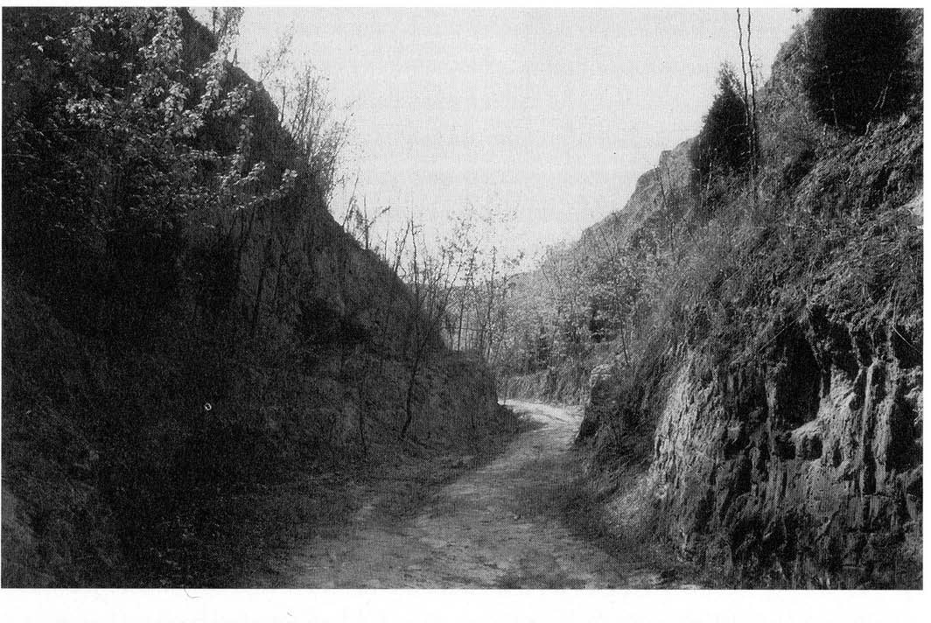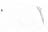

Hanku Pass. Midway between the Chou dynasty's eastern and western capitals and situated between the Yellow River and the Chungnan Mountains. This
is where Lao-tzu met Yin Hsi, Warden ofthe Pass. Photo by Bill Porter.

Loukuantai, when he noticed a purple vapor drifting from the east. He de­ duced that a sage would soon be passing through the area, and he knew that anyone travelling west would have to come through Hanku Pass. Hence he proceeded to the pass.
Ssu-ma Ch'ien, however, says Yin Hsi was Warden of the Pass and makes no mention of his association with Loukuantai. When Lao-tzu appeared, Yin Hsi recognized the sage and asked for instruction. According to Ssu-ma Ch'ien, Lao-tzu gave Yin Hsi the Taoteching and then continued on to distant, unknown realms.
Taoists agree that Lao-tzu continued on from Hanku Pass, but in the com­ pany of Yin Hsi, who invited him to his observatory 250 kilometers to the west. Taoists say Lao-tzu stopped long enough at Loukuantai to convey the teach­ ings that make up his Taoteching and then travelled on through Sankuan Pass, another 150 kilometers to the west, and into the state of Shu. Shu was founded by a branch of the same lineage that founded the state of Ch'u, although its rulers revered the cuckoo rather than the bear. And in the land of the cuckoo, Lao-tzu finally achieved anonymity as well as immortality.

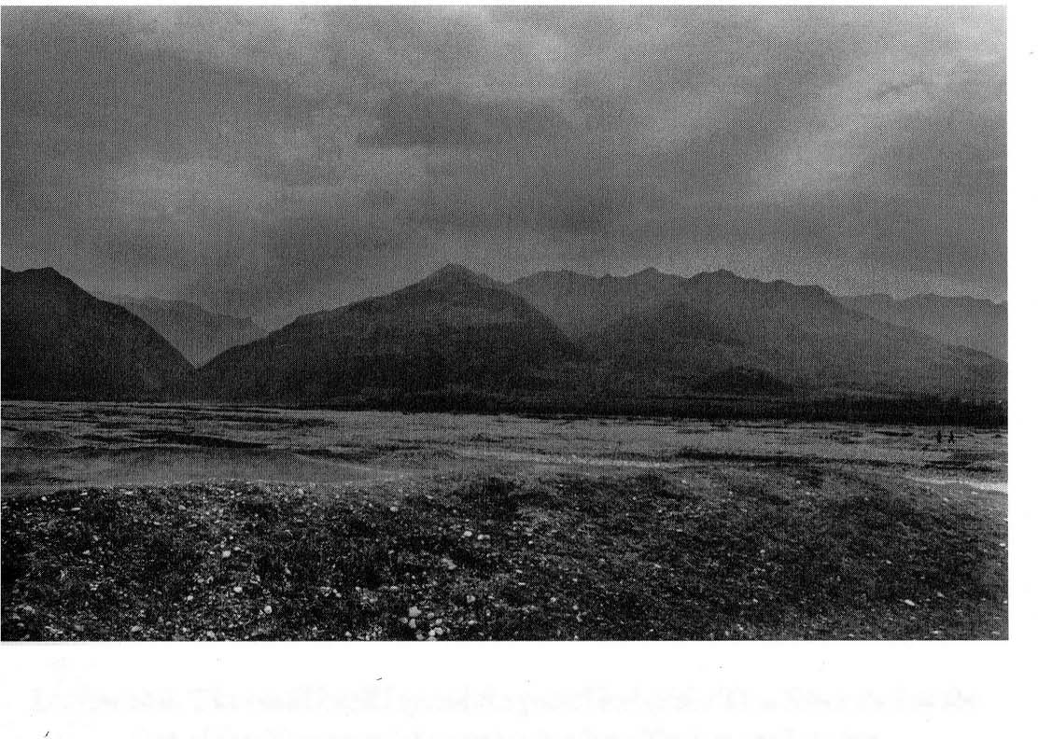

Loukuantai. The small knoll beyond the gravel bed ofthe Tim River and at the foot ofthe Chungnan Mountains is where Taoists say Lao-tzu
wrote the Taoteching. Photo by Bill Porter.

Curiously. about six kilometers west of Loukuantai, there's a tombstone with Lao-tzu's name on it. The Red Guards knocked it down in the 1960s, and when I last visited Loukuantai in 1993 it was still down. I asked Loukuantai's abbot, Jen Fa-jung, what happened to Lao-tzu. Did he continue on through Sankuan Pass, or was he buried at Loukuantai? Master Jen suggested both stories were true. As Confucius noted, Lao-tzu was a dragon among men. And being a member of the serpent family. why should we wonder at his ability to leave his skin behind and continue on through cloud-barred passes?
And so, Lao-tzu, whoever he was and whenever he lived, disappeared and left behind his small book. The book at first didn't have a name. When writers like Mo-tzu and Wen-tzu quoted from it in the fifth century Be, or Chuang-tzu 'and Lieh-tzu quoted from it in the fourth century Be, or Han Fei explained pas­ sages in the third century Be and Huai-nan-tzu in the second century Be, they simply said "Lao-tzu says this" or "Lao Tan says that." And so people started calling the source of all these quotes Laotzu.
SS1,l-ma Ch'ien also mentioned no name. He only said that Lao-tzu wrote a book, and it was divided into two parts. About the same time, people started

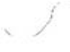
calling these two parts The Way and Virtue, after the first lines of verses and38. And to these, were added the honorific ching, meaning "ancient text." And so Lao-tzu's book was called the Taoteching, the Book of Tao and Te.
I
In addition to its two parts, it was also divided into separate verses. But, as with other ancient texts, punctuation and enumeration of passages were left up to the reader. About the same time that Ssu-ma Ch'ien wrote his biography of Lao-tzu and people started calling the book the Taoteching, Yen Tsun pro­ duced a commentary in the first century BC that divided the text into seventy­ two verses. A century earlier, or a couple of centuries later, no one knows which, Ho-shang Kung divided the same basic text into eighty-one verses. And a thousand years later, Wu Ch'eng tried a sixty-eight-verse division. But the sys­ tem that has persisted through the centuries is that of Ho-shang Kung, who also gave each verse its own title.
The text itself has seen dozens of editions containing anywhere from five to six thousand characters. The numerical discrepancy is not as significant as it might appear and is largely the result of adding certain grammatical particles for clarity or omitting them for brevity The greatest difference among editions centers not on the number of characters but on the rendering of certain phrases and the presence or absence of certain lines.
Over the centuries, several emperors have taken it upon themselves to re­ solve disputes concerning the choice among these variants. And the creation of a standard edition has resulted from their efforts. The standard edition, how­ ever, is still open to revision, and every student of the Taoteching repeats the process of choosing among variants to understand the text.
In this regard, Taoteching studies were blessed in late 1973 with the discovery of two copies of the text in a tomb that was sealed in 168 BC in a suburb of the provincial capital of Changsha known as Mawangtui. Despite the lapse of over 2,100 years, the copies, written on silk, were in remarkably good condition.
Kao Chih-hsi, who supervised their removal and who directed the Ma­ wangtui Museum until just recently. attributes their preservation to layers of clay and charcoal that covered the tomb. At least this is his official explanation. In private, he says their preservation could have also been due to the presence of an unknown gas created by the decomposition of certain substances inside the tomb. He tried to take a sample of the gas, but the discovery was made in the middle of the Cultural Revolution, and he spent two days peddling his bi­ cycle around Changsha before he found anyone who would loan him the nec­ essary equipment. By then the gas was gone.
The books, though, made up for his disappointment. Along with the
Taotcch ing there were several hitherto unknown commentaries on the Yiching

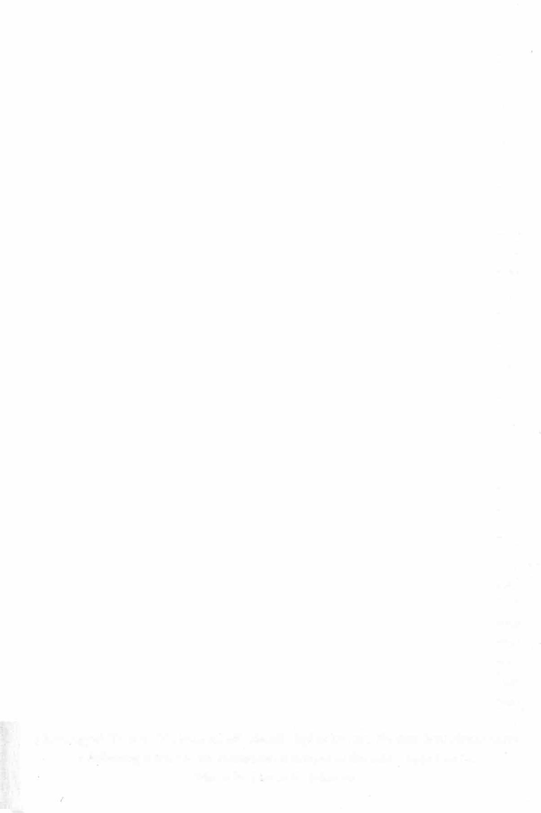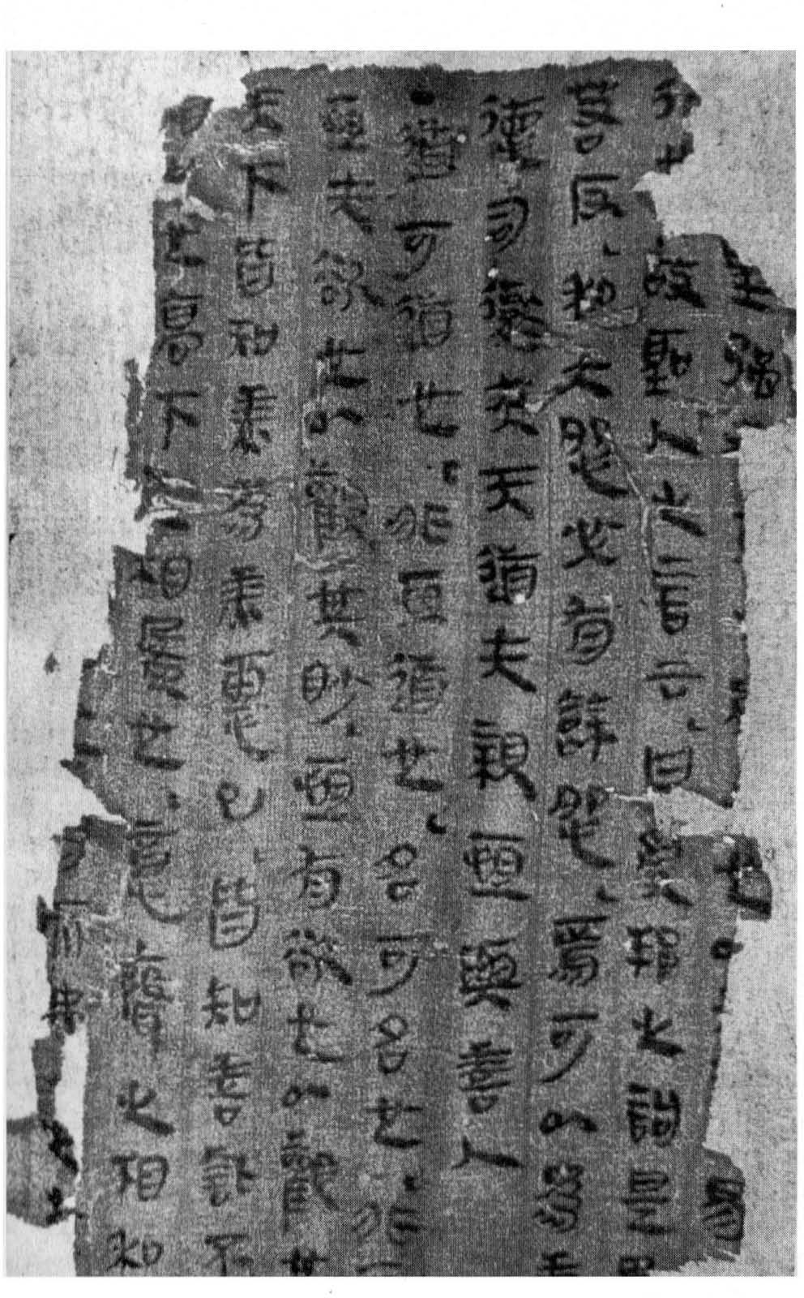

Milwangtui Text A. Written on silk shortly before 206 the text here shows verse
Be,
J following verse 79, an arrangement unique to the Mawangtui texts.
Photo by Steven R. Johnson.


as well as a number of lost texts attributed to the Yellow Emperor. The Chinese Academy of Sciences immediately convened a committee of scholars to exam­ ine these texts and decipher illegible sections.
In the years since their discovery. the two Mawangtui copies of the Taote­
ching have contributed greatly to the elucidation of a number of difficult and previously misunderstood passages. W ithout them, I would have been forced to choose among unsatisfactory variants on too many occasions. Still, the Mawangtui texts contain numerous omissions and errors and need to be used with great care.
Fortunately. we also have another text that dates from the same period. Like
the Mawangtui texts, it was discovered in a tomb that was sealed shortly after 200 Be. This tomb was located near the Grand Canal town of Hsuchou and was opened in 574 AD. Not long afterward, the court astrologer Fu Yi published an edition of the copy of the Taoteching that was found inside.
In addition to the Mawangtui and Fuyi texts, we also have more than sixty copies of the text that were found shortly after 1900 in the Silk Road oasis of Tunhuang. Most of these copies date from the eighth and ninth centuries. However, one of them was written by a man named Suo Tan in 270 AD, giving us yet another early hand-written edition to consider.
We also have a copy of the Taoteching written by the great fourth-century
calligrapher Wang Hsi-chih, as well as a dozen or so stelae on which various emperors had the entire text carved. Finally. we have the text as it appears in such early commentaries as those of Yen Tsun, Ho-shang Kung, and Wang Pi (not to mention numerous passages quoted in the ancient works of Mo-tzu, Wen-tzu, Chuang-tzu, Lieh-tzu, Han Fei, Huai-nan-tzu, and others).
In undertaking this translation, I have consulted nearly all of these editions and have produced a new recension incorporating my choices among the read­ ings. For the benefit of those able to read Chinese, I have included the resulting text with my translation. I have also added a number of commentaries.
Over the centuries, some of China's greatest writers have devoted them­
selves to explaining the Taoteching, and no Chinese would think of reading the text without the help of at least one of these line-by-line or verse-by-verse explanations. W hen I first decided to translate the Taoteching, it occurred to me that Western readers are at a serious disadvantage without the help of such materials. To remedy this situation, I have collected several dozen of the better­ known commentaries along with a few that are more obscure, and I have selected from among them those passages that provide important background information or insights.

Among the commentaries consulted, the majority of my selections come from a group of eleven men and one woman. In order of frequency. they in­ clude: Su Ch'e, Ho-shang Kung, Wu Ch'eng, Wang Pi, Te-ch'ing, Sung Ch'ang­ hsing, Li Hsi-chai, Lu Hui-ch'ing, Wang P'ang, Ch'eng Hsuan-ying, the Taoist nun Ts'ao Tao-ch'ung, and Wang An-shih. For biographical information on these and other commentators, readers are directed to the glossary at the back of this book (page 165).
Readers will also notice that I have restricted the comments to what could
fit on facing pages. The reason for this is that I envisioned this book as a discus­ sion between Lao-tzu and a group of people who have thought deeply about
.his text. And I wanted to have everyone in the same room rather than in ad-
J• om• m• g sUI• tes.
I have also added a few remarks of my own, though I have usually limited these to textual issues. In this regard, I have tried to restrict myself to those lines where my choice among variants may have resulted in a significant departure from other translations that readers might have in their possession. The
Taoteching is, after all, one of the most translated books in the world, exceeded
•
only by the Bible and the Bhagavad-Gita.
Since the text first appeared in Latin in 1788, more than a hundred transla­ tions have been published in the English language alone, and readers could not be blamed for wondering if there isn't something inherent in the text that infects those who read it with the desire to produce even more translations.
My own attempt to add to this number dates back nearly twenty-five years to when I attended a course in Taiwan given by John C.H. Wu. Professor Wu had himself produced an excellent English translation of the Taoteching, and he offered a course on the subject to graduate students in the philosophy depart­ ment at the College of Chinese Culture, which I was attending between stays at Buddhist temples.
Once a week, about six of us filed past the guards at the stately Chung­ ahanlou on Yangmingshan, where the government had provided Professor Wu a bungalow in recognition of his long service to the country. In addition
with
to translating the Taoteching, Professor Wu also translated the New Testament Ind.drafted his country's constitution, as well as served as China's ambassador to Vatican and its chief representative to the Hague. Once a week, we tea, ate his wife's cookies, and discussed a verse or two of Lao-tzu's text. classes, I tried translating the odd line in the margins of Professor
l\c:tween
ail'l'cd
the
Wu's bilingual edition, but I did not get far. After one semester, the course
ended, and I moved to a Buddhist monastery in the hills south of Taipei, where

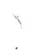I put aside Lao-tzu's text in favor of Buddhist sutras and poetry. But ever since then, I have been waiting for an opportunity to dust off this thinnest of ancient books and resume my earlier attempt at translation.
T he opportunity finally presented itself when I recently returned to Amer­ ica after more than twenty years in Taiwan and Hong Kong. In the early seven­ ties, when I was attending graduate school at Columbia University; I recall Pro­ fessor Bielenstein quoting W.A.C.H. Dobson, who said it was time for a Sinologist to retire when he announced he was working on a new translation of the Taoteching. And so I have joined the ranks of the retired.
I don't know if Dobson would have approved. His remarks, I suspect, were intended more as friendly criticism of the presumption that translating the Taoteching entails. Though relatively brief, the Taoteching is a difficult text. But it is also a transparent one.
For the past two years, one image that has repeatedly come to mind while working on this translation is skating on a newly frozen lake near my home in Idaho when I was a boy. Sometimes the ice was so clear, I felt like I was skating across the night sky; and the only sounds I could hear were the cracks that ech­ oed through the dark, transparent depths. I thought if the ice ever gave way I would find myself on the other side of the universe, and I always carried ice picks just in case I had to pull myself out. The ice never broke. But I've been hearing those cracks again.

Red Pine
Port Townsend, Washington
'
First Quarter, Last Moon, Year of the Pig

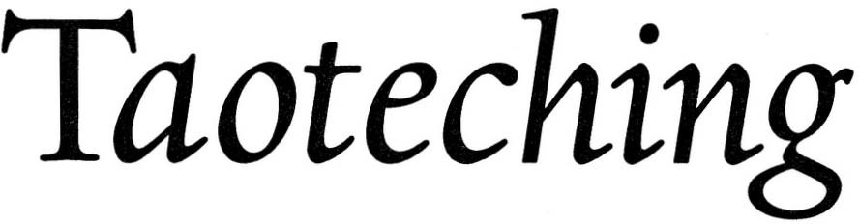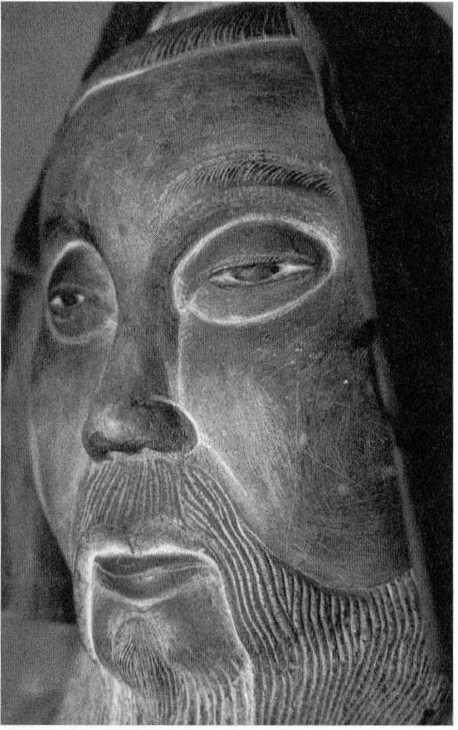Lao-tzus

Statue o!Lao-tzu at Cinnabar Cauldron, Loukuantai. Photo by
Bill Porter.

- -tA:Jt.!&*�Ofit The way that becomes a way

  - • z.it
is not the Immortal Way

Ii ,t§: � •
the name that becomes a name

-m :f • �� is not the Immortal Name
it

Z.

1!.:•
1!.:
,
z.

W:.l:J. -t:f
:Jt.ft#J.
1i'Lz.Of
,t§: the maiden of Heaven and Earth has no name
- the mother of all things has a name
-t
thus in innocence we see the beginning

- 1!.:Jlt.• -liF-t in passion we see the end

  - Fa !t ��
• •
two different names

!&� �Ii ,�t§:
-t,t§: for one and the same

•

, W:.
the one we call dark

z.r� il• l:J. �
the dark beyond dark

- WtJI.-t the door to all beginnings

The word tao means "road" or "way" and, by extension, "way of doing some­ thing." TU ER-WEI says, "Tao originally meant 'moon.' The Yiching: 42, 52 stresses the bright moon, while Lao-tzu stresses the dark moon" (pg. ii-iii).
CONFUCIUS says, "The Tao is what we can never leave. If we can leave it, it isn't the Tao" (Chungyung: x).
HO-SHANG KUNG says, "W hat we call a way is a moral or political code, while the Immortal Way takes care of the spirit without effort and brings peace to the world without struggle. It conceals its light and hides its tracks and can't be called a way. As for the Immortal Name, it's like a pearl inside an oyster, a piece of jade inside a rock: shiny on the inside and dull on the outside."
CH'ENG CHU says, '�sage doesn't reveal the Way. not because he keeps it secret, but because it can't be revealed. Hence his words are like footsteps that leave no tracks."
THE BUDDHA says, "He who says I teach the Dharma maligns me. W ho teaches the Dharma teaches nothing" (Diamond Surra: 21).

2

LI HSI-CHAI says. "Things change but not the Tao. The Tao is immortal. It arrives without moving and comes without being called."
SU C H'E says. "The ways of kindness and justice change but not the way of the Tao. No name is its body. Name is its function. The sage embodies the Tao and uses it in the world. But while entering the myriad states of being. he remains In non-being."
WANG PI says. "From the infinitesimal all things develop. From nothing all things are born. When we are free of desire. we can see the infinitesimal where things begin. When we are subject to desire. we can see where things end. 'Two' refers to 'maiden' and ·mother...·
TS' AO TAO-CH'UNG says, '''Two' refers to 'innocence' and 'passion: or in other words. stillness and movement. Stillness corresponds to nonexistence. Move­ ment corresponds to existence. Provisionally different. they are ultimately the same. Both meet in darkness."
THE SHUOWEN says. "Hsuan:dark means 'black with a bit of red in it.'"like the darker half of the yin-yang symbol. In Shensi province. where this text was writ­ ten. doors are still painted black with a thin line of red trim. And every road begins with a door.
TE-CH' ING says. "Lao-tzu's philosophy is all here. The remaining five-thou-
•
sand words only expand on this first verse."
The punctuation introduced by Ssu-ma Kuang and Wang An-shih in lines five through eight makes their subject yu:being and wu:non-being. But this is not supported by the grammatical particles of the Mawangtui texts. Also. in line five, shih:maiden normally means ·beginning." but the Shuowen says. "Shih means 'a virgin...· MA H SU-LUN says shih is a loan word for the nearly identical t·ai. While t'ai normally means "fetus." the Shuowen says it means "a woman in her third month of pregnancy." Note. too. that a woman did not receive her public name until after marriage. In line seven. most editions have miao:mysteri­ ous. But PI YUAN says. "In ancient times there was no miao:mysterious. only miao:smallibeginning, " which is what we find in the Mawangtui texts.

3

- 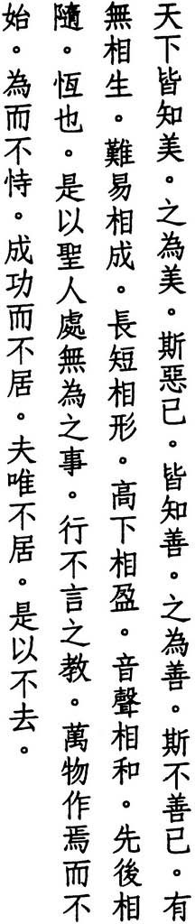All the world knows beauty but if that becomes beautiful
this becomes ugly
all the world knows good but if that becomes good this becomes bad
the coexistence of have and have not the coproduction of hard and easy the correlation of long and short
the codependence of high and low the correspondence of note and noise the coordination of first and last
is endless
thus the sage performs effortless deeds and teaches wordless lessons
he doesn't start all the things he begins he doesn't presume on what he does he doesn't claim what he achieves
and because he makes no claim he suffers no loss

LU HS(-SHENG says, "What we call beautiful or ugly depends on our feelings. Nothing is necessarily beautiful or ugly until feelings make it so. But while feel­ ings differ, they all come from our nature, and we all have the same nature.
Hence the sage transforms his feelings and returns to his nature and thus be-
.comes one
"
agaln.
WU CH'ENG says, "The existence of things, the difficulty of affairs, the size of forms, the magnitude of power, the pitch and clarity of sound, the sequence of position, all involve contrasting pairs. When one is present, both are present. When one is absent, both are absent."

4

LU HUI-CH'ING says, "These six pairs all depend on time and occasion. None them is eternal. The sage, however, acts according to the Immortal Tao, hence he acts without effort. And he teaches according to the Immortal Name, hence he teaches without words. Beautiful and ugly. good and bad don't enter
of
his mind."
WANG WU-CHIU says, "The sage is not interested in deeds or words. He simply follows the natural pattern of things. Things rise, develop, and reach their end. This is their order."
WANG AN-SHIH says, "The sage creates but does not possess what he creates. He acts but does not presume on what he does. He succeeds but does not claim I\Iccess. These three all result from selflessness. Because the sage is selfless,
he does not lose his self. Because he does not lose his self, he does not lose
others."
IU CH'E says, "Losing something is the result of claiming something. How
can a person lose what he doesn't claim?"
LI HSI-CHAI says, "Lao-tzu's 5,ooo-word text clarifies what is mysterious as well II what is obvious. It can be used to attain the Tao, to order a country. or to cultivate the body."
HO-SHANG KUNG titles this verse "Cultivating the Body."
lUNG CH'ANG-HSING says, "Those who practice the Way put an end to
_ cI.tlnctions, get rid of name and form, and make of themselves a home for the
Way and Virtue."
I have
incorporated line thirteen from the Mawangtui texts and have also used their wording of the six preceding lines. In line sixteen, I have relied on the Fuyi edition as well as Mawangtui Text B in reading shih:start in place of tZ'u:sayl I have followed the Mawangtui texts again in omitting the line "he possess what he begets" after line sixteen as an interpolation from
",JUse.
doesn't
verse 51. Lines seventeen and eighteen also appear in verse 77.

5

- 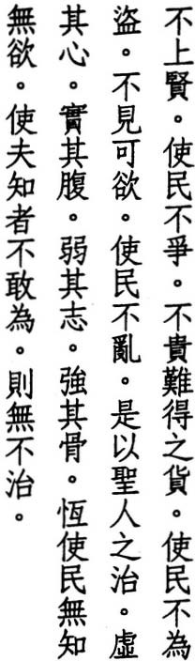Bestowing no honors keeps people from fighting
prizing no treasures
keeps people from stealing displaying no attractions
keeps people from making trouble thus the rule of the sage
empties the mind
but fills the stomach weakens the will
but strengthens the bones
by keeping the people from knowing or wanting and those who know from daring to act
he thus governs them all

SU C H'E says, "Bestowing honors embarrasses those who don't receive them to the point where they fight for them. Prizing treasures pains those who don't possess them to the point where they steal them. Displaying attractions dis­ tresses those who don't enjoy them to the point where they cause trouble. If
people aren't shown these things, they won't know what to want and will cease
.
wantmg."
WANG CHEN says, "The sage empties the mind of reasoning and delusion, he fils the stomach with loyalty and honesty. he weakens the will with humility and compliance, and he strengthens the bones with what people already have within themselves."
WANG PI says, "Bones don't know how to make trouble. It's the will that creates disorder. When the mind is empty. the will is weak."
WANG p'ANG says, 'l\n empty mind means no distinctions. A full stomach means no desires. A weak will means no external plans. Strong bones mean standing on one's own and remaining unmoved by outside forces. By bestow-

6

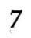lng no honors, the sage keeps people from knowing; By prizing no treasures,
he keeps people from wanting."
LU NUNG-SHIH says, "The mind knows and chooses, while the stomach doesn't know but simply contains. The will wants and moves, while bones don't want but simply stand there. The sage empties what knows and fills what doesn't know, he weakens what wants and strengthens what doesn't want."
YEN TSUN says, "He empties his mind and calms his breath. He concentrates
his essence and strengthens his spirit."
,
HUANG YUAN-CHI says, "The sage pUrifies his ears and eyes, puts an end to dis­ Ilpation and selfishness, embraces the one, and empties his mind. An empty mind forms the basis for transmuting cinnabar by enabling us to use our yang­ breath to transform our yin-essence. A full stomach represents our final form, In which our yang-breath gradually and completely replaces our yin-essence."
WEI YUAN says, "The reason the world is in disorder is because of action. Action
comes from desire. And desire comes from knowledge. The sage doesn't talk about things that can be known or display things that can be desired. This is how he brings order to the world."
LIU CHING says, "This verse describes how the sage cultivates himself in order to transform others."
In the Fuyi edition and Tunhuang copy S.477, an additional line follows "thus" of the last line: wei-wu-wei:act without acting. Commentators who accept this version often explain it with a quote from Confucius: "To govern without effort. That was Shun. And what did he do? Al he did was face south and bow" (Lunyu: 15.4). I've used the Mawangtui texts, which omit this line.
the
Lao-tzu's emphasis on the stomach over the eyes also appears in verse 12.

4 5t;5t
- -'>}
•
It The Tao is so empty
•
r!• # those who use it

1fJ. :);l: iTO
never become full again

],\G �m and so deep

if•
if• z.

as if it were the ancestor of us all

1f:);l:x
•
�t.vr�
j;p • ll
dulling our edges untying our tangles

:);l:${l:);l:i/iH• softening our light

Tz.jt-'>}

•
merging our dust

- • and so clear
�:);l:� 1-.;fJ. as if it were present
z.

%"� �
,
z. • it seems it was here before Ti
I wonder whose child it is

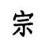

WANG AN-SHIH says, "The Tao possesses form and function. Its form is the original breath that doesn't move. Its function is the empty breath that alter­ nates between Heaven and Earth."
WU CH'ENG says, '''Empty' means empty like a bowl. The Tao is essentially empty; and people who use it should be empty too. To be full is contrary to the Tao. 'Deep' means what cannot be measured. An ancestor unites a lineage just as the Tao unites all things. i\s if' suggests reluctance to compare."
LI HSI-CHAI says, "The ancient masters of the Way had no ambition, hence they dulled their edges and did not insist on anything. They had no fear, hence they untied every tangle and avoided nothing. They did not care about beauty; hence they softened their light and forgot about themselves. They did not hate ugliness, hence they merged with the dust and did not abandon others."
WEI YUAN says, "By taking advantage of edges, we create conflicts with others. By shining bright lights, we illuminate their dust. Grinding down edges makes conflicts disappear. Turning down lights merges dust with dust and dust with darkness."

8

HUANG YUAN-CHI says, ''A person who can adjust his light to that of the crowd merge with the dust of the world is like a magic mushroom among ordi­
and
nary plants. You can't see it, but it makes everything smell better."
H51 T'UNG says, "The Tao is invisible. Hence Lao-tzu calls it 'clear.'"
THE SHUOWEN says, "Chan:clear means unseen."
LU NUNG-SHIH says, "'Clear' describes what is deep, what seems to be present and not to be present, what seems not to be present and not not to be present."
LIU CHING says, "If it's empty; it's deep. If it's deep, it's clear. The Tao comes from nothing. Hence the Tao is the child of nothing."
LI YUEH says, "Ti is the Lord of Creation. All of creation comes after Ti, except the Tao, which comes before. But the nature of the Tao is to yield, hence Lao­ tlU doesn't insist it came before. Thus he says, 'it seems.'"
JIN CHI-YU says, "In ancient times no one denied the existence of Ti, and no one
cilled
his supremacy into doubt. Lao-tzu, however, says the Tao is 'the ances­ tor of all things: which presumably included Ti as well" (pg. 34).
For such an enigmatic verse there are surprisingly few variants. In line three, I have gone along with the Fuyi edition, Tunhuang copy P.2584, and Mawangtui Text B in reading yu-pu-ying:again-not-foll in place of huo-pu-ying:maybe-not­ " Because of problems created by their interpretation of the first four lines,
JUll,
lome commentators think lines five through eight don't belong here. They do,
In fact, reoccur in verse 56. I've read them as an explanation of the Tao's ances­
tral status, which makes kin of us all.

9

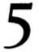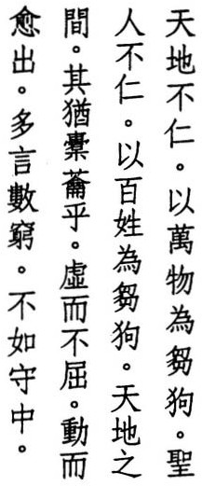Heaven and Earth are heartless treating creatures like straw dogs heartless is the sage
treating people like straw dogs between Heaven and Earth how like a bellows
empty but inexhaustible
each movement produces more talking only wastes it
better to keep it inside

The Chinese characters pu-jen:no heart also refer to a fruit that has no seed or center.
HU SHIH says, "Lao-tzu's statement that Heaven and Earth are heartless under­ cut the ancient belief that Heaven and Man were of the same lineage and thereby created the basis for natural philosophy" (p. 56).
LI JUNG says, "Love begets hate. Heaven and Earth are beyond love and hate. Hence they are heartless."
su e H ' E says, "Heaven and Earth aren't partial. They don't kill living things out of cruelty or give them birth out of kindness. We do the same when we make straw dogs to use in sacrifices. We dress them up and put them on the altar, but not because we love them. And when the ceremony is over, we throw them into the street, but not because we hate them. This is how the sage treats the people."
HUAI-NAN-TZU says, "When we make straw dogs or clay dragons, we paint them yellow and blue, decorate them with brocade, and tie red ribbons around them. The shaman puts on his black robe and the lord puts on his ceremonial
hat to usher them in and to see them off. But once they've been used, they're
nothing but clay and straw" (II). A similar description appears in Chuangtzu: 14-4-

10


WU CH'ENG says, "Straw dogs were used in praying for rain, and these particu­ lar bellows were used in metallurgy."
WANG P'ANG says, ''A bellows is empty so that it can respond to things. Some­ thing moves, and it responds. It responds but retains nothing. Like Heaven and Barth in regard to the ten thousand things or the sage in regard to the people, It responds with what fits. It isn't tied to the present or attached to the past."
WANG AN-SHIH says, "The Tao has no substance or dimension, yet it works the breath of emptiness between Heaven and Earth and gives birth to the ten thousand things."
WANG TAO says, "The Tao cannot be talked about, yet we dismiss it as heart­
less.
It cannot be named, yet we liken it to a bellows. Those who understand let the meaning and forget the words. Those who don't understand fail to see the truth and chatter away in vain."
HS IN TU-TZU says, "When the main path has many by-ways, sheep lose their way. When learning leads in many directions, students waste their lives"
(Llehrzu: 8:25).

HO-SHANG KUNG says, "Whenever the mouth opens and the tongue moves, disaster is close behind. Better to guard your inner virtue, nurture your vital elSence, protect your spirit, treasure your breath, and avoid talking too much."
lUNG CH' ANG-HSING says, "If our mouth doesn't talk too much, our spirit Itays in our heart. If our ears don't hear too much, our essence stays in our
lIenitals. In the course of time, essence becomes breath, breath becomes spirit,
and spirit returns to emptiness.
In
Western cultures, the Christmas tree occupies a place similar to that of Lao­ I:EU's "straw dogs . . ." The only textual variation here involves the appearance in Mawangtui texts of instead of the standard in line nine. But
both wen:hear yen.·talk
wen:hear wen.·ask,
Ilnce was sometimes used for the meaning isn't significantly different, hence I've keptyen:talk.

11

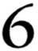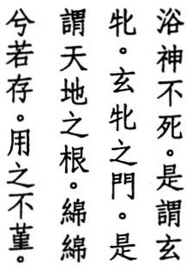The valley spirit that doesn't die we call the dark womb
the dark womb's mouth
we call the source of creation as real as gossamer silk
and yet we can't exhaust it

THE SHANHAICHING says, "The Valley Spirit of Morning Light is a black and yellow, eight-footed, eight-tailed, eight-headed animal with a human face" (9). The "valley spirit" is the moon, which runs ahead of the sun during the last eight days of its thirty-day cycle, lags behind during the first eight days, and faces the sun during its eight days of glory. For the remaining days of the month, it's too close to the sun to be visible. Like many other cul­ tures, the ancient Chinese viewed the moon as the embodiment of the female element of creation.
Shanhaichings
WANG PI says, "The valley is what is in the middle, what contains nothing, no form, no shadow, no obstruction. It occupies the lowest point, remains mo­ tionless, and does not decay. All things depend on it for their development. but no one sees its shape."
YE N FU says. "Because it is empty. we call it a valley. Because there is no limit to its responsiveness, we call it a spirit. Because it is inexhaustible. we say it never dies. These three are the virtues of the Tao."
SU CH'E says, ''A valley is empty but has form. A valley spirit is empty and has no form. What is empty and has no form is not alive. So how can it die? 'Valley spirit' refers to its virtue. 'Dark womb' refers to its capacity This womb gives birth to the ten thousand things. and we call it dark because we see it give birth but not how it gives birth."
HSUEH HUI says, "The words Lao-tzu chooses are often determined by the de­ mands of rhyme and should not be restricted to their primary meaning. Thus, p'in:ftmale animal can also be read p'in:womb."
HO-SHANG KUNG says, "The valley is what nourishes. Someone who is able to nourish his spirit does not die. 'Spirit' means the spirits of the five organs: the gall bladder, the lungs. the heart, the kidneys, and the spleen. When these five

12

organs are injured, the five spirits leave. 'Dark' refers to Heaven. In Man this means the nose, which links us with Heaven. 'Womb' refers to Earth. In Man this means the mouth, which links us with Earth. The breath that passes through our nose and mouth should be finer than gossamer silk and barely noticeable, as if it weren't actually present. It should be relaxed and never strained or exhausted."
WU CH' ENG says, "The empty valley is where spirits dwell, where breath isn't exhausted. Who relaxes their breath increases their vitality Who strains their breath soon expires."
TE-CH' ING says, "Purposeful action leads to exhaustion. The Tao is empty and acts without purpose. Hence it can't be exhausted."
SUNG CH'ANG-HSING says, "The valley spirit, the dark womb, the source of cre­ ation, all act without acting. Just because we don't see them doesn't mean they don't exist."
LIU CHING says, "It's like the silk of a silkworm or the web of a spider: hard to distinguish, hard to grab. But then, it isn't Man that uses it. Only the spirit can
. "
use It.
TU TAO-CHIEN says, "This verse also appears in Liehtzu: 1.1, where it is attrib­ uted to the Yellow Emperor instead of Lao-tzu. Lao-tzu frequently incorpo­ rates passages from ancient texts. We see their traces in 'thus the sage pro­ claims' or 'hence the ancients say.' Thus Confucius said, 'I don't create. I only relate'" (Lunyu: 7.1).
LIEH-TZU says, "What creates life is not itself alive" (I.I).

13

#*,L. jfffij ¥A �:J.• "*:It!
7 !iX. • lJ. 4f 7';. Heaven is eternal and Earth is immortal

the reason they're eternal and immortal

- :{f- l!# /f# A is because they don't live for themselves
•

/f�:J.
z.
1f1f, jfffij
tt
,

iff
but ends up in front
•

jf ro 7';.

•
hence they can live forever

# • � :It! thus the sage pulls himself back

�� .
�� lJ.
he lets himself go

7� � "*
"* ��
# iL
but ends up safe


tt • selflessness must be the reason
�� jf
-k A whatever he seeks he finds

CHU CH' IEN-CHIH says, "The line 'Heaven is eternal and Earth is immortal' was apparently an old saying, which Lao-tzu quotes in order to explain its significance."
CHIANG SSU-CH'I says, '''Heaven' refers to the point between the eyebrows. 'Earth' refers to the point just below the nave!."
LU HUI-CH' ING says, "Heaven stands for the movement of time. Earth repre­ sents the transformation of form. Heaven and Earth have their origin in the dark womb. And the essence of the dark womb is the valley spirit that doesn't die. Because it doesn't die, it isn't born. Only what isn't born can give birth to the living. And because it doesn't give birth to itself, it can live forever."
TS'AO TAO-CH' UNG says, "What is not alive is the basis for life. By equating life and death, we are no longer burdened by life and death. By abandoning bodily form, we are no longer hindered by bodily form."
WU CH' ENG says, "To pull back means tobe humble and not to try to be in front of others. To let go means to be content and not to try to add to our life. To find what one seeks means to be in front and safe."
SUNG CH' ANG-HSING says, "Heaven and Earth help creatures fulfill their needs by not having any needs of their own. Can the sage do othetwise? By following the Way of Heaven and Earth, the sage is revered by al and harmed by none. Hence he, too, lives long."

\

14


)EN FA-)UNG says, "The sage does not purposely seek long life but achieves it through selflessness."
CH' ENG CHU says, "Heaven, Earth, and Man share the same origin. Why doesn't Man share their immortality? Because Heaven and Earth are not aware they are Heaven and Earth. Only Man is aware of himself. And being aware of himself, there is nothing he won't do to stay alive. But the more he cares for his life, the more pained his life becomes. The more he nourishes his body. the sicker his body becomes. People who have not thought this out say the follow­ ers of Lao-tzu are afraid of death and only interested in immortality. But this is getting it backwards."
Ha-SHANG KUNG says, "The reason Heaven and Earth alone are eternal and Immortal is because they are content and give without expecting a reward, unlike Man who never stops chasing profit and fighting over possessions."
WANG PI says, "Those who live for themselves fight with others. Those who don't live for themselves are the refuge of others."
su CH' E says, "If Heaven and Earth fought with others over life, they would be the same as others. And if the sage fought with other men over profit, he would be just another man. Would that not be a great shame?"
WANG P'ANG says, 'l\lthough the sage is a sage, he looks the same as others. But because he embodies the Way of Heaven and doesn't fight, he alone differs from everyone else. The sage is selfless because he no longer has a self."
LU TUNG-PIN says, "The only thing the sage seeks is Virrue."

15

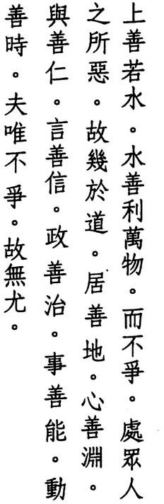8 The best are like water bringing help to all
without competing choosing what others avoid hence approaching the Tao dwelling with earth thinking with depth helping with kindness speaking with truth governing with peace working with skill
moving with time
and because they don't compete they aren't maligned

WU CH' ENG says, '�mong those who follow the Tao, the best are like water: content to be on the bottom and, thus, free of blame. Most people hate being on the bottom and compete to be on the top. And when people compete, someone is maligned."
LI HU NG-FU says, "How do we know the best don't compete? Everyone else chooses nobility. They alone choose humility. Everyone else chooses the pure. They alone choose the base. What they choose is what everyone else hates. Who is going to compete with them?"
KUAN-TZU says, 'Water is the source of creation, the ancestor of all living things. It's the bloodstream of the Earth" (39).
H UA N G Y UA N - CHI says, "Mencius says, 'People cannot live without water and fire' (7A.23). In terms of cultivation, when fire warms water, pure yang arises. When water cools fire, 'sweet dew' appears."
WA N G p'AN G says, "Water is the chief of thefive elements (for which, see verse 12). It comes from space, which is not that far from the Tao."

16

WANG PI says, "The Tao does not exist, but water does. Hence it only ap­ proaches the Tao."
HO-SHANG KUNG says, "The best people have a nature like that of water. They're like mist or dew in the sky. like a stream or a spring on land. Most people hate moist or muddy places, places where water alone dwells. The na­ ture of water is like the Tao: empty. clear, and deep. As water empties, it gives life to others. It reflects without becoming impure, and there is nothing it can­ not wash clean. Water can take any shape, and it is never out of touch with the seasons. How could anyone malign something with such qualities as this."
5 U N G CH' A N G - H SI N G says, "Those who free themselves from care stay low and avoid heights. Those whose minds are empty can plumb the depths. Those who help others without expecting any reward are truly kind. Those whose mouths agree with their minds speak the truth. Those who make demands of themselves as well as others establish peace. Those who can change as condi­ tions change work with skill. Those who act when it is time to act and rest when it is time to rest move with time."
LI ) U N G says, "Water has no purpose of its own. Those who can remain empty and not compete with others follow the natural Way. "
YEN TSUN says, "If a ruler embodies this and uses this in his government, his
virtue is most wonderful. How could he be maligned?"
HAN FEI says, "If a drowning man drinks it, he dies. If a thirsty man drinks it, lives."
he
Given Lao-tzu's usual disdain for social virtues, some commentators have trouble accepting the standard reading ofjen:kindness in line eight. For those in search of an alternative, the Fuyi and Chinglung editions havejen:others, while Mawangtui Text B has t'ien:heaven, and Mawangtui Text A compresses lines seven and eight: "helping with truth."

17




SSU-MA CH' IEN says, "When Confucius asked about the ceremonies of the an­ cients, Lao-tzu said, 'I have heard that the clever merchant hides his wealth so his store looks empry and that the superior man acts dumb to avoid calling at­ tention to himself. I advise you to get rid of your excessive pride and ambition. They won't do you any good. This is all I have to say to you'" (63).
HO-SHANG KUNG says, "Excessive wealth and desire wearies and harms the spirit. The rich should help the poor, and the powerful should aid the op­ pressed. If, instead, they flaunt their riches and power, they are sure to suffer disaster. Once the sun reaches the zenith, it descends. Once the moon becomes full, it wanes. Crearures flourish then wither. Joy rurns to sorrow. When your work is done, if you do not step down, you will meet with harm. This is the Way of Heaven."
HUANG YUAN-CHI says, "You need a raft to cross a river. But once across, you can forget the raft. You need to srudy rules to learn how to do something. But once you know how, you can forget the rules."
WANG AN- SHIH says, "The Way of Heaven is to bring down the high and to lift up the low."
The Fuyi edition adds ming-sui: when your name is made to the beginning of line nine. The Chinglung and Chingfu editions as well as Wentzu, Motzu, and Huainantzu also include this phrase but place it after kung-ch'eng: when your work succeeds. Either way. its addition breaks the rhythm of the verse, which otherwise has four syllables to a line. I have treated it as an interpolation and have followed the Mawangtui texts, which condense both phrases: kung-sui: when your work is done.

19

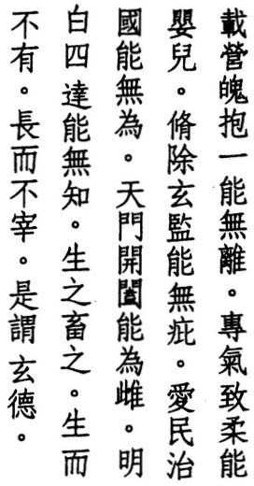10 Can you hold fast your crescent soul and not let it wander can you make your breath as soft as a baby's
can you wipe your Dark Mirror free of dust can you serve and govern without effort can you be the female at Heaven's Gate
can you light up the world without knowledge
beget things and keep them but beget without possessing keep without controlling this is Dark Virtue

The Chinese say that the hun, or bright, ethereal, yang soul, governs the upper body and the p'0, or dark, earthly; yin soul, concerns itself with the lower body.
Here, Lao-tzu mentions only the darker soul. But the word p'o also refers to
the dark of the moon, and the opening phrase can also be read as referring to the first day of the new moon. Either way; dark of the soul or dark of the moon, Taoist commentators say the first line refers to the protection of our vital es­ sence: semen and vaginal fluid, sweat and saliva, the depletion of which injures the health and leads to early death.
HSUAN-TS UNG says, "The first transformation of life is calledp 'o. When thep '0
becomes active and bright, it is called hun. "
WANG p'ANG says, "Life requires three things: vital essence, breath, and spirit."
CHIAO HUNG says, "The mind knows right and wrong. Breath makes no dis­ tinction. If we concentrate our breath and don't let the mind interfere with it, it remains soft and pure. Who else but a child can do this?"
CHUANG-TZU says, "The sage's mind is so still, it can mirror Heaven and Earth and reflect the ten thousand things" (13.1).
WU CH ENG says, "Our spirit dwells in our eyes. When the eyes see something, the spirit chases it. When we close our eyes and look within, everything is dark. But within the dark, we still see something. There is still dust. Only by putting an end to delusions can we get rid of the dust."
'

20


WAN G AN - S H I H says, "The best way to serve is by not serving. The best way to govern is by not governing. Hence Lao-tzu says 'without effort.' Those who act without effort make use of the efforts of others. As for Heaven's Gate, this is the gate through which all creatures enter and leave. To be open means to be active. To be closed means to be still. Activity and stillness represent the male and the female. Just as stillness overcomes movement, the female overcomes the male."
SU CH' E says, "What lights up the world is the mind. There is nothing the mind does not knOw. And yet no none can know the mind. The mind is one. If some­ one knew it, there would be two. Going from one to two is the origin of all delusion."
LAO-TZU says, "The Tao begets them / Virtue keeps them" (sI).
WANG PI says, "If we don't obstruct their source, things come into existence on their own. If we don't suppress their nature, things mature by themselves. Vir­ tue is present, but its owner is unknown. It comes from the mysterious depths. Hence we call it dark."
The first line has had numerous interpretations, to which I have added one more. CHENG LIANG-SHU and most other modern commentators now agree that tsai should be placed at the beginning of this verse instead of at the end of the previous verse. Although tsai can mean "carry." it can also mean "new," as in the phrase: tsai-sheng-p'o:new-born moon, or as Lao-tzu uses it here: tsai-ying­ p'o:new-lit moon/soul. After line eight, most editions add "act without presum­ ing," which also appears in a similar sequence in verses 2 and 51. I have followed the Mawangtui texts in omitting it here as irrelevant.

21

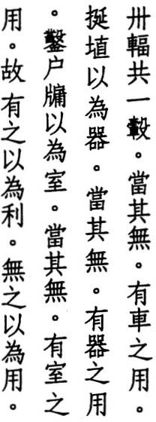1 1 Thirty spokes converge on a hub but it's the emptiness
that makes a wheel work pots are fashioned from clay but it's the hollow
that makes a pot work
windows and doors are carved for a house but it's the spaces
that make a house work
existence makes something useful but nonexistence makes it work

HSUAN-TSUNG says, "Thirty spokes converging on a hub demonstrates that less is the ancestor of more."
HO-SHANG KUNG says, 'i\ncient carts had thirty spokes in imitation of the lunar number."
LI-)UNG says, "It's because the hub is empty that spokes converge on it. Like· wise, it's because the sage's mind is empty that the people turn to him for help."
CH'ENG H SUAN-YING says, '1\ cart, a pot, and a house can hold things because they are empty. How much more the disciple who empties his mind."
wu CH'ENG says, 'l\ll of these things are useful. But without an empty place for an axle, a cart can't move. Without a hollow place in the middle, a pot can't hold things. Without spaces for doors and windows, a room can't admit people or light. But these three examples are only metaphors. What keeps our body alive is the existence of breath in our stomach. And it is our empty; nonexistent mind that produces breath."
SUNG CH'ANG-HSING says, "In this verse the Great Sage teaches us to under­ stand the source by using what we find at hand. Doors refer to a person's mouth and nose. Windows refer to their ears and eyes."
CHANG TAO-LING says, "When ordinary people see these things, they only

22

think about how they might employ them for their own advantage. When the sage sees them, he sees in them the Tao and is careful in their use."
TE-CH' ING says. "Heaven and Earth have form, and everyone knows that Heaven and Earth are useful. But they don't know that their usefulness depends on the emptiness of the Great Way. Likewise, we al have form and think ourselves us.eful but remain unaware that our usefulness depends on our empty; shapeless mind. Thus existence may have its uses, but real usefulness depends on nonexistence. Nonexistence, though, doesn't work by itself. It needs the help of existence."
HUANG YUAN-CHI says, 'What is beyond form is the Tao, while what has form are tools. Without tools we have no means to apprehend the Tao. And without the Tao there is no place for tools."
HSUEH HUI says, 'i\t the end of this verse, Lao-tzu mentions both existence and nonexistence, but his intent is to use existence to show that nonexistence is more valuable. Everyone knows existence is useful, but no one pays attention to the usefulness of nonexistence."
In line seven, the Mawangtui texts omit yi-wei-shihfor a house, but this phrase is needed to complete the line and is present in all other editions. Many people in Shensi and Honan provinces still carve their homes into the loess cliffs that dis­ tinguish this region where Chinese civilization first developed and where this text was written. The compactness of the soil makes support beams unneces­ sary. and its densiry keeps dwellings cool in the summer and warm in the win­ ter. The only building materials needed are doors and windows.

23

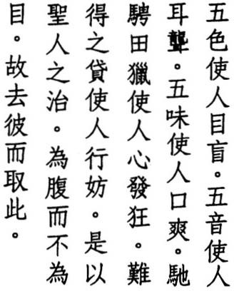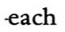1 2 The five colors make our eyes blind the five tones make our ears deaf
the five flavors make our mouths numb riding and hunting make our minds wild hard-to-get goods make us break laws thus the rule of the sage
puts the stomach ahead of the eyes thus he picks this over that

The early Chinese ascribed five states of existence to the material world: water, fire, wood, metal, and earth with its own color: blue, red, black, white, and yellow; its own taste: salty; bitter, sour, pungent, and sweet; and its own tone: la, sol, mi, re, do.
YEN TSUN says, "Color is like an awl in the eye. Sound is like a stick in the ear. Flavor is like an axe through the tongue."
TE-CH' ING says, "When the eyes are given free rein in the realm of form, they no longer see what is real. When the ears are given free rein the realm of sound, they no longer hear what is real. When the tongue is given free rein in the realm of taste, it no longer discerns what is real. When the mind is given free rein in the realm of thought, it no longer knows what is real. When our actions are given free rein in the realm of possession and profit, we no longer do what is right. Like Chuang-tzu's tapir (1.4), the sage drinks from the river, but only enough to fill his stomach.
WU CH' ENG says, "Desiring external things harms our bodies. The sage nour­ ishes his breath by filing his stomach, not by chasing material objects to please his eye. Hence he chooses internal reality over external illusion. But the eyes can't help seeing, the ears can't help hearing, the mouth can't help tasting, the mind can't help feeling, and the body can't help moving. They can't stay still. But if we let them move without leaving stillness behind, nothing can harm us. Those who are buried by the dust of the senses or who crave sensory stimula­ tion lose their way. And the main villain in this is the eyes. Thus the first of Confucius' four warnings concerns vision (Lunyu: 12.1: not to look except with propriety), and the first of the Buddha's six sources of delusion is also the eyes."

24

LI YUEH says, "The eyes are never satisfied, the stomach knows when it is full."
SUNG C H ' ANG-HSING says, "The main purpose of cultivation is to oppose the world of the senses. What the world loves, the Taoist hates. What the world wants, the Taoist rejects. Even though color, sound, material goods, wealth, or beauty might benefit a person's body, in the end they harm a person's mind. And once the mind wants, the body suffers. If we can ignore external tempta­ tions and be satisfied with the way we are, if we can cultivate our mind and not chase material things, this is the way of long life. Al the treasures of the world are no match for this."
HSUAN-TSUNG says, '''Hard-to-get goods' refer to things which we don't pos­ sess by nature but which require an effort to obtain. When we are not content with our lot and allow ourselves to be ruled by conceit, we turn our backs on Heaven and lose the Way."
CH' ENG HSUAN-YlNG says, '''That' refers to the blindness and delusion of the eyes. 'This' refers to the fullness and wisdom of the stomach."
The Mawangtui texts present lines two through five in a different sequence: 4, 5, 3, 2. However, no other edition follows suit, hence I have retained the tra­ ditional order. Until the early twentieth century. vast tracts of land in northern China were set aside for the exclusive use of the nobility and the military in conducting group hunts to practice their riding and archery.

,

25

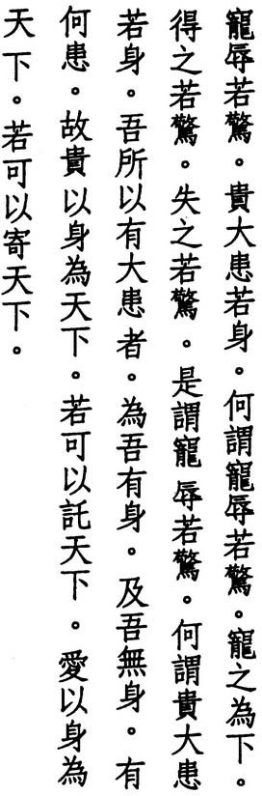1 3 Favor and disgrace are like warnings honor and disaster are like the body
and why are favor and disgrace like warnings favor means descending
to gain it is like a warning to lose it is like a warning
thus are favor and disgrace like warnings
and why are honor and disaster like the body the reason we have disaster
is because we have a body if we didn't have a body we wouldn't have disaster
who honors his body as much as the world can be entrusted with the world
who loves his body as much as the world
can be encharged with the world

WANG CHEN says, "People who are favored are honored. And because they are honored, they act proud. And because they act proud, they are hated. And be­ cause they are hated, they are disgraced. Hence the sage considers success as well as failure to be a warning:'

su CH E says, "The ancient sages worried about favor as much as disgrace, be­
'
cause they knew that favor is followed by disgrace. Other people think favor means to go up, and disgrace means to go down. But favor cannot be separated from disgrace. Disgrace comes from favor."
HO-SHANG KUNG says, "Those who gain favor or honor should worry about being too high, as if they were at the edge of a precipice. They should notflaunt their status or wealth. And those who lose favor and live in disgrace should worry about another disaster."

26

LU NUNG-SHIH says, "Why does favor become disgrace and honor become di­ saster? Favor and honor are external things. They don't belong to us. When we try to possess them, they turn into disgrace and disaster."
SSU-MA KUANG says, "Normally a body means disaster. But if we honor and cherish it and follow the natural order in our dealings with others and don't indulge our desires, we can avoid disaster."
HUANG YUAN-CHI says, 'We all possess something good and noble that we don't have to seek outside ourselves, something that the glory of power or position cannot compare with. People need only start with this and cultivate without letting up. The ancients said, 'Two or three years of hardship, ten thou­ sand years of bliss.'"
WANG p'ANG says, "It isn't a matter of having no body but of guarding the source of life. Someone who refuses to trade himself for something external is fit to receive the kingdom."
WANG PI says, "Those who are affected by favor or disgrace, honor or disaster are not fit to receive the kingdom."
TSENG-TZU says, "The superior man can be entrusted with an orphan or encharged with a state and be unmoved by a crisis" (Lunyu: 8.6).
Commentators disagree about how to read line one: is "favor" a verb and "dis­ grace" its noun object ("favor disgrace as a warning") or are they both nouns? The same question is posed for "honor" and "disaster" in line two. Some edi­
tions omitjuo-ching:like warnings in line three and have two quite different lines
for line four: "favor means up I disgrace means down." My choice is based on the Fuyi and Mawangtui texts, as well as Wang Pi. The last four lines are also found in Chuangtzu: where they are used to praise the ruler whose self­ cultivation doesn't leave him time to meddle in the lives of his subjects. They also appear in Huainantzu: where they are used to praise the ruler who val­ ues the lives of his people more than the territory in which they live.
12,
II.2,

27

- 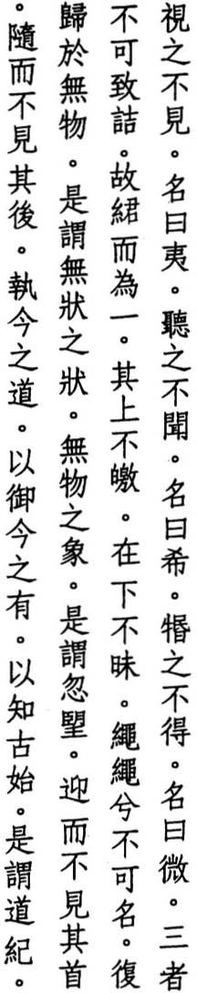We look but don't see it and call it indistinct
we listen but don't hear it and call it faint
we reach but don't grasp it
and call it ethereal
three failed means to knowledge I weave into one
with no light above with no shade below too fine to be named returning to nothing this is the formless form the immaterial image
this is the waxing waning
we meet without seeing its face we follow without seeing its back holding onto this very Way
we rule this very realm
and discover its ancient past this is the thread of the Way

HO-SHANG KUNG entitles this verse "In Praise of the Dark" and says, 'i\bout what has no color, sound, or form, mouths can't speak and books can't teach. We can only discover it in stillness and search for it with our spirit. We can't find it through investigation."
LU TUNG-PIN says, "We can only see it inside us, hear it inside us, and grasp it inside us. When our essence becomes one, we can see it. When our breath be­ comes one, we can hear it. When our spirit becomes one, we can grasp it."

28


'ENG HSUAN-YING says, "What we don't see is vital essence. What we don't
CH
hear is spirit. What we don't grasp is breath."
su CH' E says, "People see things constantly changing and conclude something is there. They don't realize everything returns to nothing."
' EN KU-YING says, "Nothing doesn't mean nothing at all bur simply no form or substance."
CH
WANG PI says, "If we try to claim it doesn't exist, how do the myriad things come to be? And if we try to claim it exists, why don't we see its form? Hence we call it the formless form. But although it has neither shape nor form, nei­ ther sound nor echo, there is nothing it cannot penetrate and nowhere it can­ not go."
LI YUEH says, "Everything is bright on top and dark on the bottom. But the Tao does not have a top or bottom. Hence it is neither bright nor dark. Likewise, we do not see its face because it never appears, and we do not see its back be­ cause it never leaves."
TS' ' UNG says, '''This very realm' refers to our body."
AO TAO-CH
' ING says, "The past isn't different from today. because we know what began in the past. And today isn't different from the past, because we know where today came from. What neither begins nor comes from anywhere else we call the thread that has no end. This is the thread of the Tao."
LU HUI-CH
CHANG TAO-LING says, "The sages who achieved long life and immortaliry in the past all succeeded by means of this Tao. Who can follow their example today has found the thread of the Tao."
In line eight, I have extended the thread morif by going along with Mawangtui Text B in reading chun:weave instead of the usual hun:merge. I have also chosen the Mawangtui versions of lines fifteen and eighteen, which the standard edi­ tion renders: "this is the indefinable" and 'bolding onto the ancient Tao."

29

- 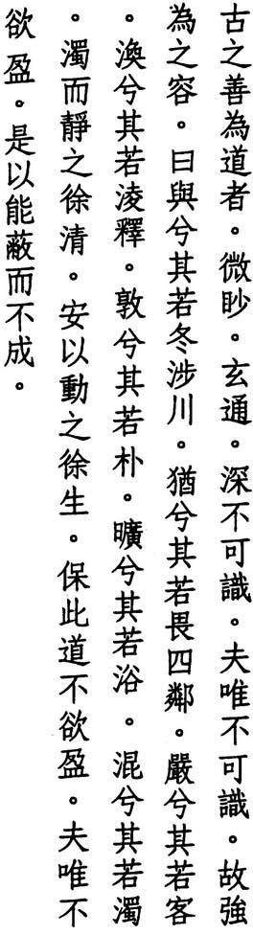The ancient masters of the Way aimed at the indiscernible
and penetrated the dark
you would never know them
and because you wouldn't know them I describe them with reluctance
they were careful as if crossing a river in winter cautious as if worried about neighbors
reserved like guests ephemeral like melting ice simple like uncarved wood open like valleys
and murky like puddles
but a puddle becomes clear when it's still and stillness becomes alive when it's roused those who treasure this Way
don't try to be full not trying to be full
they can hide and stay hidden

TS' AO TAO-CH'UNG says, 'l\lthough the ancient masters lived in the world, no one thought they were special."
' E says, "Darkness is what penetrates everything but cannot itself be per­ ceived. To be careful means to act only after taking precautions. To be cautious means to refrain from acting because of doubt or suspicion. Melting ice re­ minds us how the myriad things arise from delusion and never stay still. Uncarved wood reminds us to put an end to human fabrication and return to our original nature. A valley reminds us how encompassing emptiness is. And a puddle reminds us that we are no different from anything else."
SU CH
HUANG YUAN-CHI says, "Lao-tzu expresses reluctance at describing those who

30

succeed in cultivating the Tao because he knows the inner truth cannot be per­ ceived, only the ourward form. The essence of the Tao consists in nothing other than taking care. If people took care to let each thought be detached and each action well-considered, where else would they find the Tao? Hence those who mastered the Tao in the past were so careful they waited until a river froze before crossing. They were so cautious, they waited until the wind died down before venturing forth at night. They were orderly and respecrful, as if they were guests arriving from a distant land. They were relaxed and detached, as if material forms didn't matter. They were as uncomplicated as uncarved wood and as hard to fathom as murky water. They stilled themselves to concentrate their spirit and roused themselves to strengthen their breath. In short, they guarded the center."
WANG PI says, ':Al of these similes are meant to describe without actually denoting. By means of intuitive understanding the dark becomes bright. By means of tranquility. the murky becomes clear. By means of movement, the still becomes alive. This is the natural Way. "
HO-SHANG KUNG says, "Those who aren't full are able to maintain their con­ cealment and avoid new attainments."
WANG CHEN says, "Those who can keep to the Way fit in without making a show and stay forever hidden. Hence they don't leave any tracks."
In line rwo, I have used Mawangtui Text B in reading miao:aim for miao: myste­ rious. Other variants of the last line include: "they can be old but not new" and "they can be old and again new." My reading is based on the Fuyi edition and Mawangtui Text B as well as on the interpretation of Wang Pi and Ho-shang Kung, who read pi:hide instead of pi:old, thus recapitulating the opening lines.

31

- Let limits be empty the center be still
ten thousand things rise we watch them return creatures without number all return to their roots
return to their roots to be still to be still to revive
to revive to endure
knowing how to endure is wisdom not knowing is to suffer in vain
knowing how to endure is to be all-embracing all-embracing means impartial
impartial means the king the king means Heaven Heaven means the Way
and the Way means long life life without trouble

' SUNG CH
ANG-HSING says, "Emptiness is the Way of Heaven. Stillness is the

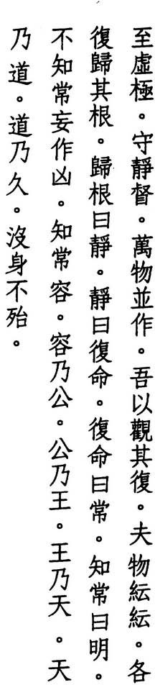way of Earth. There is nothing that is not endowed with these, and everything rises by means of them."
' ING says, 'What is meant here by emptiness is not total emptiness but the absence of fullness. And what is meant by stillness is not complete still­ ness but everything unconsciously returning to its roots."
LU HUI-CH
HUANG YUAN-CHI says, "Heaven has its fulcrum, people have their ancestors, plants have their roots. And where are these roots? Where things begin but have not yet begun, namely. the Dark Gate. If you want to cultivate the Great Way. but you don't know where this opening is, your efforts will be in vain."

32

SU CH 'E says, "We all rise from our nature and return to our nature, just as flowers and leaves rise from their roots and return to their roots, or just as waves rise from water and return to water. If you don't return to your nature, even if you still your actions and thoughts, you won't be still. Heaven and Earth, mountains and rivers might be great, but none of them endures. Only what returns to its nature becomes still and enduring, while what does not return to its nature is at the mercy of others and cannot escape."
CH ENG HSUAN-YING says, "He who embraces all things and is impartial and selfless becomes a great example to others who thus turn to him as their ruler."
'
TE-CH' ING says, "To know what truly endures is to know that Heaven and Earth share the same root, that the ten thousand things share one body. and that there is no difference between self and others. Those who cultivate this within themselves become sages, while those who practice this in the world become rulers. Rulers become rulers by following the Way of Heaven. And Heaven becomes Heaven by following the Tao. And the Tao becomes the Tao by lasting forever."
HO-SHANG KUNG says, "To know the unchanging course of the Way is to be free of passion and desire and to be all-embracing. To be ali-embracing is to be free of self-interest. To be free of self-interest is to rule the world. To rule the world is to merge your virtue with that of Heaven. And to merge your virtue with that of Heaven is to be one with the Way. If you can do this, you will last as long as Heaven and Earth and live without trouble."
Ll lUNG says, "The sage enjoys a life without limits."
My reading of line two is based on Cheng Liang-shu's interpretation of Mawangrui Text B, which has tu:center in place of the usual tu:true. The last line also appears in verse
52.

33

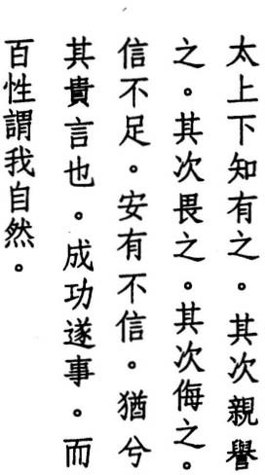1 7 During the High Ages people knew they were there then people loved and praised them
then they feared them finally they despised them when honesty fails dishonesty prevails
hesitate and guard your words when their work succeeds
let people think they did it

The Chinese of Lao-tzu's day believed their greatest age of peace and harmony occurred during the reigns of the Three Sovereigns and Five Emperors, or nearly five thousand years ago. These early rulers exercised power so unobtru­ sively. the people hardly knew they were there, as we hear in a song handed down from that distant age: "Sunup we rise / sundown we rest / we dig wells to drink / we plough fields to eat / the emperor's might / what is it to us?" (Kushihyuan: 1).
THE LICHI says, "During the High Ages people esteemed virtue. Then they worked for rewards" (1).
LU HSI-SHENG says, "The virtuous lords of ancient times initiated no actions and left no traces, hence the people knew they were there and that was all. When their virtue began to fade, they ruled with kindness andjustice, and the people loved and praised them. .When their kindness and justice no longer controlled people's hearts, they governed with laws and punishments, and the people feared them. When their laws and punishments no longer controlled people's minds, they acted with force and deceit, and the people despised them."
MENCIUS says, "When the ruler views his ministers as his hands and feet, they regard him as theirheart and soul. When he views them as dirt and weeds, they regard him as an enemy and thief" (4B.3).
SUNG CH ANG-HSING says, "The mistake of loving and praising, fearing and despising does not rest with the people but with those above. The reason the
'

34


people turn to love and praise, fear and hate is because those above cannot be trusted. And when trust disappears, chaos appears."
HUANG YUAN-CHI says, "What we do to cultivate ourselves is what we do to govern the world. And among the arts we cultivate, the most subtle of all is honesty; which is the beginning and end of cultivation. When we embrace the truth, the world enjoys peace. When we turn our backs on the truth, the world suffers. From the time of the Three Sovereigns and Five Emperors, this has never varied."
HO-SHANG KUNG says, "When those above treat those below with dishonesty; those below respond with deceit."
WANG PI says, "Where there are words, there is a response. Thus the sage hesitates."
WU CH' ENG says, "The reason sages don't speak or act is so that they can bestow their blessings in secret and so that people can live their lives in peace. And when their work succeeds and their lives go well, people think that is just the way it is supposed to be. They don't realize it was made possible by those on high."
LU HUI-CH' ING says, ':As long as the people think they did it themselves, they have no reason to love or praise anyone."
In line one, some editions have pu-chih:did not know in place of hSia-chih:people knew. I have chosen the latter version, as have the Mawangtui and Fuyi texts. The Fuyi text divides line two into two lines: "then they loved them / then they praised them." Despite the attractiveness of such a variation, placing ch'in: love in a separate line interrupts the rhyme. Also, some commentators combine this verse with the following two verses, citing a similarity in theme. However, the wide variation among their rhythms argues against this.

35

1 8 *- � t' *- When the Great Way disappears

t1' 1- tl
ttl
" " "
lt we meet kindness and justice
,9 when reason appears

1if'1{:
1if'1{: '1{:
'1{:" we meet great deceit

� :;f *-1if 1if
when the six relations fail

![ � � 1=-
we meet obedience and love

" " " • when the country is in chaos
fIl 1-'-\ " we meet honest officials

Connecting this with the previous verse, WEI YUAN says, "What people love and praise are kindness andjustice, what people fear is reason, and what people despise is deceit."

' SUNG CH
ANG-HSING says, "It isn't the Great Way that leaves mankind and

goes into hiding, but mankind that leaves the Great Way and replaces it with kindness and justice."
' E says, "When the Great Way flourishes, kindness and justice are at work, but people don't realize it. Only after the Great Way disappears do kind· ness and justice become visible."
SU CH
WANG AN-SHIH says, "The Way hides in formlessness. Names arise from dis­ content. When the Way hides in formlessness, there isn't any difference be­ rween great or small. When names arise from discontent, we get distinctions like kindness, justice, reason, and so forth."
HO-SHANG KUNG says, 'When the kingdom enjoys peace, no one thinks about kindness, and the people are free of desire. When the Great Way prevails, kind­ ness and justice vanish, just as the stars fade when the sun rises."
MENCIUS says, "Kindness means dwelling in peace. Justice means taking the right road" (4A.IO).
TE-CH' ING says, "Reason is what the sage uses to order the kingdom. It in­ cludes the arts, measurements, and laws. In the High Ages, people were inno­ cent, and these were unknown. In the Middle Ages, people began to indulge

36

their feelings, and rulers responded with reason. And once reason appeared, the people responded with deceit."
WANG PI says, "The six relations are father and son, elder and younger brother, husband and wife. When the six relations are harmonious, the country gov­ erns itself, and there is no need for obedience, love, or honesty."
WA NG P ANG says, "During a virruous age, obedience and love are considered normal, hence no one is called obedient or loving. Nowadays, when someone is obedient or loving, we praise them. This is because the six relations are no longer harmonious. Also, when peace prevails, everyone is honest. How can there be honest officials?"
'
' ENG HSUAN-YING says, "When the realm is at peace, loyalty and honesty are nowhere to be seen. Innocence and virrue appear when the realm is in chaos."
CH
LI JUNG says, "During the time of the sage emperors Fu Hsi and Shen Nung, there was no mention of officials. It was only during the time of the despots Chieh and Chou that we begin to hear of ministers like Kuan Lung-feng and Pi Kan."
WU CH'ENG says, "Shao Juo-yu assigns these four divisions to emperors, kings, the wise, and the talented."
Both Mawangrui texts begin this verse with the word ku:thus, implying a con­ nection with the previous verse. I think it does better on its own, hence I have followed the Fuyi and standard editions, which have no such connective. Com­ mentators often quote Chuangtzu here: "When springs dry up, fish find them­ selves in puddles, spraying water on each other to keep each other alive. Better to be in a river or lake and oblivious of each other" (6.5).

37

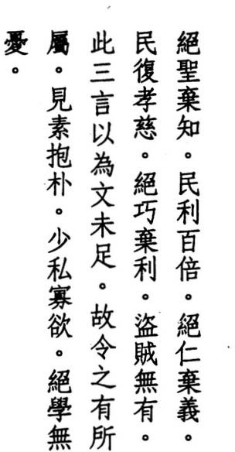19 Get rid of wisdom and reason
and people will live a hundred times better get rid of kindness and justice
and people once more will love and obey get rid of cleverness and profit
and thieves will cease to exist
but these three sayings are not enough hence let this be added
wear the undyed and hold the uncarved
reduce self-interest and limit desires
get rid of learning and problems will vanish

HO-S HANG KUNG says, "Get rid of the works of wisdom and reason and re­ turn to the primeval. The symbols and letters created by the Five Emperors were not as effective in ruling the kingdom as the simple knots used earlier by the Three Sovereigns."
TE-CH' ING says, "This is what Chuang-tzu meant when he said 'Tigers and wolves are kind: Tigers and wolves possess innate love and obedience that don't require instruction. How much more should mankind, the most intelli­ gent of creatures, possess these."
WANG CHEN says, "Put an end to wisdom that leaves tracks and reason that de­ ceives, and people will benefit greatly. Put an end to arrogant kindness and treacherous justice, and relatives will unite on their own and will once more love and obey. Put an end to excessive cleverness and personal profit, and armies will no longer appear. And when armies no longer appear, thieves will not exI. st."
HSUAN-TSUNG says, "These three only help us get rid of things. They don't ex­ plain cultivation. Hence they are incomplete."
WANG PI says, "Wisdom and reason are the pinnacles of ability. Kindness and justice are the pinnacles of behavior. Cleverness and profit are the pinnacles of practice. To tell us simply to get rid of them would be inappropriate. Without

38

giving us something else, it wouldn't make sense. Hence we are given the undyed and the uncarved to focus our attention on."
CHIAO HUNG says, "The ways of the world become daily more artificial. Hence we have names like wisdom and reason, kindness and justice, clever­ ness and profit. Those who understand the Tao see how artificial they are and how inappropriate they are to rule the world. They aren't as good as getting people to focus their attention on the undyed and the uncarved. By wearing the undyed and holding the uncarved, our self-interest and desires wane. The undyed and the uncarved refer to our original nature."
LIU CHING says, "Undyed means unmixed with anything else and thus free of wisdom and reason. Uncarved means complete in itself and thus free of kindness andjustice. Self-interest concerns oneself. Desire concerns others. As they diminish, so do cleverness and profit."

' SU CH
E says, "Confucius relied on kindness and justice, ritual and music to

order the kingdom. Lao-tzu's only concern was to open people's minds, which he accomplished through the use of metaphor. Some people, though, have used his metaphors to create disorder, while no great problems have been caused by the followers of Confucius."

' ENG HS UAN-YING says, "When we give up the study of phenomena and
CH
understand the principle of non-interference, troubles come to an end and distress disappears."
LI HSI-CHAI says, "What passes for learning in the world never ends. For every truth found, rwo are lost. And while what we find brings joy. losses bring sorrow-sorrow that never ends."
I have followed Kao Heng in moving the line that normally begins the next verse to the end of this verse, where it makes better sense as well as better poetry.

•

39

20 *-BJ: ",}-� :f* A�
�Pjt Yes and no

• • •

ft� �
aren't so far apart

"'}-�
�ft � • lovely and ugly

•

:t * *
#I:t aren't so unalike

* It . �
what others fear

if • � ;tl we too must fear
- ft * 1PJ

M � * •
before the moon wanes

",}- A • �
everyone I•S gay

*:t Jz.\.a' *iliJ �fl

as if they were at the Great Sacrifice

fJf. -& 1! • or climbing a tower in spring
Jl:. f.;i!.• :f
#I:t I sit here and make no sign
•

"'}-f.;i!. ft �
like a child that doesn't smile

A� •
� � *
��S *1PJ lost with no one to turn to

•

:f1;1. Aag
�� A,
while others enjoy more
I alone seem forgotten
- ag PJT*

  - Z. my mind is so foolish

�ft ft
•
7L� 1'l: so simple

lI.il *�
•
ft• "'}- H( 1-
� 1-
others look bright
I alone seem dim

  - liT others are certain
"'}- 1'l:
- I alone am confused
� � *
� � fJf "'}-
  - receding like the ocean waxing without cease
� A . M
A� � lf :t everyone has a goal
�

•
•

ft
� :9t* I alone am dumb and backward

.W $§-� A�
for I alone choose to differ
•

preferring still my mother's breast

40

' ENG HSUAN-YING says, Wei:yes indicates agreement and k'o:no disdain.
CH

' SUNG CH
ANG-HSING says, "Even though "yes" and "no" come from the same

source, namely the mouth, "yes" is the root of loveliness, and "no" is the root of ugliness. Before they appear there is nothing lovely or ugly and nothing to fear. But once they appear, if we don't fear them, disaster and harm are un­ avoidable."
LI HSI-CHAI says, "What others love, the sage also loves. What others fear, the sage also fears. But where the sage differs is where others don't see anything outside their own minds. The mind of the sage, meanwhile, wanders in the Tao."
WANG p'ANG says, "Everything changes into its opposite. Beginning follows end without cease. But people think everything is either lovely or ugly. How
absurd. Only the sage knows that the ten thousand ages are the same, that
,
nothing is gained or lost."

su CH E says, "People all drown in what they love: the beauty of the Great Sac­
'
rifice, the happiness of climbing to a scenic viewpoint in spring. Only the sage sees into their illusory nature and remains unmoved. People chase things and forget about the Tao, while the sage clings to the Tao and ignores everything else, just as an infant nurses only at its mother's breast."
TS'AO TAO-CH'UNG says, "People all seek external things, while the sage alone nourishes himself on internal breath. Breath is the mother, and spirit is the child. The harmony of mother and child is the key to nourishing life."
In ancient China, emperors marked the return of swallows to the capital in spring with the Great Sacrifice to the Supreme Intermediary, while people of all ranks climbed towers and hills to view the countryside in bloom and to cele­ brate the first full moon. In line seven, I have followed Mawangtui Text B in reading wangfull moon instead of the usual huang:boundless. I have used the same variant in line twenty-three.

41

21 The expression of empty virtue comes from the Tao alone
the Tao as a thing waxes and wanes
it waxes and wanes but inside is an image it wanes and waxes but inside is a creature it's distant and dark
but inside is an essence
an essence fundamentally real and inside is a heart throughout the ages
its name has never changed
so we might follow our fathers
how do we know what our fathers were like through this

WANG PI says, "Only when we take emptiness as our virtue can our actions accord with the Tao."
SUNG CH' ANG-HSING says, "Sages have it. So does everyone else. But because others are selfish and constrained, their virtue isn't empty"
HUANG YUAN-CHI says, "Emptiness and the Tao are indivisible. Those who seek the Tao cannot find it except through emptiness. But formless emptiness is of no use to those who cultivate the Tao."
YEN LING-FENG says, "Virtue is the manifestation of the Way. The Way is what Virtue contains. Without the Way, Virtue would have no power. Without Vir­ tue, the Way would have no appearance."

' SU CH E
says, "The Tao has no form. Only when it changes into Virtue does it

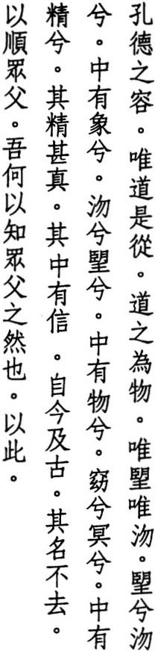have an expression. Hence Virtue is the Tao's visual aspect. The Tao neither

42

exists nor does not exist. Hence we say it waxes and wanes, while it remains in the dark unseen."

' ENG HSUAN-Y1NG says, "The true Tao exists and yet does not exist. It does
CH
not exist and yet does not not exist. Lao-tzu says it waxes and wanes to stress that the Tao is not separate from things and things are not separate from the Tao. Outside of the Tao there are no things. And outside of things there is no Tao."
WU CH ENG says, '''Inside' refers to Virrue. 'Image' refers to the breath of some­ thing before it is born. 'Crearure' refers to the form of something after it is born. 'Distant and dark' refers to the utter invisibility of the Tao."
'
CHANG TAO-LING says, "Essence is like water: the body is its embankment, and Virrue is its source. If the heart is not virruous, or if there is no embankment, water disappears. The immortals of the past treasured their essence and lived, while people today lose their essence and die."
WANG p'ANG says, "Essence is where life and the body come from. Lao-tzu calls it 'fundamentally real' because once things become subject to human fab­ rication, they lose their reality."
LIU CHING says, "Everything changes, and names are no exception. What was true in the past is false today. Only the Tao is constant."
The Mawangrui texts have introduced a number of new variants into this verse. Those which I have incorporated include wangJull moon for huang: indistinct in lines four, five, and seven; shunfollow for yueh:view and fofather forfo:beginning in line fifteen. The standard version of fifteen and sixteen reads: "so we might view all beginnings / and how do we know what all beginnings are like." Also, in line twelve, I have read hsin:lamp wick (and hence the heart of something) in place of the word's usual meaning as "talisman" (and hence
something trustworthy).

43

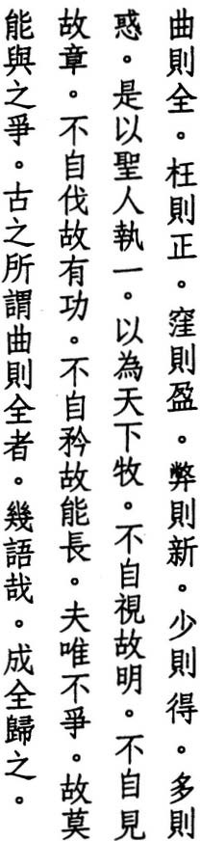22 Partial means whole
crooked means straight hollow means full worn-out means new less means content more means confused
thus the sage holds onto the one to use in guiding the world
not watching himself he appears not displaying himself he flourishes not flattering himself he succeeds not parading himself he leads because he doesn't compete
no one can compete against him
the ancients who said partial means whole came close indeed
becoming whole depends on this

CHUANG-TZU says, "Lao-tzu said everyone else seeks happiness. He alone saw that partial means whole" (33.5).
'ENG says, "By exploring one side to its limits, we eventually find all sides. By grasping one thing, we eventually encompass the whole. The caterpillar bends in order to straighten itself. A hollow in the ground fills with water. The renewal of spring depends on the withering of fall. By having less, it's easy to have more. By having more, it's easy to become confused."
wu CH
WANG PI says, '1\.s with a tree, the more of it there is, the farther it is from its roots. The less of it there is, the closer it is to its roots. More means more dis­ tant from what is real. Less means closer."
WEI YUAN says, "One is the extreme of less. But whoever uses this as the mea­ sure for the world always finds more."

44

LU HUI-CH'ING says. "Only those who find the one can act like this. Thus 'less means content.' The reason most people cannot act like this is because they have not found the one. Thus 'more means confused. . .•
LI HSI-CHAI says. "The reason the sage is able to be chief of all creatures is be­ cause he holds onto the one. Holding onto the one. he never leaves the Tao. Hence he doesn't watch himself but relies instead on the vision of others. He doesn't talk about his own strengths but relies instead on the strengths of oth­ ers. He stands apart and doesn't compete. Hence no one can compete against him,"
HSUAN-TSUNG says. "Not watching himself, he becomes whole. Not displaying himself. he becomes straight. Not flattering himself. he becomes full. Not pa­ rading himself. he becomes new."
TZU-SSU says. "Only those who are perfectly honest can fulfill their nature and help others fulfill their nature. Next are those who are partial" (Chung­ yung: 22-23) .
MENCIUS says. 'We praise those who don't calculate. We reproach those who try to be whole" (4A.2I).
HO-SHANG KUNG says. "Those who are able to practice being partial keep their physical body whole. Those who depend on their mother and father suffer no harm."
For the wording of lines eight through thirteen as well as line sixteen. I have followed the Mawangtui texts. Lines nine through rwelve appear in slightly different form in verse 24. In the last line. my use of ch'eng:become in place of the usual ch'eng:honest is based on Tunhuang texts s.6453 and P.2584. the Suichou and Chinglung editions. and on Chu Ch'ien-chih's observation that ch'eng: honest appears nowhere else in the Taoteching, while ch 'eng:become occurs sev­ enteen times. The interpolation of ''honest'' was apparently influenced by the passage from Tzu-ssu's Chungyung quoted above.

45

Whispered words are natural a gale doesn't last all morning a squall doesn't last all day who else could make these only Heaven and Earth
if Heaven and Earth can't make things last what about Man
thus in whatever we do
let those on the Way be one with the Way let those who succeed be one with success let those who fail be one with failure
be one with success
for the Way succeeds too be one with failure
for the Way fails too

' WU CH
ENG says, '''Whispered' means not heard. 'Whispered words' means no

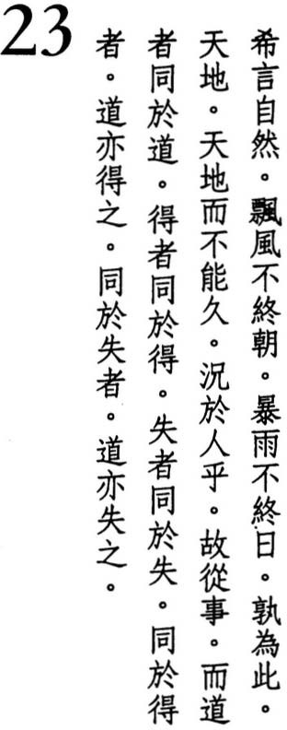words. Those who reach the Tao forget about words and follow whatever is natural,"
WANG CHEN says, "Whispered words require less effort. Hence they conform to the natural Way."
LU NUNG-SHIH says, "Something is natural when nothing can make it so, and nothing can make it not so."

'ENG HSUAN-YING says, "If the greatest forces wrought by Heaven and Earth
CH
cannot last, how can the works of Man?"
SU CH'E says, "The sage's words are faint, and his deeds are plain. But they are always natural. Hence he can last and not be exhausted."
TE-CH'ING says, "This verse explains how the sage forgets about words, embod­ ies the Tao, and changes with the seasons. Elsewhere, Lao-tzu says, 'talking only wastes it I better to keep it inside' (5). Those who love to argue get farther

46


from the Way. They aren't natural. Only those whose words are whispered are natural. Lao-tzu uses wind and rain storms as metaphors for the outbursts of those who love to argue. They can't maintain such a disturbance and dissipation of breath very long. Because they don't really believe in the Tao, their actions don't accord with the Tao. They haven't learned the secret of how to be one."
CHIAO HUNG says, "Those who pursue the Way are natural. Natural means free from success and hence free from failure. Such people don't succeed and don't fail but simply go along with the successes and failures of the age. Orif they do succeed or fail, their minds are not affected."
LU HU!-CH'ING says, "Those who pursue the Way are able to leave their selves behind. No self is the Way. Success. Failure. I don't see how they differ."
HO-SHANG KUNG says, "Those who are one with success enjoy succeeding. Those who are one with failure enjoy failing. Water is wet, and fire burns. This is their nature."
Many commentators have noted that the latter half of the standard version of this verse is marked by an awkward use of rhythm and rhyme, and most have found it confusing. I have used the simpler and smoother Mawangtui ver­ sion. However, in lines ten, twelve, and thirteen, I have chosen the Fuyi text, which has te:succeed in place of the usual te:virtue. Both characters were inter­ changeable when this text was composed, and "virtue" is clearly out of place here. The standard and Fuyi versions add this couplet to the end of the verse: "where honesty fails / dishonesty prevails." These lines also appear in verse However, they are not present in either of the Mawangtui texts, nor do they follow from the rest of this verse, in rhyme or in meaning. Hence I have not included them.
17.

47

- 'i!f * JfJ :f Ji Who tiptoes doesn't stand
:fA 1<Jf • * 'i!f who strides doesn't walk
B • :f

  - IT #- B Ir.
who watches himself doesn't appear

ifu• 'i!f:f 'i!fYL
Bt
- who displays himself doesn't flourish

� -k :f 'i!f
z. :ft- Il}J :f
who flatters himself achieves nothing

  - who parades himself doesn't lead
;(£ B• IT on the road they say
• •

;tj( it � B
too much food and a tiring pace

:f s 'i!f :tfl. some things are simply bad
it • � 'i!f
thus the Taoist shuns them

' TE CH

ING
says, "People raise themselves up on their tiptoes to see over the

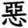heads of others, but they cannot stand like this for long. People take longer strides to stay in front of others, but they cannot walk like this very far. Neither of these are natural."
'ENG says, "To tiptoe is to lift the heels in order to increase one's height. To stride is to extend the feet in order to increase one's pace. A person can do this for a while but not for long. Likewise. those who watch themselves don't appear for long. Those who display themselves don't flourish for long. Those who flatter themselves don't succeed for long. And those who parade them­ selves don't lead for long."
WU CH
'E says, 'l\nyone can stand or walk. But if someone is not content with standing and tiptoes to extend his height or is not content with walking and strides to increase his speed. his stance and his pace are sure to suffer. It's the same with someone who watches himself. or displays himself. or flatters him­ self. or parades himself. It's like eating or drinking. As soon as you're full. stop. Overeating will make you il. It's like manual work. As soon as you're done, stop. Overwork will only exhaust you."
SU CH
SUNG CH ANG-HSING says, "Selfless and free of desire is the mind of the sage. Conniving and clever is the mind of the common man. Watching himself. dis­ playing himself, flattering himself, parading himself, he thus hastens his end. like someone who eats too much."
'

48


Ll HSI-C HAI says, "Those who cultivate the Tao yet still think about themselves are like people who overeat or overwork. Food should satisfY the hunger. Work should suit the task. Those who keep to the Way do only what is narural."
LU HUI-CH'ING says, "Why should Taoists avoid things? Doesn't the Tao dwell in what others avoid? (Taoteching: 8). The Taoist doesn't avoid what others hate, namely humility and weakness. He only avoids what others fight over, namely flattery and ostentation. Hence he avoids some things and not others. But he never fights."
CHANG TAO-LING says, "Who follows the Way lives long. Who loses the Way dies early. This is the unbiased law of Heaven. It doesn't depend on offerings or prayers. "
Line two does not appear in either Mawangrui text. The previous verse also makes do with a single-line introduction. But here the second line is needed to
establish the rhyme. In line two, k'ua:stride can also mean "straddle." TSAO TAO-CH'UNG says, "He who straddles two sides is unsure of the Way." Lines
22,
three through six also appear in slightly different form in verse and some commentators have read as one verse. For the wording and order of lines three through six, I have followed the Mawangrui texts, which reverse the usual order of lines three and four and which have shih:watch in place of the standard shih:approve in line three. A number of commentators think line eight is cor­ rupt and suggest instead: "leftover food and a cyst-covered body." Although sufficiently repulsive, this is not the sort of warning we would expect of sea­ soned travelers of the Way. The last two lines also appear in verse 31.
22-24

49

- :IlI!. S T' 1f Imagine a nebulous thing
7';.5! bZ. -i!J: #J here before Heaven and Earth
- • 5It

ll W- !if.
�
silent and elusive

lJ;
    - it stands alone not wavering

1t
•

11 7';. :j{. 7';.
it travels everywhere unharmed

II' * 41

•
:Il
it could be the mother of us all

5! :Il
�• 1:. not knowing its name

t!.\B *• z.S'
�
- I ll
W-.

•

�..
�J:
I call it the Tao forced to name it
I name it Great

* 5i •
great means ever-flowing

JI. �." �iL
1f� z. \ far-reaching means returning
ever-flowing means far-reaching

•
*119 41
fflj the Tao is great
�3c. Heaven is great
:f

•

*S

fflj • �
Earth is great

I!6

* rrfflj
the king is also great

- liltS :f
� • ;t;
A• lilt • Man imitates Earth
the realm contains four greats
of these the king is one

5! lt13 PIl;).

Earth imitates Heaven

:IlI!. . � Heaven imitates the Tao
- lt 7';.
the Tao imitates itself

WU CH'ENG says, '''Nebulous' means complete and indivisible."
su CH' E says, "The Tao is not pure or muddy. high or low; past or future, good or bad. Its body is a nebulous whole. In Man it becomes his nature.

50

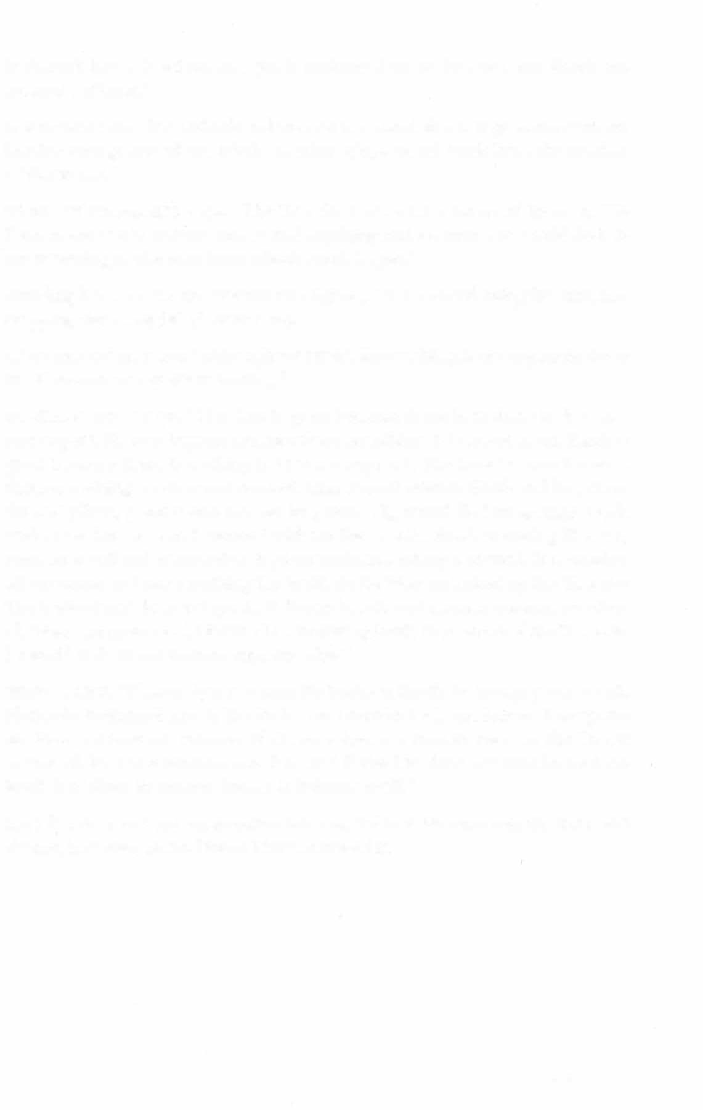
It doesn't know it exists, and yet it endures forever. Heaven and Earth are created within it."
LI HSI-CHAI says, "It stands alone but does not stand alone. It goes everywhere but does not go anywhere. It's the mother of the world, but it is not the mother of the world."
SUNG CH'ANG-HSING says, "The Tao does not have a name of its own. We force names on it. But we cannot find anything real in them. We would do bet­ ter returning to the root from which we all began."
Standing beside a stream, CONFUCIUS sighed, "To be ever-flowing like this, not stopping day or night" (Lunyu: 9.16).
TS'AO TAO-CH'UNG says, 'l\ithough we say it's far-reaching, it never gets far from itself. Hence we say it's returning."
HO-SHANG KUNG says, "The Tao is great because there is nothing it does not encompass. Heaven is great because there is nothing it does not cover. Earth is great because there is nothing it does not support. The king is great because there is nothing he does not control. Man should imitate Earth and be peace­ ful and pliant, plant it and harvest its grains, dig it and find its springs, work without exhaustion and succeed without fuss. As for Earth imitating Heaven, Heaven is still and immutable. It gives without seeking a reward. It nourishes all creatures and takes nothing for itself. As for Heaven imitating the Tao, the Tao is silent and does not speak. It directs breath and essence unseen, and thus all things come to be. As for the Tao imitating itself, the nature of the Tao is to be itself. It does not imitate anything else."
WANG PI says, "If Man does not turn his back on Earth, he brings peace to all. Hence he imitates Earth. If Earth does not turn its back on Heaven, it supports all. Hence it imitates Heaven. If Heaven does not turn its back on the Tao, it covers all. Hence it imitates the Tao. And if the Tao does not turn its back on itself, it realizes its nature. Hence it imitates itself."
Line five does not appear in either Mawangtui text. Its meaning, rhythm, and rhyme, however, all fit. Hence I have retained it.

51

- 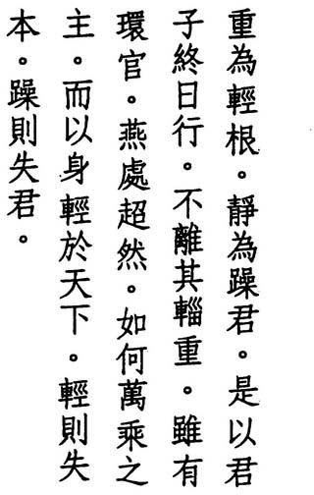Heavy is the root of light still is the master of busy
thus a lord might travel all day
but never far from his supplies even in a guarded camp
his manner is calm and aloof
why would the lord of ten thousand chariots treat himself lighter than his kingdom
too light he loses his base too busy he loses command

HAN FEI says. '''Heavy' means controlling oneself. 'Still' means not leaving one's place. Those who are heavy control those who are light. Those who are still direct those who are busy."
WANG PI says, "Something light cannot support something heavy. Something small cannot hold down something large."
CONFUCIUS says, 'J\. gentleman who has no weight is not held in awe. and his learning is not secure" (Lunyu: 1.8).
CH' ENG HSUAN-YING says, "Roots are heavy. while flowers and leaves are light. The light wither. while the heavy survive. 'Still' means tranquil, and 'busy' means excited. Excitement is subject to birth and death. Tranquility endures. Hence the still rule the busy."
TE-CH' ING says, '''Heavy' refers to the body. 'light' refers to what is external to the body: success and fame, wealth and honor. 'Still' refers to our nature, 'busy' refers to our emotions. People forget their body and chase external things. They forget their nature and follow their emotions. The sage isn't like this. Even though he travels all day. he doesn't leave what sustains him."
KUAN-TZU says, "He who moves loses his place. He who stays still remains content" (quoted by Chiao Hung).
WU CH' ENG says, 'When a lord travels for pleasure, he rides in a passenger cart.

52

When a lord travels to war, he rides in a military cart. Both of these are light carts. And behind these come the heavier supply carts. Even though a lord might travel fifty kilometers a day in a passenger cart or thirty kilometers a day in a military cart, he does not hurry so far ahead that he loses sight of the sup­ ply carts behind him.:'
TS'AO TAO-CH' UNG says, '''Supplies' mean the precious commodities with which we maintain ourselves and without which we cannot exist for a second."
HO-SHANG KUNG says, "A lord who is not heavy is not respected. A plant's leaves and flowers are light, hence they are blown about by the wind. Its roots are heavy, hence it lives long. A lord who is not still loses his power. A dragon is still, hence it is able to constantly transform itself. A tiger is busy; hence it dies young."
HSUAN-TSUNG says, "Traditionally; the Son of Heaven's fief included one mil­ lion neighborhoods with a tax revenue of 640,000 ounces of silver, one million cavalry horses and ten thousand war chariots. Hence he was called 'lord of ten thousand chariots.'"
SU CH' E says, "If the ruler is light, his ministers know he cannot be relied upon. If the ministers are busy; the ruler knows their minds are bent on profit."
A number of commentators have wondered if the standard jung-kuan:glorious scenes in line five might not be a mistake for ying-kuan:militaTY camp. The Mawangtui texts have borne them out, though with huan-kuan:guaTded camp. Line eight, which the Mawangtui texts clarifY by addingyu:than, recalls the last four lines of verse 13. In line nine, I have gone along with the Mawangtui and
Fuyi texts as well as with several early commentaries and editions in reading
pen:base in place of ch'en:minister.

53

- 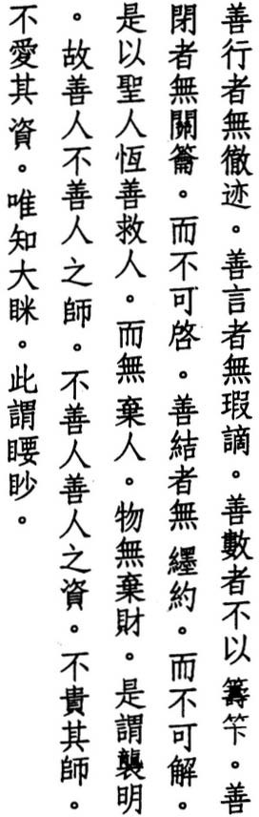Good walking leaves no tracks good talking reveals no flaws
good counting counts no beads good closing locks no locks and yet it can't be opened good tying ties no knots
and yet it can't be undone thus the sage is good at saving and yet abandons no one
nor anything of use
this is called cloaking the light thus the good instruct the bad the bad learn from the good not honoring their teachers not cherishing their students
the wise alone are perfectly blind
this is called peering into the distance

LU TUNG-PIN says, "'Good' refers to our original nature before our parents were born. Before anything develops within us, we possess this goodness. Good means natural."
HO-SHANG KUNG says, "Someone who is good at wallting finds the Way in himself, not somewhere outside. When he talks, he chooses his words. When he counts, he doesn't go beyond one. When he closes, he closes himself to de­ sire and protects his spirit. When he ties, he ties his mind."
TE-CH' ING says, "The sage moves through the world with an empty self and accepts the way things are. Hence he leaves no tracks. He does not insist that his own ideas are right and accepts the words of others. Hence he reveals no flaws. He does not care about life and death, much less profit and loss. Hence

54

he counts no beads. He does not set traps, and yet nothing escapes him. Hence he uses no locks. He is not kind, and yet everyone flocks to him. Hence he ties no knots."
WANG PI says, "These five tell us not to act but to govern things by relying on their nature rather than their form."
WU CH' ENG says, "The sage's salvation does not involve salvation. For if some­ one is saved, someone is abandoned. Hence the sage does not save anyone at all. And because he does not save anyone, he does not abandon anyone. To 'cloak' means to use an outer garment to cover an inner garment. If the work of salvation becomes apparent and people see it, it cannot be called good. Only when it is hidden is it good."
CH' ENG HSUAN-YING says, "The good always cloak their light."
HSUAN-TSUNG says, "The good are like water. Free of impuriry and without effort on their part, they show people their true likeness. Thus they instruct the bad. But unless the student can forget his teacher, his v ision will be obscured."
su CH' E says, "The sage does not care about teaching, hence he does not love his students. And the world does not care about learning, hence people do not honor their teachers. The sage not only forgets the world, he makes the world forget him."
To bring out the special salvation of the sage, as explained above by Wu Ch'eng, I have used the Mawangtui connective erh:and yet in place of ku:thus in line nine. I have also used the Mawangtui version of line ten, which replaces two lines in the standard edition: "and he is good at saving things / thus he abandons nothing." For the last two characters of the last line, I have followed the word order of the Fuyi and standard editions, although I have chosen the Mawangtui miao:peer in place of the standard miao:mystery and have read the standard yao:essential as shorthand for yao:distant.

55

- 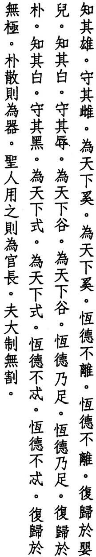Recognize the male
but hold onto the female and be the world's maid being the world's maid
don't lose your ancient virtue
not losing your ancient virtue be a newborn child again recognize the pure
but hold onto the defiled and be the world's valley being the world's valley
be filled with ancient virtue being filled with ancient virtue be uncarved wood again recognize the white
but hold onto the black
and be the world's guide being the world's guide
don't stray from ancient virtue not straying from ancient virtue be without limits again
uncarved wood can be split to make tools
the sage makes it his chief official a master tailor doesn't cut

TE-CH' ING says, "To recognize the Way is hard. Once you recognize it, to hold onto it is even harder. But only by holding onto it can you advance on the Way. "
MENCIUS says, "The great man does not lose his child-heart" (4B.12).

56


WANG TAO says, "The sage recognizes 'that' but holds onto 'this.' 'Male' and 'female' refer to hard and soft. 'Pure' and 'defiled' refer to noble and humble. 'White' and 'black' refer to light and dark. Although hard, noble, and light cer­ tainly have their uses, hard does not come from hard but from soft. Noble does not come from noble but from humble. And light does not come from light but from dark. Hard, noble, and light are the secondary forms and farther from the Tao. Soft, humble, and dark are the primary forms and closer to the Tao. Hence the sage returns to the original: uncarved wood. Uncarved wood can be made into tools, but tools cannot be made into uncarved wood. The sage is like uncarved wood, not a too!' He is the chief official, not a functionary."

' ENG HSUAN-YING says, "What has no limits is the Tao."
CH

CONFUCIUS says, 'J\ great man is not a tool" (Lunyu: 2.12).
CHANG TAO-LING says, "To make tools is to lose sight of the Way."
' ANG-HSING says, "Before uncarved wood is split, it can take any shape. Once it is split, it cannot be round if it is square. It cannot be straight if it is curved. Lao-tzu tells us to avoid being split. Once we are split, we can never return to our original state."
SUNG CH
PAO-TING says, "When I began butchering, I used my eyes. Now I use my spirit instead and follow the natural lines" (Chuangtzu: 3.2).
WANG P'ANG says, "Those who use the Tao to tailor leave no seams."

In lines three and four, I have followed nmhuang copies P.2584 and s.6453 in reading hsi:maid for the standard hsi:stream as more in keeping with the images of the preceding lines. In lines eight through twenty-one, I have followed the
Mawangtui texts, which fail to support the suspicions of some commentators that these lines were interpolated. Reverence for the spirit of wood is shared by many of the ethnic groups along China's borders. During Lao-tzu's day, the southern part of his home state of Ch'u was populated by the Miao, who trace their ancestry to a butterfly and the butterfly to the heart of a maple tree.

57

- A- ft -t! * Trying to govern the world with force
- • �* I this not succeedingsee
� )!j(; i� ll

J!lt PJ *
»., r
the. world is a spiritual thing

* • it can't be forced
)!j(; if w

* 1l{;J -t! »"
• • Z.
to force it is to harm it

• ,
* )!j(; � •
to control it is to lose it
PJ:. if W-
.$ sometimes things lead
- . J& JL sometimes they follow

)!j(; z.'
fA
#1-

sometimes blow hot

*· if
1E.!t sometimes blow cold

)!j(;!!l � .

•
sometimes expand

z. 7t sometimes collapse
k 7t• *r therefore the sage avoids extremes
l;L #} :/I avoids extravagance
¥ )!j(; .ft-
avoids excess

SUNG CH ANG-HSING says, 'We can't control something as insignificant as a mustard seed. How can we control something as big as the world?"
'
TE-CH' ING says, "Those who would govern the world should trust what is natural. The world cannot be controlled consciously. It is too big a thing. The world can only be governed by the spirit, not by human strength or knowledge."
HO-SHANG KUNG says, "Spiritual things respond to stillness. They cannot be controlled with force."
LU HUI-CH' ING says, "The world as a thing is a spiritual thing. Only the spiri­ tual Tao can control a spiritual thing. Spiritual things don't think or act. Trying to control them with force is not the Tao."
WANG CHEN says, '''Force' refers to the mobilization and deployment of troops. But the world's spirit cannot be controlled with weapons."

58


LI HSI-CHAI says, "The sage considers his body transitory and the world its temporary lodging. How can he rule what is not his and lose the true and last­ ing Way?"
su CH' E says, "The interchange of yin and yang, of high and low, of great and small is the way things are and cannot be avoided. Fools are selfish. They insist on having their own way and meet with disaster. The sage knows he cannot oppose things. He agrees with whatever he meets. He eliminates extremes and thereby keeps the world from harm."
wu CH'ENG says, "How does someone who gains control of the world keep the world from harm? The sage understands that things necessarily move between opposites but that there is a way to adjust this movement. Things that prosper too much must wither and die. By keeping things from prospering too much, he keeps them from withering and dying."
WANG PI says, "The sage penetrates the nature and condition of others. Hence he responds to them without force and follows them without effort. He elimi­ nates whatever misleads or confuses them. Hence their minds become clear, and each realizes his own nature."
WANG AN-SHIH says, "Resting where you are eliminates extremes. Treasuring Simplicity eliminates extravagance. Being content with less eliminates excess."
LU NUNG-SHIH says, "The sage gets rid of extremes with kindness. He gets rid of extravagance with simplicity. He gets rid of excess with humility. By means of these three, the sage governs the world."
HSUEH HUI says, "What Lao-tzu means by 'extremes: 'extravagance: and 'ex­ cess' is not what people mean nowadays. The Sage means whatever involves an increase in effort beyond what is easy."
For the wording of lines nine and ten, I have followed Ho-shang Kung. Be­ tween lines ten and eleven, most editions add a fourth pair of opposites: ch'iang-lei:strengthen-weaken. I have followed Mawangtui Text B, which has only three pairs. Given the three negations at the end of this verse, three pairs to be negated seems more appropriate.

59

- 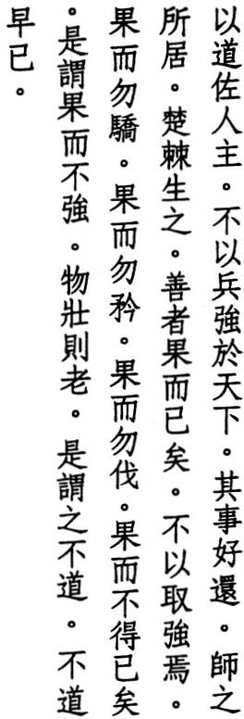Use the Tao to help your king don't use weapons to rule the land
such things soon return where armies camp brambles grow
best to win then stop don't make use of force win but don't be proud win but don't be vain win but don't be cruel
win when you have no choice this is to win without force virility means old age
this isn't the Tao
what isn't the Tao ends early

SUNG CH ANG-HSING says, '1\ kingdom's ruler is like a person's heart: when the ruler acts properly. the kingdom is peaceful. When the heart works prop­ erly. the body is healthy. What enables them to work and act properly is the Tao. Hence use nothing but the Tao to help a ruler."
'
71'.7,
Ll HSI-CHAI, quoting Mencius: says, '''If you kill someone's father, some­ one will kill your father. If you kill someone's brother, someone will kill your brother.' This is how things return."

'ENG HSUAN-YlNG says, "The external use of soldiers and arms returns in
CH
the form of vengeful enemies. The internal use of poisonous thoughts returns in the form of evil rebirths."
WANG AN-SHIH says, "Man's retribution is clear, while Heaven's retribution is obscure. Where an army spends the night, brambles soon appear. In an army's wake, bad years follow. This is the retribution of Heaven."
Paraphrasing Suntzu: 2.1, WANG CHEN says, "To raise an army of a hundred thousand requires the daily expenditure of a thousand ounces of gold. And an

60

army of a hundred thousand means a million refugees on the road. Also, noth­ ing results in greater droughts, plagues, or famines than the scourge of war­ fare. A good general wins only when he has no choice, then stops. He dares not take anything by force."
MENCIUS says, "Those who say they are great tacticians or great warriors are, in fact, great criminals" (71'.2-3).
'ING says, "To win means to defeat one's enemies. To win without being arrogant about one's power, to win without being boastful about one's ability. to win without being cruel about one's achievement, this sort of victory only comes from being forced and not from the exercise of force."
LU HUI-CH

su 'E says, "Those who possess the Tao prosper and yet seem poor, become
CH
full and yet seem empty. What is not virile does not become old and does not die. The virile die. This is the way things are. Using an army to control the world represents the height of strength. But it only hastens old age and death."
HO-SHANG KUNG says, "Once a plant reaches its height of development, it withers. Once a person reaches their peak, they grow old. Force does not pre­ vail for long. It isn't the Tao. What is withered and old cannot follow the Tao. And what cannot follow the Tao soon dies."

' WU CH
ENG
says, "Those who possess the Way are like children. They age


without growing old."
LAO-TZU says, "Tyrants never choose their end" (42).
I have gone along with the Mawangtui texts in omitting lines six and seven of the standard edition: "in an army's wake I bad years follow." I have also fol­ lowed the Mawangtui sequence of lines eight through ten. The last three lines also appear in verse 55.

61

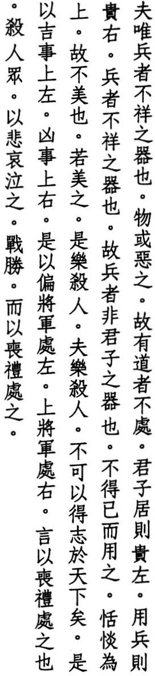3 1 Weapons are not auspicious tools some things are simply bad
thus the Taoist shuns them
in peace the ruler honors the left in war he honors the right weapons are not auspicious weapons are not a ruler's tools
he wields them when he has no choice
dispassion is the best
thus he does not beautilY them he who beautifies them
enjoys killing others
he who enjoys killing others achieves no worldly rule
thus we honor the left for joy we honor the right for sorrow
the left is where the adjutant stands the commander on the right
which means as at a funeral
when you kill another honor him with your tears when the battle is won treat it as a wake

HO-SHANG KUNG says, "In times of decadence and disorder, we use weapons to defend the people."
SU CH'E says, 'We take up weapons to rescue the distressed and not as a matter of course."

62

' SUNG CH
ANG-HSING says, "The system of ritual devised by the ancient kings


treated the right as superior and the left as inferior. Being superior, the right represented the Way of Victory. Being inferior, the left represented the Way of Humiliry But victory entailed death and desrruction. Hence those on the right were in charge of sad occasions, while those on the left were in charge of happy events."
) E N FA - ) U N G says, '''Left' refers to the east and the power of creation, while 'right' refers to the west and the power of destruction."
HS UAN -TS UNG says, "When Tibetans, Huns, or other tribes invade the borders, the ruler has no choice but to respond. But he responds as he would to a gnat. He does not act in anger. The greatest victory involves no fighting. Hence dispassion is the best policy."
LI HSI-CHAI says, "Sun-tzu discussed in detail the use of strengths and weak­ nesses, of direction and indirection in warfare, but he did not understand their basis (5-6). Lao-tzu says dispassion is the best policy, for it secures victory with­ out a display. This might seem odd, but dispassion means to rest, and rest is the root of victory. While passion means to act, and action is the basis of defeat."
KING HSIANG OF LIANG asked MENCIUS, "How can the kingdom be pacified?" Mencius answered, "The kingdom can be pacified by uniting it." King Hsiang asked, "But who can unite it?" Mencius answered, "He who does not delight in killing others can unite it" (IA.6).
LI )UNG says, "The ancients used weapons with compassion. They honored them for their virtue and disdained them as tools. Once the enemy was de­ feated, the general put on plain, undyed clothes, presided over a funeral cer­ emony, and received the mourners."
In line one, I have followed the arguments of Wang Nien-sun and ChengLiang­ shu in reading chia:fine, which precedesping:weapons in the standard edition, as a mistake for the grammatical particle wei, which here carries no meaning. Lines rwo and three also appear in verse 24. For line ten, I have followed the wording of the Fuyi and Mawangtui texts, which the standard version renders: "victory is not beautifu1."

63

- The Tao has never had a name simple and though small
no one can command it if a lord upheld it
the world would be his guest
when Heaven joins with Earth they bestow sweet dew
no one gives the order it comes down to all
the first distinction gives us names after we have names
we should know restraint
who knows restraint knows no trouble to picture the Tao in the world imagine rivers and the sea

WANG p' ANG says, "The Tao has no body. How could it have a name?"
HO-SHANG KUNG says, "The Tao can be yin or yang, it can wax or wane, it can exist or not exist. Hence it has no fixed name."
CHIAO HUNG says, "We call it 'simple' because it has not been cut or polished. We call it 'small' because it is faint and infinitesimal. Those who can see the small and hold onto it are rare indeed."

' SU CH
E says, '''Simple' means the natural state. When it expands, it's every­

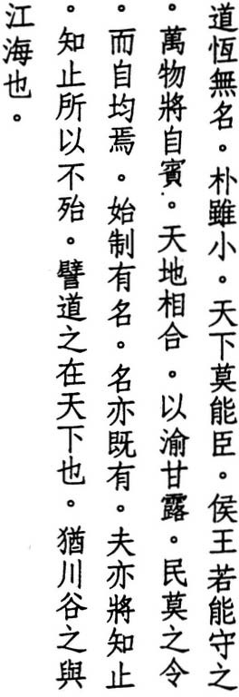where. When it contracts, it isn't as big as the tip of a hair. Hence even though it is small, it is beyond anyone's command."
WANG PI says, "If someone embraces the simple and works without effort and doesn't burden their true nature with material goods or injure their spirit with desires, all things will come to them on their own, and they will discover the Tao by themselves. To discover the Tao, nothing is better than embracing simplicity."

64

JEN FA-JUNG says, "In terms of practice, if someone can be serene and natural, free himself from desire, and put his mind at rest, his yin and yang breaths will come together on their own and penetrate every artery and organ. Inside his mouth, the saliva of sweet dew wil appear spontaneously and nourish his whole body."
LU HUI-CH' ING says, 'When a ruler acts, the first thing he does is institute names."
HSUN-TZU says, "Now that the sages are gone, names and realiry have become confused (22).
TE-CH' ING says, "What is simple has no name. Once we make something, we give it a name. But name gives rise to name. Where does it stop? Hence Lao­ tzu tells us to stop chasing names."
TS' AO TAO-CH'UNG says, "Stop thinking and take care of your body. and you will live out your days free of trouble."
LI JUNG says, '1\ child who depends on its mother suffers no harm. Those who depend on the Tao encounter no trouble."

wu ' ENG says, "The Tao has no name, but as Virtue it does. Thus from noth­
CH
ing we get something. But Virtue is not far from the Tao. If we stop there, we can still go from something back to nothing and return to the Tao. Thus the Tao is like the sea, and Virtue is like a river, flowing back to the Tao."
LI HSI-CHAI says, "Though Heaven and Earth are high and low; they join to­ gether and send down sweet dew. No one makes them do it. And there is no one who does not benefit. Though the Tao separates into things, and each thing has its name, the Tao never abandons anything. Thus the breath of rivers eventually reaches the sea, and the breath of the sea eventually reaches rivers."
LAO-TZU says, "The reason the sea can rule a hundred rivers / is because it has mastered being lower" (66).
Line thirteen also appears in verse 44.

65

- Who knows others is perceptive who knows himself is wise
who conquers others is forceful who conquers himself is strong who knows contentment is wealthy who strives hard succeeds
who doesn't lose his place endures who dies but doesn't perish lives on

' SU CH
E says, "Perception means to distinguish. Wisdom means to remove

obstructions. As long as our distinguishing mind is present, we can only know others, but not ourselves."
LI HSI-CHAI says, "Perception is external knowledge. Wisdom is internal knowl­ edge. Force is external control. Strength is internal control. Perception and force mislead us. Wisdom and strength are true. They are the door to the Tao."
HO-SHANG KUNG says, "If someone can conquer others, it is only by using force. If someone can conquer his own desires, no one in the world can com­ pete with him. Hence we call him strong."
SUNG CH' ANG-HSING says, "The strength of those who conquer themselves is of ten kinds: the strength of faith, the strength of charity. the strength of moral­ ity. the strength of devotion, the strength of meditation, the strength of con­ centration, the strength of illumination, the strength of wisdom, the strength of the Way. and the strength of Virtue."

' WU CH
ENG
says, "Elsewhere, Lao-tzu extols simplemindedness and weakness

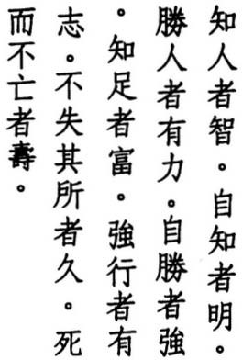over wisdom and strength. Why then does he extol wisdom and strength here? Wisdom and strength are for dealing with the inside. Simplemindedness and weakness are for dealing with the outside."
WANG p' ANG says, "The natural endowment of all things is complete in itself. Poverty does not reduce it. Wealth does not enlarge it. But fools abandon this treasure to chase trash. Those who know contentment pay the world no heed. This is true wealth. Mencius said, 'The ten thousand things are all within us' (7A.4). How could we not be wealthy?"

66

TS ' AO TAO-CH' UNG says, "Though the Great Way might be far off, if we perse­ vere without pause, we advance. We get closer and closer, until suddenly we become one with the Way. Whoever has a goal can do anything. Outside, be content with your lot. Inside, focus on the Way. And you cannot help but live long."
WANG PI says, "Those who strive with devotion reach their goal. Those who examine themselves and work within their capacity don't lose their place and are able to endure. Although we die, the Tao that gave us life doesn't perish. Ourbody disappears, but the Tao remains. If ourbody survived, would the Tao not end?"
TE-CH' ING says, "Our 'place' is like the position of the North Star. It refers to our nature."
CONFUCIUS says, "Those who govern with Virtue are like the North Star, which remains in its place, while the myriad stars revolve around it" (Lunyu: 2.1).
LU NUNG-SHIH says, "Before we distinguish them, life and death share the same form, the ten thousand things dwell in the same house. Our body is like the shell of a cicada or the skin of a snake: a temporary lodging. The shell per­ ishes but not the cicada. The skin decays but not the snake. We all have some­ thing real that survives death."
KUMARAJIVA says, "Not to live in living is to endure. Not to die in dying is to live on,"
Although line six seems at odds with Lao-tzu's dictum of wu-wei:doing nothing, the commentators are agreed that it refers to inner cultivation and not to the pursuit of worldly ambition.

67

- 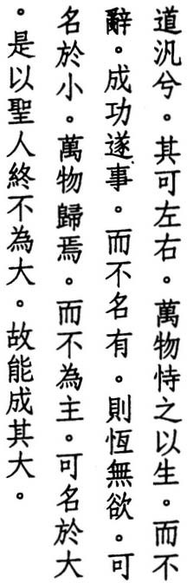The Tao drifts
it can go left or right everything lives by its grace but it doesn't speak
when its work succeeds it makes no claim
it has no desires shall we call it small everything turns to it
but it wields no control shall we call it great
therefore the sage never acts great thus he can do great things

H S UAN-TS U N G says, "To drift means to be unrestrained. The Tao is not yin or yang, weak or strong. Unrestrained, it can respond to all things and in any direction. It is not one-sided. As Chuang-tzu says, 'The Tao has no borders' (2.5)."
CH UANG-TZU also says, "Those who are skilled toil, and those who are clever worry. While those who do not possess such abilities seek nothing and yet eat their fill. They drift through life like unmoored boats" (32.1).
WANG PI says, "The Tao drifts everywhere. It can go left or right. It can go up or down. Wherever we turn to use it, it's there."
LI HSI-CHAI says, "The Great Way is a watery expanse that extends to the eight horizons. But when we use it, it's as close as our left or right hand. There is nothing that doesn't depend on it for life, and yet it never speaks of its power. There is nothing that doesn't happen without it, and yet it never mentions its achievements."
SUNG C H' ANG-HSING says, "Outside of the Tao there are no things. Outside of things there is no Tao. The Tao gives birth to things just as wind creates move­ ment or water creates waves."

68


TS' AO TAO-CH'UNG says, "Though living things might be infinite in number, the Tao creates them all through the mystery of doing nothing. It doesn't mind making so many. And it creates them without thinking about its power."
WANG p' ANG says, "When the Tao becomes small, it doesn't stop being great. When it becomes great, it doesn't stop being small. But all we see are its traces. In reality, it isn't small, and it isn't great. It can't be described. It can only be known."
CH' ENG HSUAN-YING says, "The Tao produces all things, and all things turn to it. It's like the sea. Al streams empty into it, and yet it doesn't control them."
Commenting on lines eight and eleven, ' says, "Even though there are no question indicators, these are questions and not statements, as in verse ro. If we can call something great, it isn't the Tao."
WU CH ENG
su CH'E says, "He who is great and thinks himself great is small."

LU ' ING says, "The Tao hides in what has no name, and the sage em­
HUI-CH
bodies it through what has no name. He doesn't consider himself great, and yet no one is greater. For he can go left or right. Hence he is neither small nor great. And because he is neither small nor great, he can do great things."
The Mawangtui texts omit lines three and fout. Following line six, the standard edition has two additional lines: "it cares for all things / but it wields no con­ trol." But this anticipates line ten, and I have gone along with the Mawangtui texts in omitting them. For the last two lines, I have followed the standard edi­ tion. The Mawangtui texts have the more convoluted and redundant: "there­ fore the sage can do great things / because he does not act great / he thus can do great things."

69

- 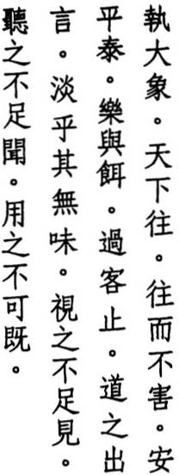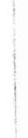Hold up the Great Image and the world will come
and be beyond harm safe serene and at one fine food and song detain passing guests when the Tao speaks it's senseless and plain we look and don't see it
we listen and don't hear it but we use it without end

CH ENG HSUAN-YING says, "Here 'hold' means to hold without holding, to hold what cannot be held."
'
HUANG YUAN-CHI says, "The Great Image is the Great Way which gives birth to Heaven and Earth and all creatures. It is called 'great' because it encom­ passes everything."
Ll JUNG says, "The Great Image has no form. What has no form is the great and empty Way. To 'hold' means to focus or keep. Those who can keep their body in the realm of Dark Virtue and focus their mind on the gate of Hidden Serenity possess the Way. Al things come to them. Clouds appear, and al crea­ tures are refreshed. Rain pours down, and al plants are nourished. And all these blessings come from such a subtle tfung."
wu ' says, "To come to no harm means to be protected. But when people turn to the sage, he uses no protection to protect them. If he protected them with protection, protection and harm would both exist. But by protect­ ing them with no protection, they are always protected and kept from harm."
CH ENG
LU TUNG-PIN says, "Unharmed, our spirit is safe. Unharmed, our breath is serene. Unharmed. our nature is at one."
TE-CH'ING says, "The sage rules the world through selflessness. All things come to him because he is one with all things. And while he forgets himself in

70

others, others forget themselves in him. Thus all things find their place, and there are none that are not at one."
CHANG TAO-LING says, "What the Tao says is the opposite of the mundane or the clever. Most people find it completely senseless. But within its senseless­ ness, there is great sense. This is what the sage savors. The Tao prefers simplic­ ity of form and a minimum of expression. Hence it is hard to see and hard to hear and also hard to follow. But those who can follow. it and use it enjoy limit­ less blessings."
CHUANG-TZU says, '1\ great man's words are plain like water. A small man's words are sweet like wine. The plainness of a great man brings people closer, while the sweetness of a small man drives them apart. Those who come to­ gether for no reason, separate for no reason" (20.5).

' SU CH E
says, "Banquets and entertainment might detain visitors, but sooner

or later the food runs out, the music ends, and visitors leave. If someone enter­ tained the world with the Great Image, no one would know how to love it, much less hate it. Although it has no taste, shape, or sound with which to please people, those who use it can never exhaust it."
HO-SHANG KUNG says, "If someone used the Tao to govern the country, the country would be rich and the people prosperous. If someone used it to culti­ vate himself, there would be no limit to the length of his life."
The Mawangtui texts add ku:thusto the beginning of line seven. I have followed the standard edition in leaving it out. Lines nine and ten are also echoed in verse 14: "we look but don't see it / and call it indistinct / we listen but don't hear it / and call it faint."

)

71

- 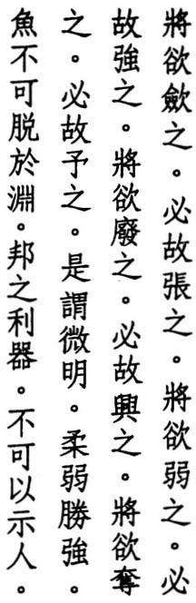What you would shorten
you should therefore lengthen what you would weaken
you should therefore strengthen what you would topple
you should therefore raise what you would take
you should therefore give this is called hiding the light
the weak conquering the strong fish can't survive out of the deep a state's greatest tool
is not meant to be shown

TE-CH'ING says, "Once things reach their limit, they go the other way. Hence lengthening is a portent of shortening. Strengthening is the onset of weaken­ ing. Raising is the beginning of toppling. Giving is the start of taking. This is the natural order for Heaven as well as for Man. Thus to hide the light means the weak conquer the strong. Weakness is the greatest tool of the state. But a ruler must not show it to his people. Deep water is the best place for a fish. But once it is exposed to the air, a fish is completely helpless. And once a ruler shows weakness, he attracts enemies and shame."
LV HUl-CH ING says, "To perceive shortening in lengthening, weakening in strengthening, toppling in raising, taking in giving, how could anyone do this if not through the deepest insight. This is the hidden light. Moreover, what causes things to be shortened or lengthened, weakened or strengthened, toppled or raised, taken or given is invisible and weak. While what is shortened or lengthened, weakened or strengthened, toppled or raised, taken or given is visible and strong. Thus the weak conquer the strong. People should not aban­ don weakness, just as fish should not abandon the depths. When fish abandon the depths, they are caught. When a person abandons weakness, he joins the league ofthe dead."
'

72

WU CH ' ENG says, '''Hiding the light' is the same as 'cloaking the light' in verse 27.
SUNG CH' ANG-HSlNG says, 'i\ccordingto the way of the world, the weakdon't conquer the strong. But Lao-tzu's point is that the weak can conquer the strong by letting the strong dowhat they want until they become exhausted and thus weak. Those who cultivate the Tao speak softly and act with care. They don't argue about right or wrong, better or worse. They understand the harmony of Heaven and Earth, the Way of emptiness and stillness, and become adept at using the hidden light."
CHANG TAO-LING says, "The Tao is like water. People are like fish."
CH UANG-TZU says, "The sage is the world's greatest tool but not one that is known to the world" (10.3).
HAN FEl says, "Rewards and punishments are the state's greatest too!."
Although the diferences are not Significant, the Mawangtui version of lines five and six abandons the rhyme. Hence I have followed the Fuyi and standard texts here. I have switched to the Mawangtui texts, however, for line ten, which the Fuyi and standard editions expand into two lines: "the soft conquer the hard / the weak conquer the strong." The copyist could have been thinking ahead to verse 78, where this couplet does, in fact, occur. Note that the appear­ ance of pang:state in line twelve of the Fuyi edition and Mawangtui Text A sug­ gests that both were copied before Liu Pang became emperor in 206 BC and made the use of his name forbidden. On the other hand, Mawangtui Text B has kuo:country, suggesting that it was copied after 206 BC.

73

- ro ;fl' • Z. :it The Tao never does a thing

iE.
o z.,
0 ,t!-

0 ;Ie 0 • •
*
;r- 0
yet there is nothing it doesn't do
ifa ruler could uphold it
people by themselves would change

tit .t ro w and changing if their desires stirred
0 z., 1t .
;r- ;fl' 0 ;r- he could make them still
1t �

tit�)

0 with simplicity that has no name
- W 0

�0 z.l;J. titfF 1*.I
stilled by nameless simplicity they would not desire

7i:. � 0 *"
.t * ��
and not desiring be at peace


r
* z. * � the world would fix itself

CH UAN G-TZU says, "The ancients ruled the world by doing nothing. This is the Virtue of Heaven. Heaven moves without moving" (12.1).
WU C H' ENG says, "The Tao's lack of effort is ancient and eternal and not simply temporary. Although it doesn't do a thing, it does everything it should do. If rulers could uphold this Tao of effortlessness, without consciously thinking about changing others, others would change by themselves."
LAO-TZU says, "I do nothing I and the people transform themselves" (57).
TE-CH' ING says, "If nobles and kings could only uphold the Tao, all creatures would change by themselves without thinking about changing. This is the effect of upholding the Tao. When creatures first change, their desires disap­ pear. But before long, their trust fades and feelings well up and begin to flow until desires reappear. When this occurs, those who are adept at saving others must block the source of desire with nameless simplicity. "
HO-SHANG KUNG says, '''Nameless simplicity' refers to the Tao, which all crea­ tures use to transform themselves and which nobles and kings use to pacify those who engage in cleverness and deceit."

' ENG HS UAN-YING says, "When people first change and begin to cultivate
CH
the Tao, they think about reaching a goal. Once this desire arises, it must be stilled with the Tao's nameless simplicity."

74

' E says, "The sage has no thought of embracing simplicity; nor does he show any sign of doing so. If the thought of becoming simple existed in his heart, he would miss the mark completely."
SU CH
HSUAN-TS UNG says, "Once the ruler uses nameless simplicity to still the desires of the masses, he must then give it up so that they don't follow its tracks and once again enter the realm of action. Once our illness is cured, we put away the medicine. Once we are across the river, we leave the boat behind. And once we are free of desire, we must also forget the desire to be free of desire. Serene and at peace, the ruler does nothing, while the world takes care of itself."

' SUNG CH
ANG-HSING says, "Other creatures follow their natures without cre­


ating chaos or disaster. They change by themselves without seeking change. People, meanwhile, race through the realm of existence and never know a quiet moment. They abandon their original innocence and don't practice the true Tao of doing nothing. They don't care about their lives, until one day they offend and retribution arrives."
The first two lines appear as one line in verse 48. The Mawangtui texts replace both lines with: "The Tao has never had a name." But this must be an interpo­ lation from verse 32. It appears in no other edition and does not anticipate the lines that follow. Hence I have decided against it. I have also decided against the Mawangtui version where it replaces yu:desire withju:shame in lines eight and
ten and also where it replaces t'ien-hsia:the world with t'ien-ti:heaven and earth
in line twelve. I have followed the Mawangtui version, however, in adding chen­ chih-yi:stilled by to the beginning of line eight.

75

- 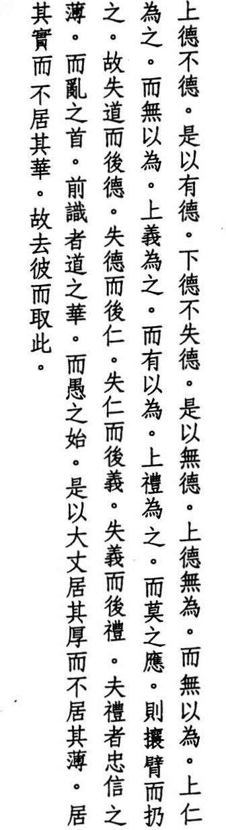Higher Virtue is not virtuous thus it possesses virtue
Lower Virtue is not without virtue thus it possesses no virtue
Higher Virtue lacks effort and the thought of effort
Higher Kindness involves effort but not the thought of effort Higher Justice involves effort and the thought of effort Higher Ritual involves effort but no response
until it threatens and compels
when the Way is lost virtue appears when virtue is lost kindness appears when kindness is lost justice appears when justice is lost ritual appears ritual marks the waning of belief and onset of confusion
augury is the flower of the Way
and beginning ofdelusion
thus the great choose thick over thin the fruit over the flower
therefore they pick this over that

HAN FEI says, "Virtue is the Tao at work."
WANG PI says, "Those who possess Higher Virtue use nothing but the Tao. They possess virtue, but they don't give it a name."

76

YEN TSUN says, "The person who embodies the Way is empty and effortless, yet he leads all creatures to the Way. The person who embodies virtue is faultless and responsive and ready to do anything. The person who embodies kindness shows love for all creatures without restriction. The person who embodies justice deals with things by matching name with reality. The person who embodies ritual is humble and reveres harmony. These five are footprints of the Tao. They are not the ultimate goal. The ultimate goal is not one, much less five."
WANG p' ANG says, "Kindness is another name for virtue. It differs, though, from virtue because it involves effort. The kindness of the sage, however, does not go beyond fulfilling his nature. He isn't interested in effort, hence he doesn't think about it."
'ING says, "Higher Kindness is kindness without effort to be kind. Kindness is simply a gifr. Justice is concerned with the appropriateness of the gift. Ritual is concerned with repayment. When ritual appears, belief disap­ pears and confusion arises."
LU HUI-CH

su CH E says, "These are the means whereby the sage helps the people to safety.
'
When the people don't respond, he threatens and forces them. If they still don't respond, he turns to law and punishment."
FAN YING-YUAN says, "i\ugury' means to see the future. People in charge of rituals think they can see the future and devise formulas for human action but thus cause people to trade the spirit for the letter."

' WU CH
ENG
says, "The Tao is like a frUit. Hanging from a tree, it contains the

power of life, but its womb is hidden. Once it falls, it puts forth virtue as its root, kindness as its stem, justice as its branches, ritual as its leaves, and knowl­ edge as its flowers. All of these come from the Tao. 'That' refers to flowers. 'This' refers to fruit. Those who embody the Tao choose the fruit over the flowers."
The above categories (Higher Virtue, etc.) also appear as chapter titles in Wentzu. After line six, the standard and Fuyi editions add: "Lower Virtue in­ volves effort / but not the thought of effort." But this is the same as 'Higher Kindness: and it does not appear in the Mawangtui texts.

77

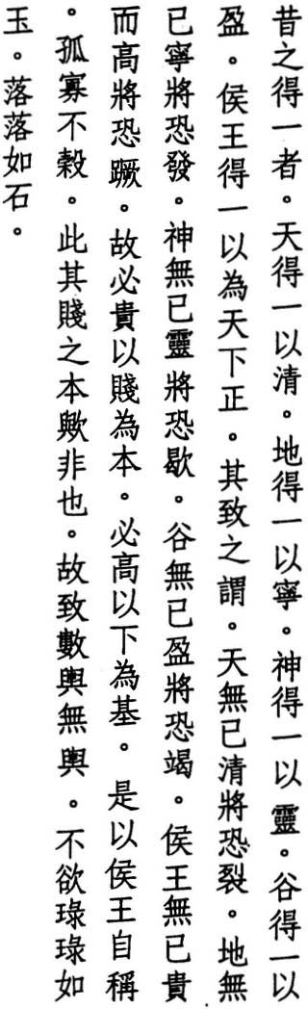•

- Of things that became one in the past Heaven became one and was clear
Earth became one and was still spirits became one arid were active sfreams became one and were full
kings became one and ruled the world
but by implication
Heaven would crack if it were always clear Earth would crumble if it were always still spirits would fail if they were always active streams would dry up if they were always full
kings would fall if they were always high and noble thus the noble is based on the humble
the high is founded on the low thus do kings refer to themselves
as orphaned widowed and destitute but is this the basis of humility counting a carriage as no carriage at all not wanting to clink like jade
they clunk like rocks

WANG PI says, "One is the beginning of numbers and the end of things. All things become complete when they become one. But once they become com­ plete, they leave oneness behind and focus on being complete. And focusing on being complete, they lose their mother. Hence they crack, crumble, col­ lapse, dry up, and fall. As long as they have their mother, they can preserve their form. But their mother has no form."
HO-SHANG KUNG says, "It's because Heaven becomes one that it graces the sky with constellations and light. It's because Earth becomes one that it remains still and immovable. It's because spirits become one that they change shape

78

without becoming visible. It's because streams become one that they never stop filing up. It's because kings become one that they pacify the world. But Heaven must move between yin and yang, between night and day. It can't only be clear and bright. Earth must include high and low; hard and soft, the five­ fold stages of breath. It can't only be still. Spirits must have periods of quies­ cence. They can't only be active. Streams must also be empty and dry. They can't only be full. Kings must humble themselves and never stop seeking wor­ thies to assist them. They can't only lord it over others. If they do, they fall from power and lose their thrones."
CHENG LIANG-SHU says, "In ancient times, kings used carriages as metaphors for the wealth and size of their kingdoms. To refer to their carriages as no car­ riages was an expression of self-deprecation."

'
su CH
E says, "Oneness dwells in the noble, but it is not noble. Oneness dwells

in the humble, but it is not humble. Oneness is not like the lustre of jade: so noble it cannot be humble, or the coarseness of rocks: so humble it cannot be noble."
Between lines five and six, the Fuyi and standard editions add the line: "all crea­ tures became one and were alive." And between lines eleven and twelve they add: "creatures would die if they were always alive." However, neither line ap­ pears in the Yen Tsun or Mawangtui texts, and I have decided against including them. In line seven, I have also chosen the Mawangtui wei:imply over the stan­
dard yi:one. I have used the Mawangtui texts again for lines eight through
twelve, where they have wu-yi:without stop/always in place of the usual wu­ yi:without means to. This usage is also supported by Ho-shang Kung. For line eighteen, I have turned to the Mawangtui texts once more, along with Cheng Liang-shu's interpretation of it. The Fuyi and standard editions have: "count­
ing their fame as no fame at all."

79

- 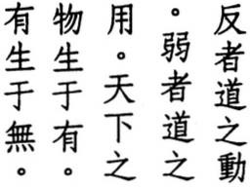The Tao moves the other way the Tao works through weakness
the things of this world come from something something comes from nothing

LIU CH'EN-WENG says, "Once things reach their limit, they have to go back the other way."
WEI YUAN says, "The Tao moves contrary to how most people look at things."
CHAO CHIH-CHIEN says, "To go back the other way means to return to the root. Those who cultivate the Tao ignore the twigs and seek the root. This is the movement of the Tao-to return to where the mind is still and empty and actions soft and weak. The Tao, however, does not actually come or go. It never leaves, hence it cannot return. Only what has form returns. 'Something' refers to breath. Before things have form they have breath. Heaven and Earth and the ten thousand things are born from breath. Hence they all come from some­ thing. 'Nothing' refers to the Tao. Breath comes from the Tao. Hence it comes from nothing. This is the movement of the Tao."
WANG AN-SHIH says, "The reason the Tao works through weakness is because it is empty. We see it in Heaven blowing through the great void. We see it in Earth sinking into the deepest depths."
TE-CH' ING says, "People only know the work of working. They don't know that the work of not working is the greatest work of all. They only know that everything comes from something. They don't know that something comes from nothing. If they knew that something carrie from nothing, they would no longer enslave themselves to things. They would turn, instead, to the Tao and concentrate on their spirit."
HO-SHANG KUNG says, "The ten thousand things all come from Heaven and Earth. Heaven and Earth have position and form. Hence we say things come from something. The light and spirit of Heaven and Earth, the flight of insects, the movement of worms, these all come from the Tao. The Tao has no form. Hence we say things come from nothing. This means the root comes before the flower, weakness comes before strength, humility comes before conceit."
LI JUNG says, "'Something' refers to Heaven and Earth. Through the protec­ tion of Heaven and the support of Earth, all things come into being. 'Nothing'

80

refers to the Tao. The Tao is formless and empty, and yet it gives birth to Heaven and Earth. Thus it is said, 'Emptiness is the root of Heaven and Earth. Nothingness is the source of all things.' Those who lose the Tao don't realize where things come from."
su CH ' E says, ')\s for the things of this world, I have heard of a mother giving birth to a child. But I have never heard of a child giving birth to its mother."
WANG PI says, "Everything in the world comes from being, and being comes from nonbeing. If you would reach perfect being, you have to go back to nonbeing."
HUANG YUAN-CHI says, "Those who cultivate the Way should act with humil­ ity and harmony. The slightest carelessness, any action at all, can destroy every­ thing. Those who cultivate Virtue look to themselves for the truth, not to the words of others. For those who understand that what moves them is also the source of their life, the pill of immortality is not somewhere outside."
In line three, some editions add wan: ten thousand to wu:things. The Mawangtui texts reverse the order of verses 40 and 41. Also, some commentators read 40 as a continuation of 39, while others combine it with 41. Wentzu: I provides a slightly different version of the first rwo lines: "The Tao works through weak­ ness / the Tao keeps moving the other way."

•

81

- 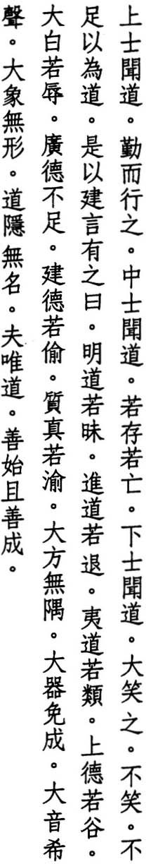When a great person hears of the Way he follows it with devotion
when an average person hears of the Way he doesn't know if it's real or not
when a small person hears of the Way
he laughs out loud if he didn't laugh
it wouldn't be the Way hence these sayings arose
the brightest path seems dark
the qUickest path seems slow the smoothest path seems rough the highest virtue low
the whitest white pitch-black
the greatest virtue wanting the staunchest virtue timid the truest truth uncertain
the perfect square lacks corners the perfect tool does nothing the perfect sound is hushed the perfect form is shapeless
the Tao is hidden and has no name
but because it's the Tao
it knows how to start and how to finish

CONFUCIUS says, "To hear of the Tao in the morning is to die content at night­ fall" (Lunyu: 4.8).
LI HSI-CHAI says, "When a great person hears of the Tao, even if people laugh at him, they can't keep him from practicing it. When an average person hears

82

of the Tao, even if he doesn't disbelieve it, he can't free himself of doubts. When a small person hears of the Tao, even the ancient sages can't keep him from laughing. Everyone in the world thinks existence is real. Who wouldn't shake his head and laugh if he were told that existence wasn't real and nonexistence was?"
TE-CH ING says, "The Tao is not what people expect. Hence the ancients cre­ ated these rwelve sayings, which Lao-tzu quotes to make clear that the Tao has rwo sides_"
'

' SU CH
E says, "These rwelve sayings refer to the Tao as it appears to us. Wher­


ever we look, we see its examples. The Tao as a whole, however, is hidden in namelessness."
LI JU NG says, "The true Tao is not fast or slow, bright or dark. It has no form, no sound, no shape, and no name. But although it has no name, it can take any name."
LU HUI-CH'ING says, "Name and reality are often at odds. The reality of the Tao remains hidden in no name."
LU HSI-SHENG says, "Tools are limited to the realm of form. The Tao is beyond the realm of form."
YEN TSUN says, "The quail runs and flies all day but never far from an over­ grown field. The swan flies a thousand miles but never far from a pond. The phoenix, meanwhile, soars into the empyrean vault and thinks it too confin­ ing. Where dragons dwell, small fish swim past. Where great birds and beasts live, dogs and chickens avoid."
THE CHANKUOTSE says, "Those who know how to start don't always know how to finish" (31).
In line ten, my reading ofju:pitch-black, instead of the usualju:disgrace, is based on the Fuyi edition. In line sixteen, I have followed Kao Heng in reading t'ou: steal as a loan for ju:timid. In the last line, I have gone along with Mawangtui Text B in reading shih:start instead of the usual, and puzzling, tai:bestow.

83

- The Tao gives birth to one one gives birth to two
two gives birth to three
three gives birth to ten thousand things ten thousand things with yin at their backs and yang in their embrace
and breath between for harmony what the world hates
to be orphaned widowed or destitute kings use for their titles
thus some gain by losing
others lose by gaining thus what people teach I teach too
tyrants never choose their deaths this becomes my teacher

HO-SHANG KUNG says, "The Tao gives birth to the beginning. One gives birth to yin and yang. Yin and yang give birth to the breath between, the mixture of clear and turbid. These three breaths divide themselves into Heaven, Earth, and Man and together give birth to the ten thousand things. These elemental breaths are what keep the ten thousand things relaxed and balanced. The or­ gans in our chests, the marrow in our bones, the spaces inside plants allow these breaths passage and make long life possible."
LI HSI-CHAI says, "The yang we embrace is one. The yin we turn away from is two. Where yin and yang meet and merge is three."

' LU HUI-CH
ING says, "Dark and unfathomable is yin. Bright and perceptible is

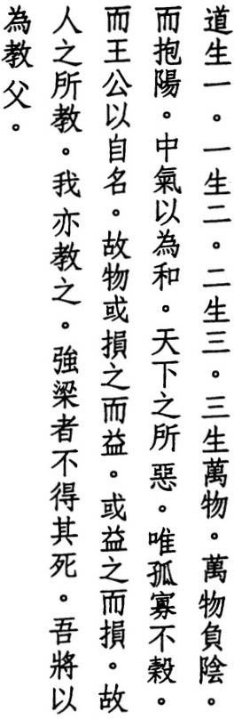yang. As soon as we are born, we all turn our backs on the dark and unfathom­ able yin and turn toward the bright and perceptible yang. Fortunately. we keep ourselves in harmony with the breath between."

84

TE-CH' ING says, "'The orphaned,' 'the widowed,' and 'the destitute' are titles of self-effacement. Rulers who are not self-effacing are not looked up to by the world. Thus by losing, some people gain. Rulers who are only aware of them­ selves might possess the world, but the world rebels against them. Thus by gaining, some people lose. We all share this Tao, but we don't know it except through instruction. What others teach, Lao-tzu also teaches. But Lao-tzu ex­ cels others in teaching us to reduce our desires and to be humble, to practice the virtue of harmony, and to let this be our teacher."
CHIAO HUNG says, "Those who love victory make enemies. The ancients taught this, and so does Lao-tzu. But Lao-tzu goes further and calls this his 'teacher.'"
KAO HENG says, 'i\ccording to the Shuoyuan: 10.25, 'Tyrants never choose their deaths' was an ancient saying, which Confucius attributed to the Chinjenming. This is what Lao-tzu refers to when he says 'what others teach.'"
WANG p' ANG says, "Whatever contains the truth can be our teacher. Tyrants kill others and are the most hated of creatures. But we can learn the principle of creation and destruction from them."
In line seven, I have followed Mawangtui Text A, which has chung:between in place of the usual ch 'ung:empty. The Yunchi Chichien says, "When breath is pure, it becomes Heaven. When turgid, it becomes Earth. And the mixture of the breath between them becomes Man." Lines nine and ten are echoed in verse
39. In line thirteen, I have incorporated ku:thus from Mawangtui Text A. In line fourteen, several Tunhuang copies add yi:justly, while Mawangtui Text A has yi:thoughtfully. Both are apparently mistakes for the nearly identicalwo:I, which appears in the Fuyi and standard editions.

85

- 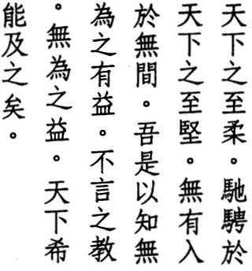The weakest thing in the world
excels the strongest thing in the world
what doesn't exist finds room where there is none thus we know doing nothing succeeds teaching without words
succeeding without effort
few in the world can equal this

LAO-TZU says, "Nothing in the world is weaker than water I but against the hard and the strong I nothing excels it" (78).
WANG TAO says, "Eight feet of water can float a thousand-ton ship. Six feet of leather can control a thousand-mile horse. Thus the weak excels the strong. Sunlight has no substance, yet it can fill a dark room. Thus what doesn't exist enters what has no cracks."
Concerning the first two lines, H UAI-NAN-TZU says, "The light of the sun shines across the Four Seas bur cannot penetrate a closed door or a covered window. While the light of the spirit reaches everywhere and nourishes everything." Concerning the second couplet, he says, "Illumination once asked Nonexist­ ence if it acrually existed or not. Nonexistence made no response. Unable to perceive any sign of its existence, Illumination sighed and said, 'I, too, do not exist, but I cannot equal the nonexistence of Nonexistence'" (12).
LI HSI -CHAI says, "Things are not acrually things. What we call 'strong' is a fiction. Once it reaclres its limit, it rerurns to nothing. Thus the weakest thing in the world is able to overcome the strongest thing in the world. Or do you think the reality of nonexistence cannot break through the fiction of existence?"
WANG PI says, "There is nothing breath cannot enter and nothing water cannot penetrate. What does not exist cannot be exhausted. And what is perfectly weak cannot be broken. From this we can infer that doing nothing brings success."

su CH E says, "If we control the strong with the strong, one will break, or the
'
other will shatter. But if we control the strong with the weak, the weak will not be exhausted, and the strong will not be damaged. Water is like this. If we use

86


existence to enter existence, neither is able to withstand the other. But if we use nonexistence to enter existence, the former will not strain itself, while the lat­ ter will remain unaware. Spirits are like this."
HO-SHANG KUNG says, '''What doesn't exist' refers to the Tao. The Tao has no form or substance. Hence it can come and go, even where there is not any space. It can fil the spirit and help all creatures. We don't see it do anything, and yet the ten thousand things are transformed and completed. Thus we realize the benefit to mankind of doing nothing. Imitating the Tao, we don't speak. We follow it with our bodies. Imitating the Tao, we don't act. We care for ourselves, and our spirit prospers. We care for our country. and the peo­ ple flourish. And we do this without effort or trouble. But few can match the Tao in caring for things by doing nothing. Lao-tzu's final 'in the world' refers to rulers."
YEN TSU N says, ';<\ction is the beginning of chaos. Stillness is the origin of order. Speech is the door of misfortune. Silence is the gate of blessing."
TE-CH' ING says, "Words mean traces. Traces mean knowledge. Knowledge means presumption. Presumption means involvement. And involvement means failure."
One day CONFUCIUS said, "I would rather not speak." Tzu-kung asked, "If you do not speak, what will we have to record?" Confucius replied, "Does Heaven speak? The seasons travel their course, and creatures all flourish. What does Heaven say?" (Lunyu: 17.19).

87

- 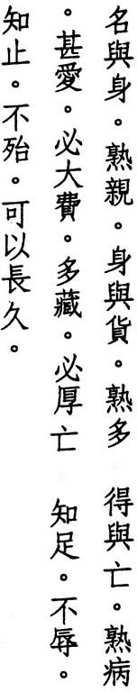Which is more vital fame or health
which is more precious health or riches
which is more harmful
loss or gain
the deeper the love the higher the cost the bigger the treasure
the greater the loss
•
•
who knows contentment suffers no shame
who knows restraint encounters no trouble and thus lives long

HUANG MAO-TS AI says, 'What the world calls fame is something external, and yet people abandon their bodies to fight for it. What the world calls riches are unpredictable, and yet people sacrifice their bodies to possess them. How can they know what is vital or precious? Even if they succeed, it's at the cost of their health."
'
SSU-MA KUANG says, ''Which is more harmful: to gain riches and fame and lose one's health, or to gain one's health and lose riches and fame?"
LU HUI-CH'ING says, "Heroes seek fame and merchants seek riches, even to the point of giving up their lives. The one loves fame because he wants to glorify himself. But the more he loves fame, the more he loses what he would really glorify. Hence the cost is high. The other amasses wealth because he wants to enrich himself. But the more wealth he amasses, the more he harms what he would truly enrich. Hence the loss is great. Meanwhile, the man of virtue knows the most vital thing is within himself. Thus he seeks no fame and suffers no disgrace. He knows the most precious thing is within himself. Thus he seeks no riches and encounters no trouble. Hence he lives long."

88


LI HSI-CHAI says, "If we love something, the more we love it, the more it costs us. If we treasure something, the more we treasure it, the more it exhausts us. A little results in shame. A lot results in ruin. And regret comes too late. A wise person is not like this. He knows that he has everything he needs within him­ self. Hence he does not seek anything outside himself. Thus those who would shame him find nothing to shame. He knows his own limits, and his limits are the Tao. Hence he doesn't act unless according to the Tao. Thus those who would trouble him find nothing to trouble. Hence he survives and, surviving, lives long."
HO-SHANG KUNG says, "Excessive sensual desire exhausts our spirit. Excessive material desire brings us misfortune. The living keep their treasures in store­ rooms. The dead keep their treasures in graves. The living worry about thieves. The dead worry about grave robbers. Those who know contentment find happiness and wealth in themselves and don't exhaust their spirit. If they should govern a country; they don't trouble their people. Thus they are able to live long."
H UAI- NAN-TZU says, "Long ago Chih Po-ch'iao attacked and defeated Fan Chung-hsing. He also attacked the leaders of Han and Wei and took parts of their territories. Still he felt this wasn't enough, so he raised another army and attacked Yueh. But Han and Wei counter-attacked, and Chih's army was defeated near Chinyang, and he was killed east of Kaoliang. His skull became a drinking bowl, his kingdom was divided among the victors, and he was ridiculed by the world. This is what happens when you don't know when to stop" (IS).
Some editions preface lines seven and/or eleven with ku:thus.

89

- 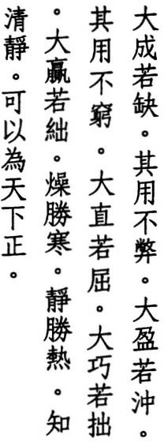The greatest thing seems incomplete yet it never wears out
the fullest thing seems empty yet it never runs dry
the straightest thing seems crooked the cleverest thing seems clumsy the richest thing seems poor activity overcomes cold
stillness overcomes heat who can be perfectly still is able to govern the world

WU CH' ENG says, "To treat the great as great, the full as full, the straight as straight, and the clever as clever is mundane. To treat what seems incomplete as great, what seems empty as full, what seems crooked as straight, what seems clumsy as clever, this is transcendent. This is the meaning of Lao-tzu's entire book: opposites complement each other."
LU NUNG-SHIH says, "The greatest thing cannot be seen in its entirety; hence it seems incomplete. The fullest thing cannot be seen in its totality; hence it seems empty. The straightest thing cannot be seen in its completeness, hence it seems crooked. The cleverest thing cannot be seen in its perfection, hence it seems clumsy."
'E says, "The world considers what is not incomplete as great, hence great includes worn out. It considers what is not empty as full, hence full in­ cludes exhausted. The sage, meanwhile, doesn't mind if the greatest thing is incomplete or the fullest thing is empty. For the greatest thing never wears out, and the fullest thing never runs dry."
su CH
HAN FEI says, "Ordinary people employ their spirit in activity. But activity means extravagance, and extravagance means wastefulness. The sage employs his spirit in stillness. Stillness means moderation, and moderation means frugality."

90

' SUNG CH
ANG-HSING says, "We keep warm in winter by moving around. But


sooner or later we stop moving and become cold again. We keep cool in sum­ mer by sitting still. But sooner or later we stop sitting still and become hot again. This is not the way of long life. This is how the great become incom­ plete, the full become empty. the straight become crooked, and the clever be­ come clumsy. Those who want balance should look for it in perfect stillness. Perfect stillness is the essence of the Tao. Those who achieve such balance are free from hot and cold."
Ll HSI-CHAI says, '1\ctivity overcomes cold but cannot overcome heat. Stillness overcomes heat but cannot overcome cold. Whereas perfect stillness or lack of effort doesn't try to overcome anything, and yet nothing in the world can over­ come it. Thus it is said that perfect stillness can govern the world."
CONFUCIUS says, "Those who govern with virtue are like the North Star, which remains in its place, while the myriad stars revolve around it" (Lunyu: 2.1).
In most editions, line seven reads: "the most eloquent thing seems dumb." I have replaced this with the version introduced by Mawangtui Text B, with which the commentary of Yen Tsun agrees. A number of commentators have had trouble making sense of lines eight and nine and have wondered if they are not corrupt. Some, for example, have suggested: "cold overcomes hot I still­ ness overcomes activity" as more in keeping with Lao-tzu's usage of these terms elsewhere (26, 60, and 72). I have accepted them as they stand. In line ten, I have gone along with the Fuyi text's addition of chih:know how. And in the last line, I have followed Mawangtui Text A in adding k'o:able.

91

- When the Tao prevails
courier horses manure fields instead of roads when the Tao fails
war-horses are raised on the border
no crime is worse than yielding to desire no wrong is greater than discontent
no curse is crueler than getting what you want the contentment ofbeing content
is true contentment indeed

HO-SHANG KUNG says, "'When the Tao prevails' means the ruler possesses the Tao. In ordering the country. he does not use weapons, and he sends courier horses back to do farm work. In ordering himself, he redirects his yang essence to fertilize his body."
YEN TSUN says, "The lives of the people depend on the ruler. And the position of the ruler depends on the people. When a ruler possesses the Tao, the people prosper. When a ruler loses the Tao, the people suffer."
WANG PI says, "When the Tao prevails, contentment reigns. People don't seek external things but cultivate themselves instead. Courier horses are sent home to manure fields. When people don't control their desires, when they don't cultivate themselves but seek external things instead, cavalry horses are bred on the borders."

' WU CH
ENG says, "In ancient times, every district of sixty-four neighborhoods

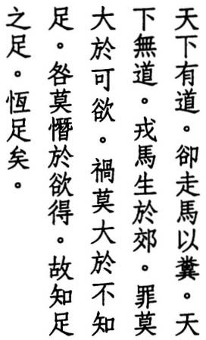was required to provide a horse for the army."
CHIAO HUNG says, 'i\ border' refers to the land between two states. When war-horses are raised on the border, it means soldiers have not been home for a long time."
THE YENTIEHLU N says, "It is said thadong ago, before the wars with the north­ ern Hu and the southern Yueh, taxes were low; and the people were well off. Their clothes were warm, and their larders were stocked. Cattle and horses grazed in herds. Farmers used horses to pull ploughs and carts. Nobody rode

92


them. During this period, even the swiftest horses were used to manure fields.
Later, when armies arose, there were never enough horses for the cavalry, and mares were used as well. Thus, colts were born on the battlefield" (IS).
LI HSI-CHAI says, ''When the ruler possesses the Tao, soldiers become farm­ ers. When the ruler does not possess the Tao, farmers become soldiers. Some­ one who understands the Tao turns form into emptiness. Someone who does not understand the Tao turns emptiness into form. To yield to desire means to want. Not to know contentment means to grasp. To get what you want means to possess. Want gives birth to grasping, and grasping gives birth to possess­ ing, and there is no end to possessing. But once we know that we do not need to grasp anything outside ourselves, we know contentment. And once we know contentment, there is nothing with which we are not content."
LU HSI-SHENG says, "When the mind sees something desirable and wants it, even though it does not accord with reason, there is no worse crime. When want knows no limit, and it brings harm to others, there is no greater wrong. When every desire has to be satisfied, and the mind never stops burning, there is no crueler curse. We all have enough. When we are content with enough, we are content wherever we are."
LU TUNG-PIN says, "To know contentment means the Tao prevails. Not to know contentment means the Tao fails. What we know comes from our mind, which Lao-tzu represents as a horse. When we know contentment, our horse stays home. When we don't know contentment, it guards the border. When the Tao prevails, we put the whip away."
HSUAN-TSUNG says, "Material contentment is not contentment. Spiritual con- tentment 1. S true contentment."

93

- 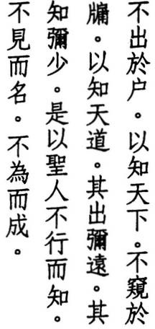Without going out his door he knows the whole world
without looking out his window he knows the Way of Heaven the farther people go
the less people know
therefore the sage knows without moving names without seeing
succeeds without trying

CH UANG-TZU says, "Who takes Heaven as his ancestor, Virtue as his home, the Tao as his door, and who escapes change is a sage" (33.1).
HO-SHANG KUNG says, "The sage understands other persons by understand­ ing himself. He understands other families by understanding his own family. Thus he understands the whole world. Man and Heaven are linked to each other. If the ruler is content, the breath of Heaven will be calm. If the ruler is greedy; Heaven's breath will be unstable. The sage does not have to ascend into the sky or descend into the depths to understand Heaven and Earth."
WANG PI says, "Events have a beginning. Things have a leader. Though roads diverge, they lead back together. Though thoughts multiply; they all share one thing. The Way has one constant. Reason has one principle. Holding onto the ancient Way; we are able to master the present. Though we live today; we can understand the distant past. We can understand without going outside. If we don't understand, going farther only leads us farther astray."
SU C H' E says, "The reason the sages of the past understood everything without going anywhere was simply because they kept their natures whole. People let themselves be misled by things and allow their natures to be split into ears and eyes, body and mind. Their vision becomes limited to sights, and their hearing becomes limited to sounds."
WANG P' ANG says, "If we wait to see before we become aware and wait to be­ come aware before we know, we can see ten thousand different views and still be blind to the reason that binds them all together."

94


LI HSI-CHAI says, "Those who look for Heaven and Earth outside look for forms. But Heaven and Earth cannot be fathomed through form, only through reason. Once we realize that reason is right here, it doesn't matter if we close our door. For the sage, knowledge is not limited to form. Hence he doesn't have to go anywhere. Name is not limited to matter. Hence he doesn't have to look anywhere. Success is not limited to action. Hence he doesn't have to do anything."
LA 0 - TZU says, "The name that becomes a name / is not the Immortal Name" (l).
CH ENG HSUAN-YING says, "'Without moving' means to know without depending on previous or external experience. 'Without seeing' means to know that everything is empty and that there is nothing to see. 'Without trying' means to focus the spirit on the tranquility that excels at making things happen."
'
'ENG says, "'Succeeds without trying' is the result of the previous two lines. Because the sage knows everything without going anywhere and sees everything without looking at anything, he succeeds at everything without any effort at all."
WU CH
Some commentators wonder if line eight is not corrupt, if ming:name is not a mistake for ming:understand, and if the line should not instead read: "he under­ stands without seeing." However, the only early edition that supports such an emendation is that of Han Fei. In a similar sequence, theChungyung has: "flour­ ish without any display / change without any movement / succeed without any effort" (26.6). I have retained line eight as it stands.

95

- 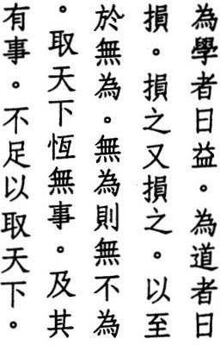Those who seek learning gain every day those who seek the Way lose every day
they lose and they lose
until they find nothing to do
nothing to do means nothing not done who rules the world isn't busy
if someone is busy
he can't rule the world

HO-SHANG KUNG says, '''Learning' refers to knowledge of administration and rhetoric, ritual and music."
CONFUCIUS asked Tzu-kung, "Do you think I learn in order to increase my knowledge?" Tzu-kung answered, "Well, don't you?" Confucius said, "No, I seek one thing that ties everything together" (Lunyu: 15.2).
SUNG CH' ANG-HSING says, "Those who seek the Tao don't use their ears or eyes. They look within, not without. They obey their natures, not their desires.
They don't value knowledge. They consider gaining as losing and losing as
. . .,
gammg.
YEN TSUN says, "Get rid of knowledge. The knowledge of no knowledge is the ancestor of all knowledge and the teacher of Heaven and Earth."
WANG PI says, "Those who seek learning seek to improve their ability or to in­ crease their mastery. while those who seek the Tao seek to return to emptiness and nothingness. When something is done, something is left out. When noth­ ing is done, nothing is not done."
HUAI-NAN-TZU says, "The sage cultivates the inner root and does not make a display of the outer twigs. He protects his spirit and eliminates cleverness. He does nothing, which means he doesn't act until others act. And yet there is nothing that isn't done, which means he relies on the actions of others" (1).
TE-CH' ING says, "He who seeks the Tao begins by using wisdom to eliminate desires. Thus he loses. Once his desires are gone, he eliminates wisdom. Thus he loses again. And he goes on like this until the mind and the world are both forgotten, until selfish desires are completely eliminated, and he reaches the

96

state of doing nothing. And while he does nothing, the people transform them­ selves. Thus by doing nothing, the sage can do great things. Hence those who would rule the world should know the value of not being busy."
K U MARAJ I VA says, "Those who lose eliminate everything coarse until they for­ get about the bad, then they eliminate everything fine until they forget about the good. The bad is what they dislike. The good is what they like. First they eliminate dislikes, then they eliminate likes. Once they forget their likes and dislikes and cut themselves offfrom desire, their virrue becomes one with the Tao, and they reach the state of doing nothing. And while they do nothing, they let others do what they want. Hence there is nothing that isn't done."
SU CH'E says, "Everyone wants to rule the world. But when people see others doing something to possess it, they cringe. And when the people see the sage doing nothing, they rejoice. The sage doesn't seek to rule the world. The world comes to him."

TS' 'UNG says, "When someone uses laws to restrict the world, might
AO TAO-CH
to compel it, knowledge to silence it, and majesty to impress it, there are al­ ways those who don't follow. When someone rules by means of the Tao, the world follows without thinking. 'The world' refers to the ten thousand things."
WEN-TZU says, "In ancient times, those who were good rulers imitated the sea. The sea becomes great by doing nothing. Doing nothing, it governs hundreds of rivers and streams. Thus it rules by not being busy" (8).

97

- 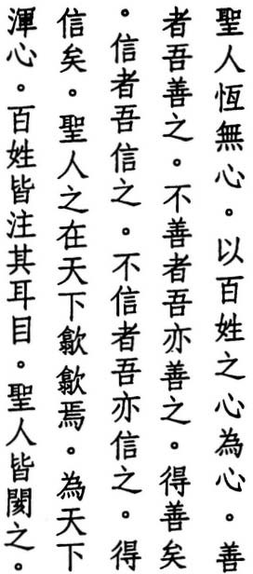The sage has no mind of his own his mind is the mind ofthe people
to the good he is good to the bad he is good until they become good to the true he is true
to the false he is true until they become true
in the world the sage withdraws with others he merges his mind people open their ears and eyes the sage covers them up

SU C H'E says, "Emptiness has no form. It .takes on the form of the ten thousand things. If emptiness had its own form it could not form anything else. Thus the sage has no mind of his own. He takes on the minds of the people and treats everyone the same."
HUI-TSUNG says, "Because it is empty; the sage's mind can receive. Because it is still, it can respond."
YEN TSUN says, '1\ mindless mind is the chief of all minds. The sage, therefore, has no mind of his own but embraces the minds of the people. Free of love and hate, he is not the enemy of evil or the friend of good. He is not the protector of truth or the attacker of falsehood. He supports like the earth and covers like the sky. He illuminates like the sun and transforms like the spirit."
WANG p'ANG says, "Good and bad are the result of delusions, and delusions are the result of self-centered minds. Those who open themselves up to the Great Way. though their eyes see good and bad, their minds distinguish no differ­ ences. They don't treat the bad with goodness out of pity but because they don't perceive any difference. Though the ten thousand things are different, their differences are equally real-and equally false. To see the real in the false and the false in the real is how the sage's wisdom differs from others."

98


CONFUCIUS says, "In his dealings with the world, the great man is neither for nor against anyone. He follows whatever is right" (Lunyu: 4.ro).
WANG PI says, "The mind of the sage has no point of view, and his thoughts have no direction."
JEN FA-JUNG says, "Wherever the sage goes in the world, he acts humble and withdrawn and blends in with others. He treats everyone, noble or common, rich or poor, with the same kindness and equality. His mind merges with theirs. Ordinary people concentrate on what they hear and see and concern themselves with their own welfare. The sage's mind is like that of a new-born baby; pure and impartial."
HSUAN-TSUNG says, "The sage covers up the tracks of his mind by blending in with others."

' ENG HSUAN-YING says, "Stop the eyes and the ears, and the other senses
CH
follow."
In lines five and eight, some editions have te:virtue in place of te:until. Although the two characters were interchangeable, I have sided with the Fuyi and Yen Tsun editions in choosing "until." For lines eleven and twelve, most commen­ tators read: "the people focus their ears and eyes on him / and the sage treats them like babies." But in verses ro, 20, 28, and 55, Lao-tzu likens the sage, not the people, to a child, and I suspect the text is corrupt here. Unfortunately; both Mawangtui texts are indecipherable, while the Fuyi variation ofk'o:cough, the
Tunhuangvariation of hai:su.ffer, and Yen Tsun's hai:startle are clearly loans. But
loans for what? Most commentators argue for hai:infant. I've gone along with
Kao Heng, who suggests ai:obstruct.

99

- 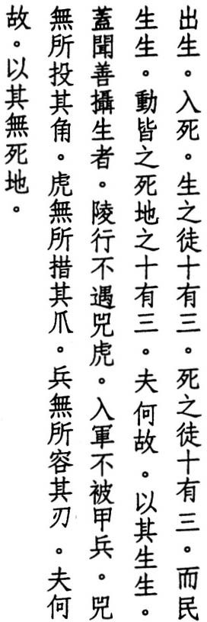Appearing means life
disappearing means death thirteen are the followers of life thirteen are the followers of death but people living to live
join the land of death's thirteen and why
because they live to live
it's said that those who guard life well aren't injured by soldiers in battle
or harmed by rhinos or tigers in the wild
for rhinos have nowhere to sink their horns tigers have nowhere to sink their claws
and soldiers have nowhere to sink their blades and why
because for them there is no land of death

' ENG CHU says, "Of the ten thousand changes we all experience, none are
CH
more important than life and death. People who cultivate the Tao are con­ cerned with nothing except transcending these boundaries."
In lines three, four, and six, the phraseshih-yu-san has long puzzled commenta­ tors. HAN FEI says it means "three and ten" or "thirteen" and refers to the four limbs and nine orifices of the body. which can be guarded to preserve life or indulged to end it.
TU ER-WEI also reads "thirteen" but sees its numerical significance in the moon, which becomes full thirteen days after it first appears and which disap­ pears after another thirteen days.
WANG PI says it means "three in ten" and refers to three attirudes toward life among ten people. WANG AN-SHIH summarizes these as: "Some seek life be­ cause they hate death, some seek death because they hate life, and some live as

100

if they were dead." The remainder belongs to the sage, who neither hates death nor loves life, but who lives long.
The Mawangtui texts, which I have followed, word lines five and six in such a way as to make Wang Pi's interpretation unlikely; if not impossible. As for choosing between Han Fei and Tu Er-wei, I think Tu's interpretation comes closer to what Lao-tzu had in mind.
WANG PI says, "Eels consider the depths too shallow, and eagles consider the mountains too low. Living beyond the reach of arrows and nets, they dwell in the land of no death. But by means of bait, they are lured into the land of no life."
SU CH'E says, "We know how to act but not how to rest. We know how to talk but not how to keep still. We know how to remember but not how to forget. Everything we do leads to the land of death. The sage dwells where there is neither life nor death."
TE-CH'ING says, "Those who guard their life don't cultivate life but what con­ trols life. What has life is form. What controls life is nature. When we cultivate our nature, we return to what is real and forget bodily form. Once we forget form, our self becomes empty. Once our self is empty; nothing can harm us. Once there is no self, there is no life. How could there be death?"
CHIAO HUNG says, "The sage has no life. Not because he slights it, but because he doesn't possess it. If someone has no life, how can he be killed? Those who understand this can transcend change and make of life and death a game."
I have followed the Mawangtui wording of lines five, six, and also eight, to which some editions add the phrase chih-hou:to excess, while others add the last two lines of verse 75 as well. Although soldiers are still plentiful in China, tigers are rare, and rhinos limited to the imagination of a zoologist I met in Sian at the Chinese Academy of Science, who reports seeing them in the nearby Chinling Range.

101

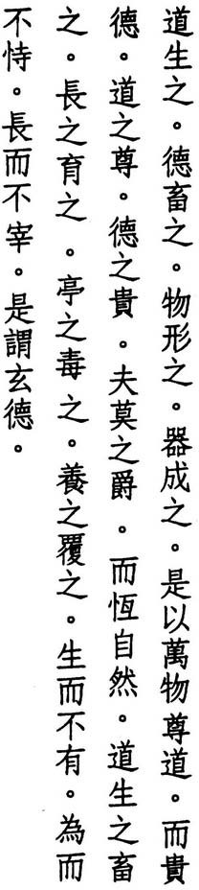5 1 The Way begets them Virtue keeps them
matter shapes them usage completes them
thus do all things honor the Way and glorifY Virtue
the honor of the Way
the glory of Virtue are not conferred but always so
the Way begets and keeps them cultivates and trains them steadies and adjusts them nurtures and protects them
but begets without possessing acts without presuming
and cultivates without controlling this is called Dark Virtue

' ENG says, "What is begotten is sprouted in spring; what is kept is col­ lected in fall; what is shaped is raised in summer from sprouts grown in spring; what is completed is stored in winter from the harvest of fall. Begetting, rais­ ing, harvesting, and storing all depend on the Way and Virtue. Hence the ten thousand things honor the Tao as their father and glorify Virtue as their mother. The Way and Virtue are rwo, but also one. In spring, from one root many are begotten: the Way becomes Virtue. In fall, the many are brought back together: Virtue becomes the Way. The Way and Virtue are mentioned at the beginning of this verse, but only the Way is mentioned later. This is because Virtue is also the Way."
WU CH
LI HSI-CHAI says, "What the Way and Virtue bestow, they bestow without thought. No one orders them. It is simply their nature. It is their nature to

1 02

beget and their nature to keep. It is their nature to cultivate and train, to steady and adjust, to nurture and protect. And because it's their nature, they never tire of begetting or expect a reward for what they give. This is what is meant by 'Dark Virtue.'"
LU HSI-SHENG says, "To beget is to endow with essence. To keep is to instill with breath. To cultivate is to adapt to form. To train is to bring forth ability. To steady is to weigh the end. To adjust is to measure the use. To nurture is to preserve the balance. To protect is to keep from harm. This is the Great Way. It begets but does not try to possess what it begets. It acts but does not presume on what it does. It cultivates bue does not try to control what it culti­ vates. This is Dark Virtue. In verse ro, Man is likened to the Way and Virtue. Here, the Way and Virtue are likened to Man. The expressions are the same, and so is the meaning."
HO-SHANG KUNG says, "The Way does not beget the myriad creatures to pos­ sess them for its own advantage. The actions of the Way do not depend on a reward. And the Way does not cultivate or nurture the myriad creatures to buecher them for profit. The kindness performed by the Way is dark and invis­ ible." Where Ho-shang Kung reads 'buecher," Lu Hsi-sheng reads "control." I have followed Lu.
WANG PI says, "The Way is what things follow. Virtue is what they attain. 'Dark Virtue' means virtue is present bue no one knows who controls it. It comes from what is hidden."
In line four, I have followed the Mawangtui texts in reading ch'i:usage for shih:condition. I have also gone along with the Mawangtui texts in omitting mo­ pu:none does not from line five and in using their version of line twelve, in which ting:steady and tu:atljust appear in place of ch'eng:mature and shu:ripen.

1 03

- 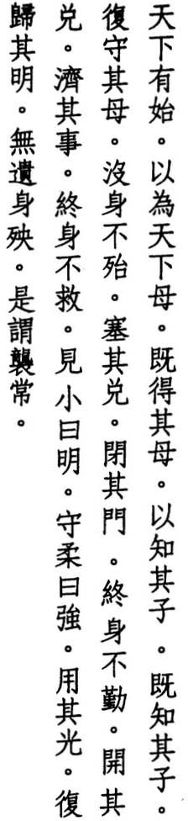The world has a maiden
she becomes the world's mother who knows the mother understands the child
who understands the child keeps the mother safe
and lives without trouble
who blocks the opening who closes the gate lives without toil
who unblocks the opening who meddles in affairs lives without hope
who sees the small has vision
who protects the weak has strength
- who uses his light
who trusts his vision lives beyond death
this is the Hidden Immortal

LAO-TZU says, "The maiden of Heaven and Earth has no name / the mother of all things has a name" (1)_
KUAN-TZU says, "The ancients say. 'No one understands a child better than its father. No one understands a minister better than his ruler'" (7).
LI HSI-CHAI says, "The Way is the mother of all things. Things are the children of the Way. In ancient times, those who possessed the Way were able to keep mother and children from parting and the Way and things together. Since things come from the Way. they are no different from the Way. just as children are no different from their mother. And yet people abandon things when they search for the Way. Is this any different from abandoning the children while

104


searching for the mother? If people knew that things are the Way. and children are the mother, they would find the source in everything they meet."
CONFUCIUS says, "Things have their roots and branches. Those who know what comes first and last approach the Tao (Tahsueh: intro.).
TUNG SSU-CHING says, "People are born when they receive breath. Breath is their mother. And spirit dwells in their breath. When children care for their mother, their breaths become one and their spirits become still."
WU CH ENG says, '''Opening' refers to the mouth. 'Gate' refers to the nose. By controlling our breath to the point where there is no breath, where breath is concentrated within, we are never exhausted."
'
WANG p'ANG says, "When the opening opens, things enter. And the spirit is ex­ hausted trying to deal with the problems that develop. Once we are swept away by this flood, who can save us?"
HSUAN-TSUNG says, "If someone can see an event while it is still small and can change his behavior, we say he has vision."
WANG PI says, "Seeing the great is not vision. Seeing the small is vision. Pro­ tecting the strong is not strength. Protecting the weak is strength."
WANG AN-s HI H says, "Light is the function of vision. Vision is the embodiment of light. If we can use the light to find our way back to the source, we can live our lives free of misfortune and become one with the Immortal Way."
While translating this verse, I have often recalled Confucius' words: "When I was young, historians still left blanks" (Lunyu: 15.25). Not being a historian, I have proceeded despite uncertainty. In the last line, I have based my reading of ch'ang:immortal, in place of the usual constant, on the fact that ch'ang is also the name of the Spirit of the West, namely the new and reborn moon.

1 05

- � �l � 1t Were I sufficiently wise

� 3t • �

•
I would follow the Great Way ^{I}

� *• ili� ;ffr
�
I
••
and only fear going astray

�if 1tftl f%!i1.
the G reat Way is smooth
•

It itl
- 1'T�- but people love byways

� _• fI:it
•
ji;*-
their palaces are spotless

� � lt
their fields are overgrown

*' • • and their granaries are empty

•

)'t
:itEE
�"it they wear fine clothes

M . � they carry sharp swords
;f • .£ they tire of food and drink
� ;t •

�• :itht

*-lt
and possess more than they need
this is called robbery

� • :it

and robbery is not the Way



KU HSI-CH'OU says, "The Tao is not hard to know, but it is hard to follow."
HO-SHANG KUNG says, "Lao-tzu was concerned that rulers of his day did not follow the Great Way Hence he hypothesized that if he knew enough to con­ duct the affairs of a country, he would follow the Great Way and devote himself to implementing the policy of doing nothing."
LU HSI-SHENG says, "The Great Way is like a grand thoroughfare: smooth and easy to travel, perfectly straight and free of detours, and there is nowhere it doesn't lead. But people are in a hurry. They take shortcuts and get into trouble and become lost and don't reach their destination. The sage only worries about leading people down such a path."
LI HSI-CHAI says, "A spotless palace refers to the height of superficiality. An overgrown field refers to an uncultivated mind. An empty granary refers to a lackof virtue."
HAN FEI says, "When the court is in good repair, lawsuits abound. When law­ suits abound, fields become overgrown. When fields become overgrown,

106

granaries become empty. When granaries become empty. the country be­ comes poor. When the country becomes poor, customs become decadent, and there is no trick the people don't try."

' SUNG CH
ANG-HSING
says, "When the court ignores the affairs of state to beau­

tifY its halls and interrupts farmwork to build towers and pavilions, the people's energy ends up at court, and fields turn to weeds. Once fields turn to weeds, state taxes are not paid and granaries become empty. And once grana­ ries are empty. the country becomes poor, and the people become rebellious. When the court dazzles the people with fine clothes, and threatens the people with sharp swords, and takes from the people more than it needs, this is no different than robbing them."
LI JUNG says, "A robber is someone who never has enough and who takes more than he needs."
WANG PI says, "To gain possession of something by means other than the Way is wrong. And wrong means robbery."
WANG NIEN-SUN sees a problem with the standard version of line three, which reads: "and only fear acting." Wang suggests shih:act should read yi:go astray. The Mawangtui texts have t'a:he, which is clearly a mistake but which makesyi just as likely as shih. All three characters are nearly identical. Further support for Wang's suggested emendation comes from the connection it provides be­ tween line three and lines four and five, all of which share a common rhyme.
In the last two lines, tao:rob is followed by k'ua:grand in the Fuyi edition and blank text in the Mawangtui editions. I have read k'ua as a mistake for a nearly identical character: hsi, which functions like a comma and which provides a sharper delineation of the Chinese pun in which robbery and Way are homophones.

107

- What is planted right is not uprooted what is held right is not ripped away
future generations worship it forever cultivated in the self virtue becomes real cultivated in the family virtue multiplies cultivated in the village virtue increases cultivated in the state virtue prospers cultivated in the world virtue abounds thus view the self through the self
view the family through the family view the village through the village view the state through the state view the world through the world
how do we know what the world is like through this

WU CH' ENG says, "Those who plant it right, plant without planting. Thus it is never uprooted. Those who hold it right, hold without holding. Thus it is never ripped away."
WANG AN-SHIH says, 'What we plant right is virtue. What we hold right is oneness. When virtue flourishes, distant generations give praise."
TS AO TAO-C H U NG says, "First improve yourself, then reach outto others, and to later generations bequeath the noble, pure, and kindly Tao. Thus blessings reach your descendants, virtue grows, beauty lasts, and worship never ends."
' '

' SUNG CH
ANG-HSING
says, "In ancient times, ancestral worship consisted in

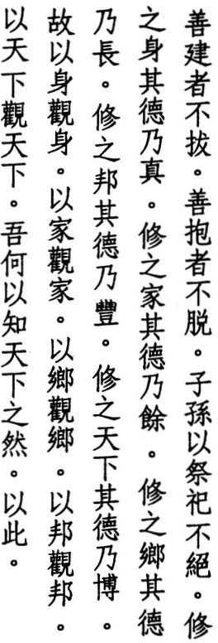choosing an auspicious day before the full moon, in fasting, in selecting sacrifi· cial animals, in purifying the ritual vessels, in preparing a feast on the appointed day. in venerating ancestors as if they were present, and in thanking them for their virtuous example. Those who cultivate the Way likewise enable later gen· erations to enjoy the fruits of their cultivation."

1 08



- 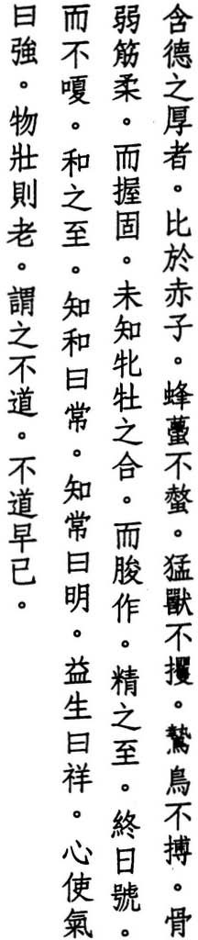He who contains virtue in abundance resembles a newborn child
wasps don't sting him beasts don't claw him
birds of prey don't carry him off
his bones are weak his tendons are soft and yet his grip is firm
he hasn't known the union of sexes
and yet his penis is stiff so full of essence is he he cries all day
yet never gets hoarse so full of breath is he
who knows how to breathe endures who knows how to endure is wise who lengthens his life tempts luck who breathes with his will is strong but virility means old age
this isn't the Way
what isn't the Way ends early

WANG p'ANG says, "The nature of virtue is lasting abundance. But its abun­ dance fades with the onset of thoughts and desires."

su ' E says, "Once we have a mind, we have a body. And once we have a body,
CH
we have enemies. If we did not have a mind, we would not have enemies and could not be harmed. The reason a newborn child is not harmed is because il has no mind."
HO-SHANG KUNG says, ''A newborn child doesn't harm anyone, and no Oil<'
harms it. In an age of perfect peace, mankind knows neither noble nor basI' Even wild beasts do people no harm."

110


TE-CH' ING says, "Those who cultivate the Tao should first focus their minds. When the mind doesn't stray, it becomes calm. When the mind becomes calm, breath becomes balanced. When breath becomes balanced, essence becomes stable, spirit becomes serene, and our true nature is restored. Once we know how to breathe, we know how to endure. And once we know how to endure, we know our true nature. If we don't know our true nature but only know how to nourish our body and lengthen our lives, we end up harming our body and destroying our lives. A restless mind disturbs the breath. When the breath is disturbed, the essence weakens. And when the essence weakens, the body withers."
HSUN-TZU says, "Everything must breathe to live . When we know how to breathe, we know how to nurture life and how to endure" (17).
' ANG-HSING says, "The basis of life rests on this breath. If someone can nourish the pure and balanced breath within himself for fifteen minutes, he will discover the principle of Heaven and Earth's immortality. If he can do this for half an hour, he will enter the gate of eternity. But if he tries to extend his life or force his breath, he will create the womb of his destruction."
SUNG CH
WANG AN-SHIH says, "Life cannot be extended. But people keep trying and thus incur misfortune."
MOU -TZU says, "Those who attain the Way don't become active and don't be­ come strong. They don't become strong and don't become old. They don't become old and don't become ill. They don't become ill and don't decay. Thus Lao-tzu calls the body a disaster" (32).
The Mawangtui texts compress lines three through five into rwo lines. In lines thirteen and fourteen, I have followedHuainantzu: 2 and Huangti Neiching: 69-70 in reading ho:gentle as short for ho-ch'i:gentle breath. Line fifteen also appears in verse 16, and the last three lines also occur at the end of verse 30.

1 1 1

- 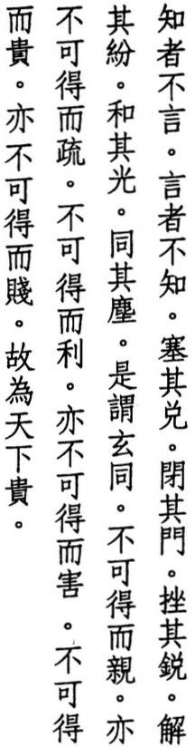Those who know don't talk those who talk don't know
seal the opening close the gate dull the edge untie the tangle soften the light join the dust
this is called the Dark Union it can't be embraced
it can't be abandoned
it can't be helped it can't be harmed it can't be exalted it can't be debased
thus does the world exalt it

HO-SHANG KUNG says, "Those who know value deeds not words. A team or
horses can't overtake the tongue. More talk means more problems."
TS' AO TAO-CH' UNG says, "Those who grasp the truth forget about words. Those who don't practice what they talk about are no different from those who don't know."
SU CH'E says, "The Tao isn't talk, but it doesn't exclude talk. Those who know don't necessarily talk, and those who talk don't necessarily knOw."
HUANG YUAN-CHI says, "We seal the opening and close the gate to nourish the breath. We dull the edge and untie the tangle to still the spirit. We soften th(' light and join the dust to adapt to the times and flow with the world."
LI HSI-CHAI says, "By sealing the opening. we guard the exit. By closing the gate. we bar the entrance. By dulling the edge, we adjust the inside. By untying the tangle, we straighten the outside. By softening the light, we focus on our-

1 12

selves. By joining the dust, we adapt to others. What is devoid of exit and en­ trance, inside and outside, self and other, we call the Dark Union."
WANG TAO says, "The Dark Union unites all things but leaves no visible trace."
WANG PI says, "If something can be embraced, it can be abandoned. If some­ thing can be helped, it can be harmed. If something can be exalted, it can be debased."
TE-CH' ING says, "The sage transcends the mundane and the superficial, hence he cannot be embraced. His utter honesty enables others to see, hence he can­ not be abandoned. He is content and free of desires, hence he cannot be helped. He dwells beyond life and death, hence he cannot be harmed. He views high position as so much dust, hence he cannot be exalted. Beneath his rags he har­ bors jade, hence he cannot be debased. The sage walks in the world, yet his mind transcends the material realm. Hence he is exalted by the world."
WEI YUAN says, "Those who seal the opening and close the gate don't love or hate, hence they don't embrace or abandon anything. Those who dull the edge and untie the tangle don't seek help, and thus they suffer no harm. Those who soften the light and join the dust don't exalt themselves, and thus they aren't debased by others. Forgetting self and other, they experience Dark Union with the Tao. Those who haven't yet experienced this Dark Union unite with 'this' and separate from 'that.' To unite means to embrace, to help, to exalt. To sepa­ rate means to abandon, to harm, to debase. Those who experience Dark Union unite with nothing. From what, then, could they separate?"
Lines three and four also occur in verse 52, and lines five through eight appear in verse 4 as well. The Mawangtui texts begin line ten with ku:thus.

1 13

- Use direction to govern a country use indirection to fight a war
use inaction to rule the world how do we know this works the greater the prohibitions the poorer the people
the sharper the weapons the darker the realm
the smarter the scheme the stranger the outcome the finer the treasure
the thicker the thieves thus the sage declares I change nothing
and the people transform themselves I stay still
and the people adjust themselves
I do nothing
and the people enrich themselves
I want nothing
and the people simplifY themselves

SUN-TZU says, "In waging war, one attacks with direction, one wins with indi­ rection" (5.5).
WANG AN-SHIH says, "Direction can be used in governing, but nowhere else. Indirection can be used in warfare, but that is all. Only those who do nothing are fit to rule the world."

' SU CH
E says, "The ancient sages were kind to strangers and gentle to friends.

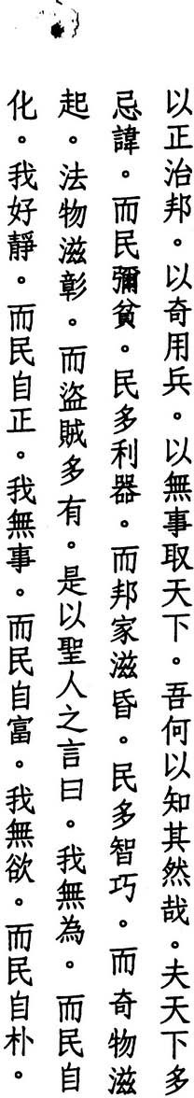They didn't think about warfare. Only when they had no choice did they fight.

1 14

And when they did, they used indirection. But indirection can't be used to rule the world. The world is a mercurial thing. To conquer it is to lose it. Those who embody the Tao do nothing. They don't rule the world, and yet the world comes to them."

' LU HUI-CH
ING says, "How do we know that we can rule the world by means


of inaction? Because we know that we cannot rule the world by means of
.
action."

TE-CH ING says, "Prohibitions, weapons, schemes, treasures, all of these in­ volve action and cannot be used to rule the world."
'
WANG PI says, "Prohibitions are intended to put an end to poverty; and yet the people become poorer. Weapons are intended to strengthen the country; and yet the country becomes weaker and more confused. This is due to cultivating the branches instead of the roots."
WANG P ANG says, "Prohibitions interfere with the people's livelihood. Thus poverty increases. Sharp weapons mean sharp minds. And sharp minds mean darkness and chaos. Once minds become refined, customs become depraved, and the unusual becomes commonplace."
'
HO-SHANG KUNG says, "In cultivating the Tao, the sage accepts the will of Heaven. He doesn't change things, and the people transform themselves. He prefers not to talk or teach, and the people correct themselves. He doesn't force others to work, and the people become rich at their occupations. He doesn't use ornaments or luxuries, and the people emulate his simple ways."
CONFUCIUS says, "The virrue of the ruler is like wind. The virrue of the people is like grass. When the wind blows, the grass bends" (Lunyu: I2.I9).
At the end of line four, the Fuyi, Suman, and standard editions answer with: yi­ tz'u:because of this. I have followed the Mawangrui texts, which omit this phrase. In most editions, line eleven hasfa-ling:laws and orders. I have gone along with Mawangrui Text B and Ho-shang Kung, both of which havefa-wu:fine things.

1 15

- 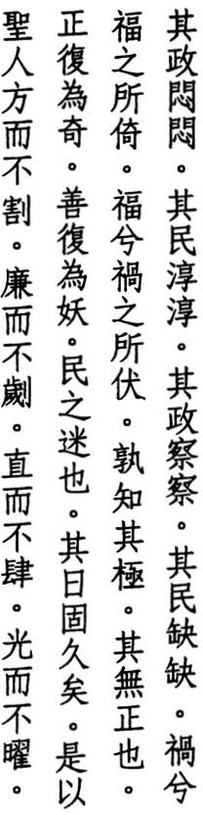Where government stands aloof the people open up
where government steps in the people slip away happiness rests in misery misery hides in happiness who knows where they end there is no direction
direction turns into indirection good turns into evil
the people have been lost for a long long time
thus the sage is an edge that doesn't cut a point that doesn't pierce
a line that doesn't extend a light that doesn't blind

HS UAN-TSUNG says, "To stand aloof is to be relaxed and unconcerned. To open up is to be simple and honest. The ruler who governs without effort lets things take care of themselves."
WANG PI says, "Those who are good at governing use neither laws nor mea­ sures. Thus the people find nothing to attack."
LI HSI-CHAI says, "When the government makes no demands, the people reo spond with openness instead of cleverness. When the government makes de· mands, the people use every means to escape. The government that stands aloof leaves power with the people. The government that steps in takes their power away. As one gains, the other loses. As one meets with happiness, the other encounters misery."
WANG P' ANG says, "Everything shares the same breath. But the movement of this breath comes and goes. It ends only to begin again. Hence happiness and misery alternate like the seasons. But only the sage realizes this. Hence in ev-

1 16


erything he does, he aims for the middle and avoids the extremes, unlike the government that insists on direction and goodness and forbids indirection and evil, the government that wants the whole world to be happy and yet remains unaware that happiness alternates with misery."
LU NUNC-SHIH says, "Only those who are free of direction can transcend the appearance of good and evil and eliminate happiness and misery. For they alone know where these end. Meanwhile, those who cannot reach the state where there is no direction, who remain in the realm of good and evil, suffer happiness and misery as if they were on a wheel that carries them farther astray...
TE-CH' INC says, "The world withers, and the Tao fades. People are not the way they once were. They don't know direction from indirection or good from evil. Even the sage cannot instruct them. Hence to transform them, he enters their world of confusion. He joins their dust and softens his light. And he leaves no trace...

WU 'ENC says, "The sage's inaction is inaction that is not inaction. Edges al­
CH
ways cut. But the edge that is not an edge doesn't cut. Points always pierce. But the point that is not a point doesn't pierce. Lines always extend. But the line that is not a line doesn't extend. Lights always blind. But the light that is not a light doesn't blind. All of these are examples of inaction."
Most editions make it possible to read line eight as a question or a statement. I have followed Mawangtui Text B, which words it as a statement. In line thir­ teen, Text B omits sheng-jen:the sage. Line fourteen also appears in the Lichi: "The gentleman compares his virtue to that ofjade: pointed but not piercing" (48). And linefifteen recalls verse 45: "the straightest thing seems crooked." Wu Ch' eng combines this with the previous verse.

1 1 7

- 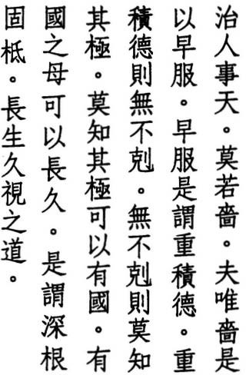In governing people and caring for Heaven nothing surpasses economy
economy means planning ahead
planning ahead means accumulating virtue accumulating virtue means overcoming all overcoming all means knowing no limit knowing no limit means guarding the realm guarding the realm's mother means living long this means deep roots and a solid trunk
the Way of long and lasting life

LI HSI-CHAI says, "Outside, we govern others. Inside, we care for Heaven. III both, nothing surpasses economy. Those who are economical are economical in everything. They're watchful within and on guard without. Only if we arc still, does virtue have a place to collect."
MENCIUS says, "The way we care for Heaven is by guarding our minds and nourishing our natures" (7A.I).
WANG TAO says, "Caring for Heaven means preserving what one receives from Heaven. It means cultivating oneself."

Linking this with the previous verse, su 'E says, "Economy is the reason the
CH
sage's edges don't cut, his points don't pierce, his lines don't extend, and his light doesn't blind. Economy means possessing without using."
WANG PI' says, "Economy means farming. Farmers cultivate their fields by weeding out different species and concentrating on one thing. They don't worry about pulling out the withered and diseased. They pull out the causes of withering and disease. Above, they accept the will of Heaven. Below; they nour­ ish the people."
HAN FEI says, "Most people use their minds recklessly Recklessness means waste, and waste means exhaustion. The sage uses his mind calmly. Calmness means carefulness, and carefulness means economy. Economy is an art born of an understanding of the Tao. Those who know how to govern others calm their thoughts. Those who know how to care for Heaven clear their openings.

' 1 18


When thoughts are calm, old virtue remains within. When openings are clear, new breath enters from without."
HO-SHANG KU NG says, "Someone whose virtue knows no limits can guard the gods of the realm and bring happiness to the people."
THE LICHI says, "He who guards the realm is ever careful" (27).
LI JUNG says, "When the ruler maintains the Tao, the country is at peace. When he fails to maintain the Tao, the country is in chaos. The country is the offspring. The Tao is the mother."
'ENG says, "The realm is a metaphor for the body. Breath is the body's mother. Breath that has no limit can preserve the body. Someone who fils themselves with breath can conquer the world and remain unharmed. Breath rises from below as if from the roots of a tree. By nourishing the roots, the roots grow deep. Breath flourishes above as the trunk of a tree does. By nour­ ishing the trunk, the trunk grows firm. Thus the tree doesn't wither."
wu CH
LU NUNG-SHIH says, "The roots are in the dark, and the trunk is in the light. The roots refer to life, and the trunk refers to nature. What nothing can fathom is deep. Only life can match this. What nothing can topple is firm. Only nature can match this."
In line two, shih:pattern appears in some editions instead of se:economy. Also, in lines three and four,ji<:return appears in some texts in place ofji<:subdue/plan. In both cases, I have followed the Fuyi and Suotan editions as well as Mawang­ tui Text B in choosing the latter. The last line appears as a saying in other an­ cient texts, including Hsuntzu: 4 and Lushih Chunchiu: 1.3, in which commenta­
tors interpret shih:vision as a cliche for "life."

1 19

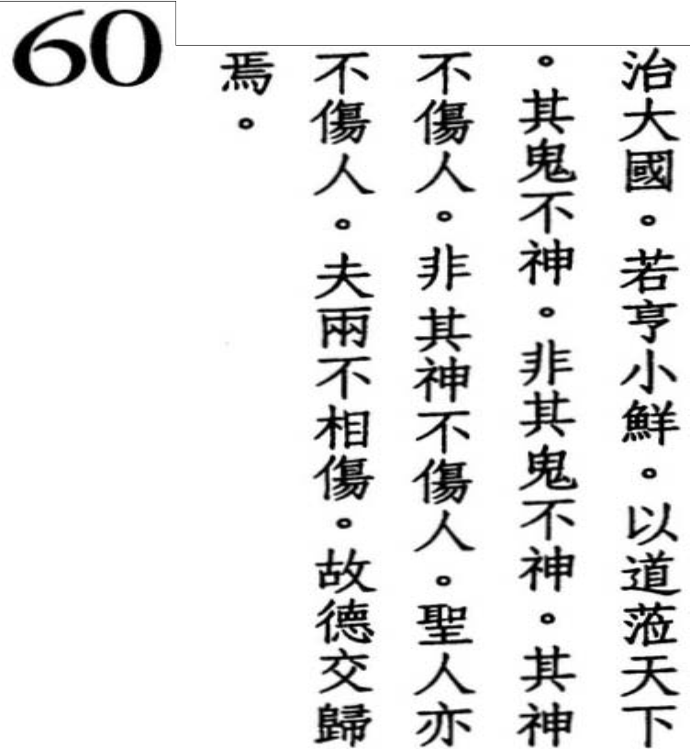Ruling a great state
is like cooking a small fish
when you govern the world with the Tao spirits display no powers
not that they display no powers
their powers do people no harm
not that their powers do people no harm the sage does people no harm
and neither harms the other for both rely on Virtue

,

In a poem bemoaning the absence of virruous leaders, THE SHIHCHING says, "Who can cook fish / I'll wash out the pot" (Kuei.4).
LI HSI-CHAI says, "For the sage, ruling a state is a minor affair, like cooking " small fish."
HO-SHANG KUNG says, "If you cook a small fish, don't remove its entrails, don·r scrape off its scales, and don't stir it. If you do, it will rurn to mush. Likewise, too much government makes those below rebel, and too much cultivation makes vitality wither."
HAN FEI says, "In cooking a small fish, too much rurningruins it. In governing a great state, too much reform embitters the people. Thus a ruler who pos­ sesses the Way values inaction over reform."
TE-CH ING says, '1\ cruel government brings calamity down on the people. The people, though, think their suffering is the work of ghosts and spirits and rurn to sacrifice and worship to improve their lot, when, acrually. their misforrune is caused by their rulers."
'
THE TSOCHUAN says, "If the state is meant to flourish, listen to the people. If the state is meant to perish, listen to the spirits" (Chuang.32).
WANG CHEN says, "The government that takes peace as its basis doesn't lose the Way. When the government doesn't lose the Way. yin and yang are in har­ mony. When yin andyang are in harmony. wind and rain arrive on time. When

120

wind and rain arrive on time, the spirit world is at peace. When the spirit world is at peace, the legion of demons can't perform their sorcery."
WANG PI says, "Spirits don't injure what is natural. What is natural gives spirits no opening. When spirits have no opening, spirits cannot act like spirits."
' ENG HSUAN-YING says, "Spirits dwell in the yin, and people dwell in the
CH
yang. When both accept their lot, neither injures the other."

su 'E says, "The inaction of the sage makes people content with the way
CH
they are. Outside, nothing troubles them. Inside, nothing frightens them. Even spirits have no means of using their powers. It isn't that spirits have no powers. They have powers, but they don't use them to harm people. The reason people and spirits don't harm each other is because they look up to the sage. And the sage never harms anyone."
'ENG says, "The reason spirits don't harm the people is not because they can't but because the sage is able to harmonize the energy of the people so that they don't injure the energy of the spirit world. The reason neither injures the other is due to the sage's virtue. Hence they both rely on the virtue of the sage."
WU CH
HS UAN-TSUNG says, '''Neither' refers to spirits and the sage."
LI JU NG says, "Spirits and sages help others without harming each other. One is hidden, the other manifest. But both rely on virtue."
'ANG-HSING says, "Spirits are spirits because they respond but can't be seen. The sage is a sage because he governs but doesn't act. The virtue of the sage and the virtue of spirits is the same."
SUNG CH
Commentators are divided as to whether the subjects of lines nine and ten are spirits and the people or spirits and the sage. Although both are possible, I pre· fer the latter interpretation.

12 1

- The great state is a watershed the confluence of the world
the female of the world
through stillness the female conquers the male in order to be still
she needs to be lower
the great state that is lower governs the small state
the small state that is lower is governed by the great state
some lower themselves to govern some lower themselves to be governed the great state's only desire
is to unite and lead others the small state's only desire is to join and serve others
for both to achieve their desire the greater needs to be lower

LAO-TZU says, "The reason the sea can govern a hundred rivers / is because it has mastered being lower" (66).
HO-SHANG KUNG says, "To lead a great state we should be like the sea: we should be at the bottom of a watershed and not fight even the smallest current. A great state is the meeting place of the high and the low. The female refers to everything yin: weak, humble, yielding, what doesn't lead."
TS' AO TAO-CH' UNG says, "The female is the mother. Al creatures revere their mother. The sage recognizes the male but upholds the female. Hence all crea­ rures rurn to the sage."

' SU CH
E says, "The world rurns to a great statejust as rivers flow downstream.

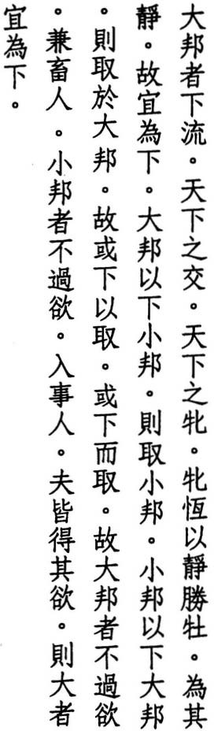If a great state can lower itself, small states will attach themselves to it. If a

122

small state can lower itself, a great state wil take it under its care. A great state lowers itself to govern others. A small state lowers itself to be governed by others."
wu CH'ENG says, "The female doesn't make the first move. It is always the male who makes the first move. But to move means to lose. To wait means to gain. To move means to be above. To wait means to be below. The great state that doesn't presume on its superiority gains the voluntary support of the small state. The small state that is content with its inferiority enjoys the generosity of the great state. The small state doesn't have to worry about being lower, while the great state does. Hence the great state needs to be lower."
WANG AN-SHIH says, "To serve someone greater is easy. To serve someone smaller is hard. Because it is hard, Lao-tzu says 'the greater needs to be lower.'"
MENCIUS says, "Only a virtuous ruler is able to serve a smaller state. Only a wise ruler is able to serve a greater state" (IB.3).
WANG PI says, "By cultivating humility; each gets what it wants. When the small state cultivates humility; it preserves itself, but that is all. It can't make the world turn to it. The world turns to the great state that cultivates humil­ ity. Thus each gets what it wants, but it is the great state that needs to be more humble."
The Fuyi edition adds t'ien-hsifl-chih:o! the world to line one, and the Mawangtui texts invert lines two and three. I have decided against both variants in favor of the standard edition. However, I have followed the Mawangtui texts in their worcling of lines five and six. And I have followed them again, along with the Fuyi text, in their addition of the particle yu:by to line ten. This variant clarifies a relationship between great and small which was previously ambiguous and easily misinterpreted in the standard edition.

123

- 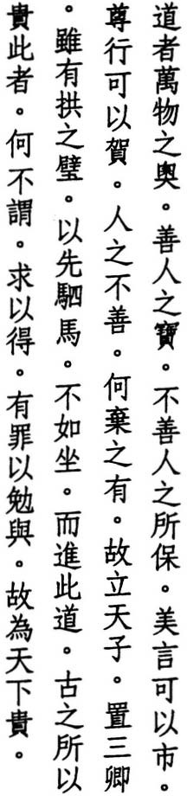The Tao is creation's sanctuary treasured by the good
it keeps the bad alive
beautiful words might be the price noble deeds might be the gift
how can we abandon people who are bad
thus when emperors are enthroned or ministers installed
though there be great discs of jade followed by teams of horses
they don't rival one who sits and offers up this Way
why the ancients exalted it did they not proclaim
who searches thereby finds who errs thereby escapes thus the world exalts it

THE HSISHENGCHING says, "The Tao is the sanctuary of the deepest depth and the source of empty nothingness."
WU CH' ENG says, '''Sanctuary' means the most honored place. The layout of ancestral shrines includes an outer hall and an inner chamber. The southwest corner of the inner chamber is called the 'sanctuary,' and the sanctuary is where the gods dwell."
su CH'E says, ':All we see of things is their outside, their entrance hall. The Tao is their sanctuary. We all have one, but we don't see it. The wise alone are able to find it. Hence Lao-tzu says the good treasure it. The foolish don't find it. But then, who doesn't the Tao protect? Hence he says it protects the bad. The Tao doesn't leave people. People leave the Tao."

124


WANG PI says, "Beautiful words can excel the products of the marketplace. Noble deeds can elicit a response a thousand miles away. "
TE-CH' ING says, "The Tao is in us all. Though good and bad might differ, our natures are the same. How, then, can we abandon anyone?"
lAO-TZU says, "The sage is good at saving / yet he abandons no one / thus the good instruct the bad / the bad learn from the good" (27).
WANG P' ANG says, 'Jade discs and fine horses are used to attract talented men to the government. But a government that finds talented men and does not implement the Tao is not followed by the people."
CHIANG HSI-CH'ANG says, "In ancient times, the less valuable presents came first, hence jade discs preceded horses."
LI HSI-CHAI says, "Better than discs ofjade followed by teams of horses would be one good word or one good deed to keep the people from losing sight of the good."
LU NUNG-SHIH says, "If words and deeds can be offered to others, how much more the Tao."
WA N G AN -S H I H says, "There is nothing that is not the Tao. When good people seek it, they are able to find it. When bad people seek it, they are able to avoid punishment."
In line one, both Mawangtui texts have chu:jlowlchiefinstead of ao:sanctuary. But this destroys the rhyme in the following lines and is not supported by any other edition. In lines four and five, commentators have long suspected an er­ ror, and the Mawangtui texts have given us a partial solution. In line five, I have used their ho-jen:g;ve to people in place of the standard chia-jen:surpass people. However, I have deleted jen:people as a copyist error for the word that begins the next line in Chinese. In my translation, I have inverted the order of the two lines that follow.

125

- 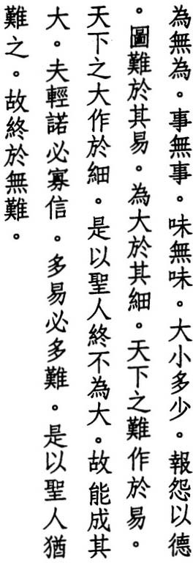Act without acting work without working
taste without tasting
great or small many or few repay each wrong with virtue plan for the hard while it's easy
work on the great while it's small
the hardest task in the world begins easy the greatest goal in the world begins small therefore the sage never acts great
he thus achieves great things
who quickly agrees is seldom trusted who makes it all easy finds it all hard therefore the sage makes everything hard he thus finds nothing hard

HO-SHANG KUNG says, "To act without acting means to do only what is natural. To work without working means to avoid trouble by preparing in advance. To taste without tasting means to taste the meaning of the Tao through meditation."
LI HSI-CHAI says, "When we act without acting, we don't exhaust ourselves. When we work without working, we don't trouble others. When we taste without tasting, we don't waste anything."
WANG TAO says, "What people do involves action. What the sage does accords with the Tao of inaction. 'Work' refers to the conditions of action. 'Taste' refers to the meaning of action."
' ANG-HSING says, "To act without acting, to work without working, to taste without tasting is to conform with what is natural and not to impose oneself on others. Though others treat him wrongly. the wrong is theirs and not the sage's. He responds with the virtue within his heart. Utterly empty and detached, he thus moves others to trust in doing nothing."
SUNG CH

126

CHIAO HUNG says, 'i\ction involves form and thus includes great and small. It is also tied to number and thus includes many and few. This is where wrongs come from. Only the Tao is beyond form and beyond number. Thus the sage treats everything the same: great and small, many and few. Why should he respond to them with anger?"
TS' AO TAO-CH'UNG says, "If we repay wrongs with kindness, we put an end to revenge. If we repay wrongs with wrongs, revenge never ends."
HAN FEI says, "In terms of form, the great necessarily starts from the small. In terms of duration, the many necessarily starts from the few. The wise ruler detects small schemes and thus avoids great plots. He enacts minor punish­ ments and thus avoids major rebellions."
DUKE WEN OF CHIN told KUO YEN, "In the beginning, I found it easy to rule the kingdom. Now I find it hard." Kuo Yen replied, "If you consider something easy. it is bound to become hard. If you consider something hard, it is bound to become easy" (Kuoyu: ChinA).
WANG CHEN says, "If a ruler disdains something as easy. misfortune and trouble are sure to arise from it. If a ruler does not pay attention to small matters, even­ tually they will overwhelm even the greatest virtue. Thus the sage guards against the insignificant lest it amount to something great. If he waits until something is great before he acts, his action will come too late."
TE-CH' ING says, "When I entered the mountains to cultivate the Way. at first it was very hard. But once I learned how to use my mind, it became very easy. What the world considers hard, the sage considers easy. What the world con­ siders easy. the sage considers hard."
In Wentzu: I, line three appears as "know without knowing." But this variant occurs nowhere else. Lines ten and eleven also appear in verse 34.

127

64 Z.,

It's easy to rule while it's peaceful

- � • * � it's easy to plan before it arrives
t;,t • k i. �
'" JlIJ t;,t jf,; � it's easy to break while it's fragile
•

� J& A * :jt:
it's easy to disperse while it's small

* � • *

• •
act before it exists

M§J
Pl.:JL ��� govern before it rebels

k tk z. it
t;,t �
a giant tree grows from the tiniest shoot

mi . • a great tower rises from a basket of dirt
:f ¥ J& � :jt: a thousand-mile journey begins at your feet
� A • jf,; M;
� � - .. � but to act is to fail
- � ± 1it:f
to control is to lose
� • • •
  - tk f" :jt: therefore the sage doesn't act

mi -1}c
:f
.f.z. ��

he thus doesn't fail

..•
14 � taskwhen people pursue a
�• ff� tt
he doesn't control

- he thus doesn't lose
z. jf,;
z. tt ){. z.
� . r jf,; they always fail near the end
o 0 :t*- care at the end as well as the start
0
�

¥:f jf,;·tx

z. .

means an end to failure
the sage thus seeks what no one seeks
z.

mi mi z. jf,;
.
Pl.
J&
,
he doesn't prize hard-to-get goods

1t J&
AW z.
�• *.L

z. •
he studies what no one studies he turns to what others pass by


•
z. t� � � to help all things be natural
rJf � 1}c #!.
he thus dares not act

LU HUl-CH' ING says, 'We should act before things exist, while they are peace­ ful and latent. We should govern before they rebel, while they are fragile and

128

small. But to act before things exist means to act without acting. To govern before things rebel means to govern without governing."

'
su CH E
says, "To act before things exist comes first. To govern before they


rebel comes next."
KUAN-TZU says, "Know where gain and loss lie, then act" (47).
HUAl-NAN-TZU says, '1'1. needle makes a tapestry. A basket of earth makes a wall. Success and failure begin from something small" (16).
SUNG CH'ANG-HSING says, "From a sprout, the small becomes great. From a basket of earth, the low becomes high. From here, the near becomes far. But trees are cut down, towers are toppled, and journeys end. Everything we do eventually results in failure. Everything we control is eventually lost. But if we act before things exist, how can we fail? If we govern before they rebel, how can we lose?"
WANG p' ANG says, "Everything has its course. When the time is right, it arrives. But people are blind to this truth and work to speed things up. They try to help Heaven and end up ruining things just as they near completion."
HO-SHANG KUNG says, "Others seek the ornamental. The sage seeks the sim­ ple. Others seek form. The sage seeks Virtue. Others study facts and skills. The sage studies what is natural. Others study how to govern the world. The sage studies how to govern himself and how to uphold the truth of the Way."
HAN FEI says, "The wise don't fil their lessons with words or their shelves with books. The world may pass them by. but the ruler turns to them when he wants to study what no one studies."
'
WU CH ENG says, "The sage seeks without seeking and studies without study­
ing. For the truth of all things lies not in acting but in doing what is natural. By not acting, the sage shares in the naturalness of all things."
For line nine, the Mawangtui texts have: "a height of a hundred fathoms."

129

z.t*
,9;nt! � Z. tried not to enlighten

.f
65 � • # 11 The ancient masters of the Way

- JI #A �
but to keep men in the dark

II*' *m

�1:J
4fl! what makes the people hard to rule

· � .
is knowledge

��
{t •

ffi.
*'
1F 1Il 1�:J,�
who rules the realm with knowledge spreads evil in the realm

� 1Il 1!Jl who rules without knowledge
z. �
•

J'J• ,t! �
9;n
�
JIf. spreads virtue in the realm

•

{t ;;r- I:J
*-
p� � I:J �
who understands these two
understands the universal key

  - �� z.· understanding the universal key
- k

�� 1Il �
t� 1Il· i
�
this is called Dark Virtue
Dark Virtue goes deep goes far

. z., goes the other way
•
� t� I:J until it reaches perfect harmony

' WU CH
ENG says, "To make the people more natural, the ancient sages did not

try to make the people more knowledgeable but to make them less knowledge· able. This radical doctrine was later misused by the First Emperor of the Ch'in dynasty, who burned all the books (in 213 BC) to make the people ignorant."
CH UANG-TZU says, "When the knowledge of bows and arrows arose, the birds above were troubled. When the knowledge of hooks and nets proliferated, the fish below were disturbed. When the knowledge of snares and traps spread, the creatures of the wild were bewildered. When the knowledge of argument and
disputation multiplied, the people were confused. Thus are the world's troubles due to the love of knowledge" (10-4).
WANG PI says, "When you rouse the people with sophistry. treacherous thoughts arise. When you counter their deceptions with more sophistry. the people see through your tricks and avoid them. Thus they become secretive and devious."

130

' LIU CHUNG-P
ING says, "Those who rule without knowledge turn to Heaven.

Those who rule with knowledge turn to Man. Those who turn to Heaven are in harmony. Those who are in harmony do only what requires no effort. Their government is lenient. Those who turn to Man force things. Those who force things become lost in the Great Inquisition. Hence their people are dishonest." Liu's terminology here is indebted to Chuangtzu: 19.2 and Mencius: 48.26.
HO-SHANG KUNG says, '''Two' refers to 'knowledge' and 'without knowledge: Once you know that knowledge spreads evil and lack of knowledge spreads virtue, you understand the key to cultivating the self and governing the realm. Once you understand the key. you share the same virtue as Heaven. And Heaven is dark. Those who possess Dark Virtue are so deep they can't be fath­ omed, so distant they can't be reached, and are always doing the opposite of others. They give to others, while others think only of themselves."
SUNG CH' ANG-HSING says, "Because it is so deep, you can't hear it or see it. Be­ cause it is so far, you can't talk about it or reach it. Dark Virtue differs from ev­ erything else, but it agrees with the Tao."
su CH'E says, "What the sage values is virtue. What others value is knowledge. Virtue and knowledge are opposites. Knowledge is seldom harmonious, while virtue is always in harmony."
LIN HSI-YI says, '''Perfect harmony' is whatever is natural."
Line one also begins verse 15. I have followed the Mawangtui texts in line six, where they omit to:too much, and also in line nine, where they replacefo:blessing with te:virtue. This last variant also appears in Wentzu: 1.

13 1

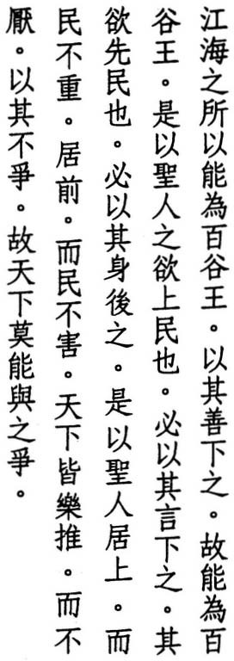66 The reason the sea can govern a hundred rivers is because it has mastered being lower
thus it can govern a hundred rivers
thus if the sage would be above the people he should speak as if he were below them if he would be before them
he should act as if he were behind them thus when the sage is above
the people are not burdened when he is in front
the people are not hindered the world never wearies
of pushing him forward
because he doesn't struggle
no one can struggle against him

YEN TSUN says, "Rivers don't flow toward the sea because of its reputation or its power, but because it does nothing and seeks nothing."
TE-CH' ING says, 'J\ll rivers flow toward the sea, regardless of whether they arc muddy or clear. And the sea is able to contain them all because it is adept at sta ng below them. This is a metaphor for the sage. The world turns to him because he is selfless."
yi
'ING says, "When the sage possesses the kingdom, he speaks of him­ self as 'orphaned, widowed, and impoverished,' or 'inheritor of the country's shame and misfortune.' Thus in his speech, he places himself below others. He does not act unless he is forced. He does not respond unless he is moved. He does not rise unless he has no choice. Thus in his actions, he places himself behind others."
LU HUI-CH
HO-SHANG KUNG says, "When the sage rules over the people, he doesn't op­ press those below with his position. Thus the people uphold him and don't think of him as a burden. When he stands before them, he doesn't blind them

132

with his glory. Thus the people love him as a parent and harbor no resentment. The sage is kind and loving and treats the people as if they were his children. Thus the whole world wants him for their leader. The people never grow tired of him because he doesn't struggle against them. Everyone struggles against something. But no one struggles against a person who doesn't struggle against anything. "

' SU CH
E says, "The sage doesn't try to be above or in front of others. But when

he finds himself below or behind others, the Tao can't help but lift him up and push him forward."
.

YAN G HS 1 U NG says, "He who holds himself back is advanced by others. He who lowers himself is lifted up by others" (Fayen: 7).
Ll HSI-CHAI says, "The people aren't burdened when the sage is above them, because they aren't aware they have a ruler. And the people aren't hindered when the sage is before them, because he isn't aware they are his people."
WANG CHEN says, "Through humility the sage gains the approval of the people. Once he gains their approval, he gains their tireless support. And once he gains their tireless support, struggling over rank naturally comes to an end."
There is a relative lack of commentary for this verse. Wang Pi, for example, says nothing at all. The only texrual issue is whether to read the last two lines as a statement or as a rhetorical question CIs it not because he doesn't struggle / no one can struggle against him?"). The Mawangtui and Fuyi texts word them as a question, while the Suotan and standard versions, which I have followed, word them as a statement. Both lines also appear as a statement In verse 22.

133

67 JI@� iL71:; .1111.
• • •
M'. �r
1li �
The world calls me great great but useless

� JI� /f � � because I am great I am useless
#f 7E � z. � if I were of use
� * i.v • *-

Z. • � - •
I would have stayed small

- }i;. r

J;J.

•
I13�'"
*- but I possess three treasures

I� �J;J.
71:; 'it
/f1li I treasure and uphold

Z.if-

�JlIJ
!t1111.
--•
i!i first is compassion

- 13
� i.v 1t
--. "l

Ji'1.
- second is austerity
third is reluctance to excel

'1'J;J.
}i;.
it.iJ. - *-!t
because I am compassionate

/fS /f
I can be valiant

=It � i!i
� �i.v * I can be extravagant
because I am austere

� r i!i because I am reluctant to excel

iLJj
71:;. !A' I can be chief of all tools

}i;. *
if I renounced compassion for valor

=It 'itI�'" 1.t� austerity for extravagance

{t�
iL•
•

=It
{i
�

•

!tIIJj�
{t•

•
}i;.•

'tI
�
il
---
reluctance for supremacy I would die
compassion wins every battle
and outlasts every attack what Heaven creates

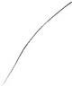!t " let compassion protect

HO-SHANG KUNG says, "Lao-tzu says the world calls his virtue great. But if his virtue were great in name alone it would bring him harm. Hence he acts stu­ pid and useless. He doesn't distinguish or differentiate. Nor does he demean others or glorify himself."

134

WANG PI says, "To be useful is to lose the means to be great."
su CH' E says, "The world honors daring, exalts ostentation, and emphasizes progress. What the sage treasures is patience, frugality, and humility. all of which the world considers useless."
TE-CH' ING says, '''Compassion' means to embrace all creatures without reser­ vation. l\usterity' means not to exhaust what one already has. 'Reluctance to excel' means to drift through the world without opposing others."
WANG AN-SHIH says, "Through compassion, we learn to be soft. When we are soft, we can overcome the hardest thing in the world. Thus we can be valiant. Through austerity. we learn when to stop. When we know when to stop, we are always content. Thus we can be extravagant. Through reluctance to excel, we are excelled by no one. Thus we can be chief of all tools. Valor, extrava­ gance, and excellence are what everyone worries about. And because they
worry. they are always on the verge of death."
LIU SHIH- P' Ei says, "To be chief of all tools means to be the chief official." For "chief of all tools:' see verse 28.
CONFUCIUS says, "The gentleman is not a tool" (Lunyu: 2.12).
wu CH' ENG says, "Compassion is the chief of the three treasures. The last sec­ tion only mentions compassion because it includes the other two. All people love a compassionate person as they do their own parents. How could anyone
oppose their parents? Hence he who attacks or defends with compassion meets no oppOSI, tI. On."
MENCIUS says, "He who is kind has no enemy under Heaven" (78.3).
Several editions read line one: "The world calls my Tao great." But the word Tao does not appear in the Fuyi or Suotan editions, the Mawangtui texts, or in other early copies. In line sixteen, Han Fei and Mawangtui Text A have ch'eng­ shih-chang:chief of those who succeed. For the penultimate line, I have followed the Mawangtui version, which haschien:create instead of the standard chiu:save.

135

- 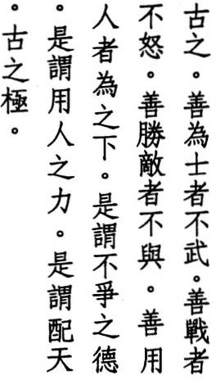In ancient times
the perfect officer wasn't armed the perfect warrior wasn't angry the perfect victor wasn't hostile
the perfect commander acted humble this is the virtue of nonaggression this is using the strength of others this is uniting with Heaven
which was the ancient end

CHIAO HUNG says, "In ancient times, officers went to battle in chariots. They / were dressed in mail, and there were three to a vehicle: one on the left armed with a bow; one on the right armed with a spear, and one in the middle ill charge of the reins, the flag, and the drum. Below and arrayed around every chariot were seventy-two soldiers."
SUN-TZU says, ''A ruler must not mobilize his armies in anger. A general must not engage the enemy in wrath. Anger can turn to joy; and wrath can turn to gladness. But once a state is destroyed, it cannot be restored. And once a man is dead, he cannot be reborn" (12.18-21). Sun-tzu also says, "To win every battle is not supreme excellence. Supreme excellence is to conquer without fighting" (302).
HO-SHANG KUNG says, "Those who honor the Way and Virtue are not fond of weapons. They keep hatred from their hearts. They eliminate disaster before it arises. They are angered by nothing. They use kindness among neighbors and virtue among strangers. And they conquer their enemies without fighting. They commmand through humility."
LIE H -TZU says, "He who governs others with worthiness never wins them over. He who serves them with worthiness never fails to gain their support" (6.3).
WANG CHEN says, "You must first win their hearts before you can command others."

136

KUMARAJI VA says, "Empty your body and mind. No one can fight against nothing."

' WU CH
ENG says, "Even though our wisdom and power might surpass that


of others, we should act as if we possessed neither. By making ourselves lower than others, we can use their wisdom and power as our own. Thus we can win without taking up arms, without getting angry. and without making enemies. By using the virtue of nonagression and the power of others, we are like Heaven, which overcomes without fighting and reaches its goal without moving."
TZU-SSU says, "Wide and deep, he is able to support others. High and bright, he is able to protect others. He who is wide and deep unites with Earth. He who is high and bright unites with Heaven" (Chungyung: 26.4-5).
.IE-CH'ING says, "Heaven is yang and Earth is yin. But if Heaven and Earth re­ main stationary. everything stops, and nothing comes into existence. Only when yang descends and yin rises does everything flourish. Thus Heaven's po­ sition is to be above, but its function is to descend. When the sage is above the people, and his heart is below, we call this uniting with Heaven. This was the pole star of the ancient kings."
Some editions drop the opening phrase: ku-chih:in ancient times and combine this with the previous verse. I have followed the Fuyi edition in retaining it as it stands (Mawangtui Text B has ku:thus). In line seven, both Mawangtui texts omit the phrase: chih-li:the strength of, but no other edition follows suit. Finally. some commentators read the last two lines as one line, eliminating ku:ancient as a copyist error: "we call this the end of uniting with Heaven." But this is not supported by any early commentary or text.

137

- 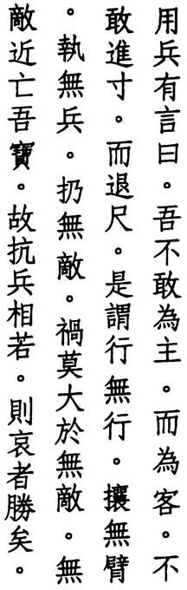In warfare there is a saying rather than a host
better to be a guest
rather than advance an inch better to retreat a foot
this means to form no column to wear no armor
to brandish no weapon to repulse no enemy
no fate is worse than to have no enemy without an enemy we would lose our treasure thus when opponents are evenly matched
the remorseful one prevails

WANG CHEN says, "In warfare, we say the one who mobilizes first is the host and the one who responds is the guest. The sage only goes to war when he has no choice. Hence he is the guest."
CHIAO HUNG says, "This was a saying of ancient military strategists." If so, they remain unnamed. Sun-tzu, meanwhile, calls the invading force the k'o:guest (n.2o).
HO-SHANG KUNG says, ':According to the Tao of warfare, we should avoid be­ ing the first to mobilize troops, and we should go to war only after receiving Heaven's blessing."
' says, "The host resists, and the guest agrees. The host toils, and the guest relaxes. One advances with pride, while the other retreats in humil­ ity. One advances with action, while the other retreats in quiet. He who meets resistance with agreement, toil with relaxation, pride with humility, and action with quiet has no enemy. Wherever he goes, he conquers."
LU HUI-CH I NG
'ANG-HSING says, "In warfare, the sage leaves no traces. He advances by retreating."
SUNG CH

138


WU CH' ENG says, "Those who go to war form themselves into columns, equip themselves with weapons, and advance against the enemy. But when the sage goes to war, he acts as if columns did not exist, armor did not exist, weapons did not exist, as if enemies did not exist."
SUN-TZU says, "The general who advances with no thought of fame, who re­ treats with no fear of punishment, who thinks only of ptotecting his country and helping his king is the treasure of the realm" (10.24).
su CH'E says, "The sage regards compassion as his treasure. To treat killing lightly would be to lose the reason for compassion."
TE-CH ING says, "When opponents are evenly matched, and neither is supe­ rior, the winner is hard to determine. But if one is remorseful and compassion­ ate, he wil win. For the Way of Heaven is to love life and to help those who are compassionate to overcome their enemies."
'
WANG PI says, 'Those who are remorseful sympathize with their opponents. Th(}y don't try to gain an advantage but to avoid injury. Hence they always
. "
Win.
WANG p ANG says, "To be remorseful is to be compassionate. He who is com­ passionate is able to be courageous. Thus he triumphs."
'
LIN HSI-Yl says, "Those who attack with drums and cheer the advent of war are not remorseful. They are remorseful who do not consider warfare a plea­ sure but an occasion for mourning. In this verse, warfare is only a metaphor for the Tao."
LAO-TZU says, "When you kill another / honor him with your tears / when the battle is won / treat it as a wake" (31).
The standard edition reverses lines eight and nine. In lines ten and eleven, it also has ch 'ing-ti:treat enemies lightly in place of wu-ti:without enemies. And in line twelve, it has hsiang-chia:meet each other in place of hsiang-juo:evenly matched. In all three cases, I have followed the Mawangtui and Fuyi editions.

139

- • �� i ! My words are easy to understand

•
•

* , a
� � �,- -t�
easy to employ
but no one can understand them

�l;J.
1-l;J. 'fT � no one can employ them

A � � ,}t
•
•
words have an ancestor

tit � ;f � deeds have a master
- :>F ff
:f,%
b
� because they have no understanding

• • •
ffij � . ffij people fail to understand me

,.:f.It

*� �;f A�
rare are they who understand me thus am I exalted

• • • Z.
,
�

�JlIJ 7<:."it
�� the sage therefore wears coarse cloth and keeps his jade inside



TS AO TAO-CH UNG says, "Nothing is simpler or easier than the Tao. But be­ cause it's so simple, it can't be explained by reasoning. Hence no one can un­
' '
derstand it. And because it's so near, it can't be reached by stages. Hence no one
.
"
can put It to use.
WANG p' ANG says, "Because the sage teaches us to be in harmony with the course of our life, his words are simple, and his deeds are ordinary. Those who look within themselves understand. Those who follow their own nature do what is right. Difficulties arise when we turn away from the trunk and follow the branches."
LI HSI-CHAI says, "The Tao is easy to understand and easy to put to use. It is also hard to understand and hard to put to use. It is easy because there is no Tao to discuss, no knowledge to learn, no effort to make, no deeds to perform. And it is hard because the Tao cannot be discussed, because all words are wrong, because it cannot be learned, and because the mind only leads us astray. Effortless stillness is not necessarily right. And actionless activity is not neces­ sarily wrong. This is why it is hard."

su CH E says, "Words can trap the Tao, and deeds can reveal its signs. But if the
'
Tao could be found in words, we would only have to listen to words. And if it could be seen in deeds, we would only have to examine deeds. But it cannot be

140

found in words or seen in deeds. Only if we put aside words and look for their ancestor, put aside deeds and look for their master, can we find it."

WU ' ENG says, "The ancestor unites the clan. The master governs the state.
CH
Softness and humility are the ancestor of all words and the master of all deeds."
YEN TSUN says, "Wild geese fly for days but don't know what exists beyond the sky. Officials and scholars work for years, but none of them knows the extent of the Way. It's beyond the ken and beyond the reach of narrow-minded, one­ sided people."
LU HUI-CH' ING says, "The reason the Tao is exalted by the world is because it cannot be known or perceived. If it could be known or perceived why should it be exalted? Hence Lao-tzu is exalted because so few understand him. Thus the sage wears an embarrassed, foolish expression and seldom shows anyone his great and noble virtue."
� u
HO-SH G- K NG says, "The reason people don't understand me is because my vir.ru€ls dark and not visible from the outside."
CONFUCIUS says, "I study what is below and understand what is above. Who knows me? Only Heaven" (Lunyu: 14.37).
WANG PI says, "To wear coarse cloth is to become one with the mundane. To keep one'sjade inside is to treasure the truth. The sage is difficult to know be­ cause he does not differ from the mundane and because he does not reveal his treasure ofjade."
In line ten, the word ts<:thus can also mean follow, and some commentators have read the line: "who follows me is exalted." As with geodes, jade is found inside ordinary-looking rocks. Officials once wore it on their hats as an em­ blem of their status, and alchemists often included it in their elixirs.

141

- 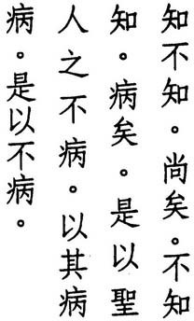To understand yet not understand is transcendence
not to understand yet understand is affliction
the reason the sage is not afflicted
is because he treats affliction as affliction hence he is not afflicted

CONFUCIUS says, "Shall I teach you about understanding? To treat understand­ ing as understanding and to treat not understanding as not understanding, this is understanding" (Lultyu: 2.17).
TE-CH ING says, "The ancients said that the word 'understanding' was the door to all mysteries as well as the door to all misfortune. If you realize that you don't understand, you eliminate false understanding. This is the door to all mysteries. If you cling to understanding while trying to discover what you don't understand, you increase the obstacles to understanding. This is the door to all misfortune."
'
WU CH'ENG says, "Those who understand yet who seem not to understand are the wisest of men. They protect their understanding with stupidity. Those who don't understand yet who think they understand are, in fact, the stupidest of men. They think blind eyes see and deaf ears hear. This is what is meant by 'affliction.'"
TS'AO TAO-CH'UNG says, "If someone understands, but out of humility he says he doesn't understand, this is when reality is superior to name. Hence we call it transcendence. If someone doesn't understand but says he does understand, this is when name surpasses reality Hence we call this an afflic­ tion. Those who are able to understand that affliction is affliction are never afflicted. "
SU CH' E says, "The Tao is not something that can be reached through reason­ ing. Hence it cannot be understood. Those who do not yet understand do not understand that there is no entrance. And if they do understand, and they think about their understanding, they become afflicted by understanding."

142


CHIAO HUNG says, 'i\nything that is understood is a delusion. Anything that is a delusion is an affliction. Understanding is not the affliction. It is the under­ standing of understanding that becomes the affliction. To understand what is the affliction is to cure the illness without medicine."
LI HSI-CHAI says, "Understanding depends on things, hence it involves fabrica­ tion. Not understanding returns to the origin, hence it approaches the truth. If someone can understand that not understanding approaches the truth and that understanding involves fabrication, they are transcendent. If they don't understand that understanding involves fabrication and vainly increase their understanding, they use the affliction as the medicine. Only by understanding that understanding is affliction can one be free of affliction. This is why the sage is not afflicted."
HO-SHANG KUNG says, "To understand the Tao yet to say that we don't is the transcendence ot virtue. Not to understand the Tao and to say that we do is the a .of virtue. Lesser people don't understand the meaning of the Tao and vainly act according to their forced understanding and thereby harm their spirit and shorten their years. The sage doesn't suffer the affliction of forced understanding because he is pained by the affliction of others."
ffl�
The Fuyi and standard editions include two additional lines between lines four and five: "because he treats affliction as affliction / he is not afflicted." But this makes the last lines more redundant than they already are, and they are not included by Han Fei, the Mawangtui texts, the Chinglung edition, or at least two Tunhuang copies.

143

- 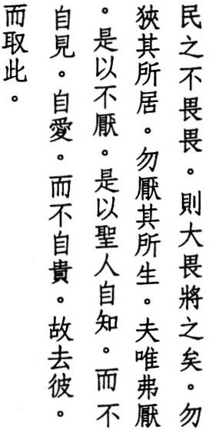When people no longer fear authority a greater authority will appear
don't restrict where people dwell don't repress how people live
if they aren't repressed they won't protest
thus the sage knows himself but doesn't reveal himself he loves himself
but doesn't exalt himself thus he picks this over that

WU CH ENG says, "The authority we fear is what shortens years and takes lives. The 'greater authority' is our greater fear, namely death. When people no longer fear what they ought to fear, they advance their own death until the greater fear appears."
'
WANG P' ANG says, "When people are simple and their lives are good; they fear authority But when those above lose the Way and enact all sorts of measures to restrict the livelihood of those below, people respond with deceit and are no longer subdued by authOrity. When this happens, natural calamities occur and misfortunes arise."
WANG CHEN says, "When ordinary officials and the common people have no fear, punishment occurs. When ministers and high officials have no fear, banishment occurs. When princes and kings have no fear, warfare occurs."
WEI YUAN says, '''Where they dwell' refers to conditions such as wealth and poverty. 'How they live' refers to bodily activities such as toil and rest. When people think that where they dwell or how they live is not as good as others.
. they feel embarrassed and thus restricted, restricted and thus repressed. And when they feel repressed, they protest against 'this' and seek 'that: not mow­ ing that once their desire is fulfilled what they fear comes close behind."
WANG PI says, "In tranquility and peace is where we should dwell. Humble and empty is how we should live. But when we forsake tranquility to pursue desires

144

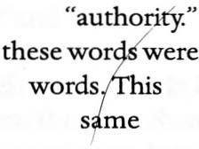and abandon humility for authority. crearures are disrurbed and people are distressed. When authority cannot restore order, and people cannot endure authority. the link between those above and those below is severed, and naru­ ral calamities occur."
HO-SHANG KUNG says, "He knows what he has and what he doesn't have. He doesn't display his virrue outside but keeps it hidden inside. He loves his body and protects his essence and breath. He doesn't exalt or glorify himself before the world. 'That' refers to showing and glorifying himself. 'This' refers to knowing and loving himself."
TS' AO TAO-CH' UNG says, "'That' refers to external things. 'This' refers to one's inner reality."
Lao-tzu begins this verse with two puns. The force of the first pun in lines one and two is somewhat weakened in the standard edition by the use of homo- phones for "fear" and In his edition of 1587, Chiao Hung noted that in ancient times interchangeable, and he suggested using one character for both is, in fact, what occurs in the second pun in lines five and six, where the character is used for "repress" as well as for "pro- test." The Mawangrui texts, it rums out, agree with Chiao Hung, and I have amended lines one and two accordingly. In lines three and four, I have also turned to the Mawangrui texts for the negative injunction wu:don't. Other edi­ tions have wu:has not orpu:does not, both of which result in problems regarding the referant and thus different interpretations of the entire verse. The last line also occurs at the end of verses 12 and 38 .

•

145

73 .. ..
jJ4.
. �" Daring to act means death

1t ffi
0 i!t- � a

0
daring not to act means life
f

7;.tl¥l
. � �Jl� o
these two

0
#{ T- z. 0
one benefits

#{ � fJT
t,
�1J
0 ffi
one harms
what Heaven hates

� i!t- 0 T- who knows the reason
ffi J.l! tIi �
T- o � Jl� the Way of Heaven

*-0

:t
T- 7&o
.g ;l;t0
ffi

wins easily without a fight answers wisely without a word

ru 7;.
Jltm comes qUickly without a summons

*o 1tz. :tf0
jJ4

plans ingeniously without a thought

AAt 0 the Net of Heaven is all-embracing ffi T- t� its mesh is wide but nothing escapes

LI HSI-CHAI says, "Everyone knows about daring to act but not about daring not to act. Those who dare to act walk on the edge of a knife. Those who dare not to act walk down the middle of the path. Comparing these two, walking on a knife-edge is harmful, but people ignore the harm. Walking down the middle of the path is beneficial, but people are not aware of the benefit. Thus it is said, 'People can walk on the edge of a knife but not down the middle of a path'" (Chungyung: 9).
'
SU CH E says, "Those who dare to act die. Those who dare not to act live. This
is the normal pattern of things. But sometimes those who act live, and some­ times those who don't act die. What happens in the world depends on luck. Sometimes what should happen doesn't. The Way of Heaven is far-off. Who knows where its love and hate come from?"

SUNG
CH
' ANG-HSING says, "The mechanism whereby some live and others die

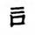is obscure and hard to fathom. If the sage finds it difficult to know, what about ordinary people?"
YEN TSUN says, "Heaven does not consider life in its schemes or death in its work. It is impartial."

146

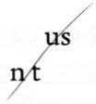LU NUNG-SHIH says, "Loosely viewed, the hard and the strong conquer the soft and the weak. Correctly viewed, the soft and the weak conquer the hard and the strong. Hence the hard and the strong are what Heaven hates."
wu CH ENG says, "Because the sage does not lightly kill others, evildoers slip through his net, but not the Net of Heaven. Heaven does not use its strength to fight against evildoers as Man does, and yet it always triumphs. It does not speak with a mouth as Man does, and yet it answers faster than an echo. It does not have to be summoned but arrives on its own. Evil has its evil reward. Even the clever cannot escape. Heaven is unconcerned and unmindful, but its retri­ bution is ingenious and beyond the reach of human plans. It never lets an evil­ doer slip through its net. The sage does not have to kill him. Heaven will do it for him."
'
WANG AN-SHIH says, "Yin and yang take turns, the four seasons come and go, the moon waxes and wanes. All things have their time. They don't have to be summoned to come." ,/
Ll HUNG-FU says, "It wins beca e it doesn't fight. It answers because it doesn't speak. It comes because it is ' summoned. If it had to fight to win, something would escape, even if its mesh were fine."
After line seven, the Fuyi, Suotan, and standard editions have: "thus even the sage finds it hard." However, this line does not appear in the Mawangtui, Chinglung, or Suichou editions, Tunhuang copies P.2347, P.25I7, s.6453, or the Yen Tsun text. Ma Hsu-lun considers it an interpolation from verse 63, where it also appears, and I tend to agree. The last two lines have become a proverb.

147

- 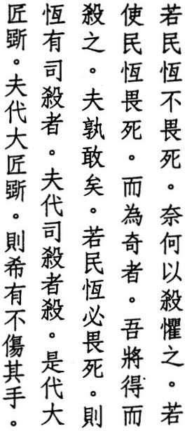If people no longer fear death why do we threaten to kill them
and if others fear death and still act perverse
and we catch and kill them who else will dare
as long as people fear death the executioner will exist
to kill in the executioner's place
is to take the carpenter's place who takes the carpenter's place is bound to hurt his hands

YIN WEN says, "Lao-tzu says if people are not afraid to die, what good is threat­ ening to kill them? If people are not afraid to die, it is because punishments arc excessive. When punishments are excessive, people don't care about life. When they don't care about life, the ruler's might means nothing to them. When punishments are moderate, people are afraid to die. They are afraid to die be­ cause they enjoy life. When you know they enjoy life, you can threaten them with death" (2).
LI HSI-CHAI says, "This implies that punishments cannot be relied upon for governing. If people are not afraid of death, what use is threatening them with execution? And if they are afraid of death, and we catch someone who breaks the law, and we execute them, by killing one person we should be able to gov­ ern the rest. But the more people we kill, the more break the law. Thus punish­ ment is not the answer."
MING T' AI-TSU says, "When I first ascended the throne, the people were un­ ruly and officials corrupt. If ten people were executed in the morning, a hun­ dred were breaking the same law by evening. Being ignorant of the Way of the ancient sage kings, I rurned to the Taoteching. When I read: 'If the people no longer fear death / why do we threaten to kill them,' I decided to do away with

148

capital punishment and put criminals to work instead. In the year since then, the burdens of my heart have been lightened. Truly; this book is the greatest teacher of kings."

' WU CH
ENG says, '''Perverse' means 'unlawful.' If those who act perverse and

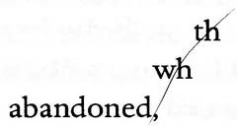break the law do not meet with misfortune at the hands of Man, they will cer­ tainly be punished by Heaven."
HO-SHANG KUNG says, "If the ruler teaches according to the Tao, and people respond with perversion instead, the ruler is within his rights to arrest them and kill them. Lao-tzu, however, was concerned that the ruler should use the Tao first before he turned to punishment."
LU HUI-CH ING says, "The meaning of 'the executioner will exist' is the same as 'the Net of Heaven is all-embracing / its mesh is wide but nothing escapes' (verse 73). The executioner is Heaven."
'
' E says, "Heaven is the executioner. If the world is at peace and someone engages in perversity and rebellion, en surely he has been abandoned by Heaven. If we kill him, it is Heaven 0 kills him and not us. But if we kill those whom Heaven has not this is to take the executioner's place. And he who takes the executioner's place puts himself within reach of the axe."
SU CH
THE LUSHIH CHUNCHIU says, "A great carpenter does not cut" (1.4).
MENCIUS says, "The wise are not alone in desiring something greater than life and in hating something greater than death. This is true of everyone. But the wise don't forget it" (6A.ro).
Line seven appears only in the Mawangtui texts, but it seems needed to com­ plete the meaning of line eight. At the end of line eight, the Fuyi and standard editions add an extra sha:to kill. I have followed the Suotan, Chingfu, and Mawangtui texts in omitting it.

149

- 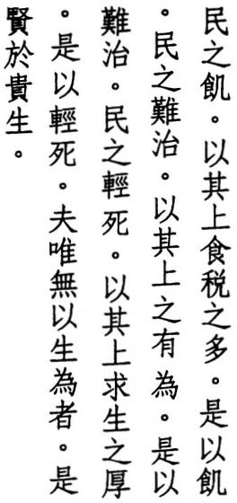The reason the people are hungry
is because those above levy so many taxes thus the people are hungry
the reason the people are hard to rule is because those above are so forceful thus the people are hard to rule
the reason the people think little of death
is because those above think so much of life thus the people think little of death meanwhile those who do nothing to live are more esteemed than those who love life

DUKE Al approached YU JUO, "The year is one of famine, and my revenues are wanting. What am I to do?" Yu Juo replied, "Return to the IO percent rate of taxation." Duke Ai said, "But I cannot get by on 2I) percent, how will I survive on 10 percent?" Yu Juo replied, "When the people do not want, why should the ruler want. When the people want, why should the ruler not want?" (Lunyu: I2.9).
WANG PI says, "The reason the people hide and disorder prevails is because of those above, not because of those below. The people follow those above."
Ll HSI-CHAI says, "If those above take too much, those below will be impover­ ished. If those above use too much force, those below will rebel. This is a mat­ ter of course. When someone thinks his own life is more important, and he disregards the lives of others, why should others not treat death lightly. The sage doesn't think about life unless he is forced to."
TE-CH' ING says, "Robbers and thieves arise from hunger and cold. If people are hungry and have no means to live, they have no choice but to steal. When people steal, it's because those above force them. They force people to turn to stealing and then try to rule them with cleverness and laws. But the more laws they make, the more thieves appear. Even the threat of the executioner's axe doesn't frighten them. And the reason the people aren't frightened by death is because those above are so concerned with life."

150

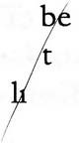SU CH'E says, "When those above use force to lead the people, the people re­ spond with force. Thus do complications multiply, and the people become hard to rule."
WANG CHEN says, '''Forceful' refers to the ruler's love of might and arms. But once arms prevail, disorder is certain."
HUAI-NAN-TZU says, "The reason people cannot live out their alloted years and are sentenced to death in mid-life is because they think so much of life. Mean­ while, those who do nothing to stay alive are able to lengthen their lives" (7).
HO-SHANG KUNG says, "Only those who do nothing to stay alive, who aren't moved by titles or sinecures, who aren't affected by wealth or advantages, who refuse to serve the emperor or run errands for lesser lords, they alone are more esteemed than those who love life."
YEN TSUN says, "The Natural Way always tl,lrns things upside down. What has no body lives. What has a body dies. To alive and to seek advantages is the beginning of death. Not to be alive and 0 get rid of advantages is the begin­ ning of life. Those who don't work to 've live long."
WANG TAO says, "The meaning of the last two lines is: If I didn't have this body of mine, what worries would I have?"
WANG p' ANG says, "If you understand only one of these three, you can under­ stand the other two."
In line eight, I have followed the Fuyi edition in reading ch'i-shang:those above.
Other editions have simply ch'i:those, leaving the referent in doubt.

151

- 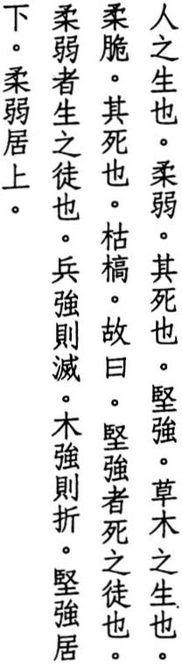When people are born they are soft and supple
when they perish they are hard and stiff
when plants shoot forth
they are soft and tender when they die
they are withered and dry thus it is said
the hard and strong are followers of death the soft and weak are followers of life
when an army becomes strong it suffers defeat when a plant becomes hard it snaps
the hard and strong dwell below the soft and weak dwell above

HO-SHANG KUNG says, "When people are born, they contain breath and spirit. This is why they are soft. When they die, their breath ceases and their spirit disappears. This is why they are hard."
'
wu CH ENG says, "Seeing that the living are soft and the dead are hard, we can
infer that those whose virtue is hard and those whose actions are forceful die before they are ready, while those who are soft and weak are able to preserve their lives."
LI HSI-CHAI says, 'f\.lthough the soft and weak aren't the same as the Tao, they approach its absence of effort. Hence they aren't far from the Tao. Although the hard and strong aren't outside the Tao, they involve effort. Hence they lead people away from it."
LIEH-TZu says, "The world has a path of perennial victory and a path of peren­ nial defeat. The path of perennial victory is weakness. The path of perennial defeat is strength. These two are easy to recognize, but people remain oblivi­ ous to them" (2.17).

152

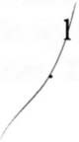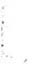LAO-TZU says, "The weak conquer the strong" (36).
WANG CHEN says, "It isn't hard for an army to achieve victory. But it is hard to hold onto victory. There is no great army that has not brought on its own defeat through its victories."
HSI T' UNG says, 'When wood becomes hard, it loses its flexibility and becomes easy to break."
WANG p' ANG says, "In terms of yin andyang, yin comes before, andyang comes after. In terms of Heaven and Earth, Heaven is exalted, and Earth is humble. In terms of Virtue, the soft and the weak overcome the hard and the strong. But
. in terms of material things, the hard and the strong control the soft and the weak. The people of this world only see things. They don't understand Virtue."

su CH E says, 'i\s long as it contains empty breath, the body does not suffer
'
from rigidity. As long as they reflect perfect reasoh, actions are not burdened
by severity. According to the unchanging princip e of things, the refined rises to the top, while the coarse sinks to the bottom The refined is soft and weak, while the coarse is hard and strong."
LI JUNG says, "The living belong above. The dead belong below."
In line five, most editions include the phrase wan-wu:ten thousand creatures be· fore tS'ao-wu:plants. Chiang HSi-ch'ang thinks that in light of the plant-specific adjectives of lines six and eight this must be an interpolation, and I agree. It does not appear in Yen Tsun or the Fuyi edition. In line nine, I have relied on the Mawangtui texts for the addition of yueh:it is said. In line thirteen, I have turned to Liehtzu: 2.17, Huainantzu: I, and Wentzu: 1 for che:snap. Meanwhile, the standard, Suotan, and Fuyi editions have the puzzling kung:together, Wang Pi has the equally strange ping:army, and the Mawangtui texts offer no help with keng:end and ching:compete.

153

- 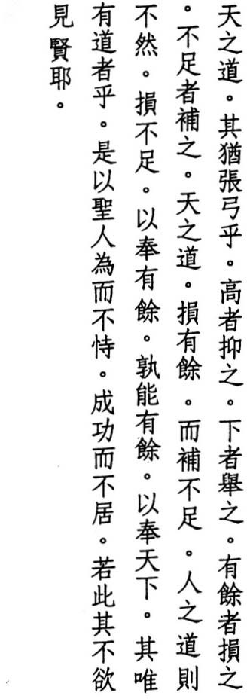The Way of Heaven
is like stringing a bow pulling down the high lifting up the low shortening the long lengthening the short the Way of Heaven takes from the long
and supplements the short unlike the Way of Man taking from the short
and giving to the long who can find the long and give it to the world
only those who find the Way
thus the sage does not presume on what he does or claim what he achieves
thus he chooses to hide his skill

KAO HENG says, "In attaching a string to a bow. we pull the bow down to attach the string to the top. We lift the bow up to attach it to the bottom. If the string is too long, we make it shorter. If the string is too short, we make it longer. This is exactly the Way of Heaven." My reading of line two, which agrees with that of Kao Heng, is based on the Shuowen, which says, "Chang means to attach a string to a bow."
TU ER-WEI says, "Not only the Chinese, but the ancient Greeks and Hindus, the Finns, the Pawnee, the Arapaho all likened the moon to a bow. Thus the Way of Heaven is like a bow" (pp. 97-98).
HO-SHANG KUNG says, "The Way of Heaven is so dark, we need metaphors to understand it. To prepare a bow for use, we string it by pulling down the top

154

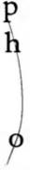and by lifting up the bottom. Likewise, the Way of Heaven takes from the strong and gives to the weak."
LU HU I-CH' I NG says, "The Way of Heaven does not intentionally pull down the high and lift up the low. It does nothing and relies instead on the nature of things. Things that are high and long cannot avoid being pulled down and shortened. Things that are low and short cannot avoid being lifted up and lengthened. The full suffer loss. The humble experience gain."
TE-CH ING says, "The Way of Heaven is to give but not to take. The Way of Man is to take but not to give."
'
WANG p' ANG says, "The Way of Heaven is based on the natural order. Hence it is fair. The Way of Man is based on desire. Hence it is not fair. Those who pos­ sess the Way follow the same Way as Heaven."
su CH' E says, "Those who possess the Way su ply the needs of the ten thou­ sand creatures without saying a word. Only t ose who possess the Way are capable of this."
LU HSI-SHENG says, "Who can imitate the Way f Heaven and make it the Way of Man, take what one has in abundance and give it to those in need? Only those who possess the Way. The Yiching says, 'To take means to take from the low and give to the high (41). To give means to take from the high and give to the low' (42)."
LI JU N G says, 'l\lthough the sage performs virtuous deeds, he expects no re­ ward and tries to keep his virtue hidden."
' ANG-HSING says, "The skill of the sage is unfathomable and inex­ haustible. How could it be revealed?"
SUNG CH
In lines thirteen and fourteen, I have followed the simpler wording of Mawang­ tui Text B and the Suoran edition. Lines sixteen and seventeen also appear in verses 2 and 51. For the last line, I have used the briefer Fuyi version.

155

- 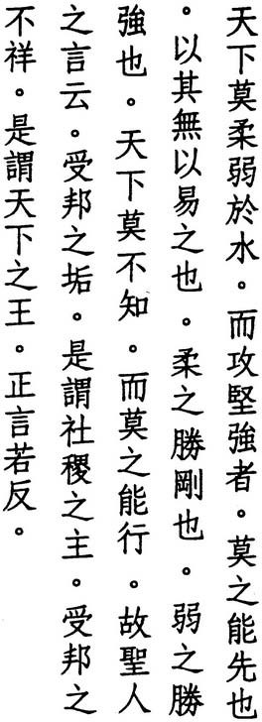Nothing in the world is weaker than water but against the hard and the strong
nothing excels it
for nothing can change it the soft overcomes the hard
the weak overcomes the strong this is something everyone knows but no one is able to practice
thus the sage declares
who accepts a country's disgrace we call the lord of soil and grain who accepts a country's misfortune we call the king of all under Heaven upright words sound upside down

HSUAN-TSUNG says, "The nature of water is to stay low, not to struggle, and to take on the shape of its container. Thus nothing is weaker. But despite such weakness, it can bore through rocks, while rocks cannot wear down water."'
LI H UNG-FU says, "The soft and the weak do not expect to overcome the hard and the strong. They simply do."'
HSI T'UNG says, "You can hit it, but you can't hurt it. You can stab it, but you can't wound it. You can hack it, but you can't cut it. You can light it, but you can't burn it. Nothing in the world can alter this thing we call water."
CHU TI-HUANG says, "We can alter the course and shape of water, but we can't alter its basic nature to descend, by means of which it overcomes the hardest and strongest things."
TS' AO TAO-CH'UNG says, "The reason people know this but don't put this into practice is because they love strength and hate weakness."
SUNG CH' ANG-HSING says, "Spies and traitors, thieves and robbers, people who have no respect for the law, disloyal subjects and unfilial children, these

156


are disgraces. Excessive drought and rain, epidemics and locusts, untimely death, famine and homelessness, ominous plants, and misshapen animals, these are misforrunes."
PO-TSUNG says, "Rivers and swamps contain mud. Mountains and marshes harbor diseases. The most beautiful gem has a flaw. The ruler of a state suffers disgrace. This is the Way of Heaven" (Tsochuall: Hsuan.I5).
SHU N says, "If I commit an offense, it has nothing to do with my people. If my people commit an offense, the offense rests with me" (Shuchillg: 4C.8).
CH UANG -TZU says, "Everyone wants to be first, while I alone want to be last: which means to endure the world's disgrace" (33.5).
MENCIUS says, "If the ruler of a state is not kind, he cannot protect the spirits of the soil and grain" (4A.3).
su CH' E says, "Upright words agree with the Tao and contradict the world. The world considers enduring disgrace shameful and enduring misforrune a calamity"
LI J UNG says, "The world sees disgrace and innocence, forrune and misfor­ rune. The Taoist sees them all as empty"
KAO YEN-TI says, "The last line sums up the meaning of the abstruse phrases that occur throughout the Taotechillg, such as 'to act without acting.' The words may contradict, but they complement the truth."
In line four, yi:challge can also mean "to be easy" (Ho-shang Kung), "to slight" (Li Hung-fu), or "to replace" (Ch'en Ku-ying). In line five, Mawangrui Text B has shui:water in place of jou:soft, in which case, kallg:hard would be read "metal." Wu Ch'eng puts the last line at the beginning of the next verse, Yen Tsun combines both verses, and some commentators suggest combining this with verse 43.

157

79 �-fi' i�� :fJ;A -fi'� *�
A �

ii] • • •
In resolving a great dispute a dispute is sure to remain
how can this be good ,

1t �A
•
J;A �
;It

� 1if

thus the sage holds the left marker

•
!'-� #.1if AfA �� flJL i3'J � !Jt 'tI• � W i;A
" 1� 1£ •
•
- PJ
he makes no claim on others thus the virtuous oversee markers the virtueless oversee taxes
the Way of Heaven favors no one
,
but always helps the good



TE-CH' ING says, "In Lao-tzu's day. whenever the feudal rulers had a dispute, the most powerful lord convened a meeting to resolve it. But the resolution of a great dispute invariably involved a payment, And if the payment was not forth­ coming, the dispute continued."
WANG PI says, "If we don't arrange a contract clearly. and a dispute results, even using virtuous means to settle it won't restore the injury. Thus a dispute will
,
remaI· n."
SU CH E says, "If we content ourselves with trimming the branches and don't pull out the roots, things might look fine on the outside, but not on the inside. Disputes come from delusions, and delusions are the product of our nature. Those who understand their nature encounter no delusions, much less disputes,"
'
HO-SHANG KUNG says, "Murderers are killed, and criminals are punished in ac­ cordance with their crime. But those who inflict such punishments offend their own human feelings and involve innocent people as well. If even one person sighs, we offend the Heart of Heaven, How can resolving disputes be consid­ ered good?"
CH' ENG HSUAN-YING says, "If someone lets go of both sides but still clings to the middle, how can they be completely good?"
'
SUNG CH ANG-HSING says, "Seeking to make peace with others is the Way of
Man. Not seeking to make peace but letting things make peace by themselves is the Way of Heaven, Despite the expenditure of energy and action, energy

158


and action seldom bring peace. Thus the sage holds the left marker because he relies on inaction and the subtlety of letting things be."
CHENG LIANG-SHU says, "In ancient times, contracts were divided in rwo. In the state of Ch'u, the creditor kept the left half, and Lao-tzu was from Ch'u. In the central plains, this was reversed, and the creditor kept the right half."
' says, "If one does not make demands of others, disputes
CH IANG HSI-CH ANG
cannot arise. If one constantly takes from others, great disputes cannot h.elp but occur."
WANG AN-SHIH says, "Those concerned with taxes cannot avoid making claims on others and thus cannot prevent disputes. This is why they lack virtue."
MENCIUS says, "The rulers of the Hsia dynasty exacted a kung:tribute on every five acres of land. The rulers of the Shang exacted a chu:share on every seven acres. The rulers of the Chou exacted a ch'e:tax on every ten acres. In reality; what was paid was a tithe of ten percent" (3A.3). See also Lunyu: 12.9.
LU TUNG-PIN says, "Those who are good cultivate themselves. They don't con­ cern themselves with others. Once you concern yourself with others, you have disputes. The good make demands of themselves. They don't make demands of others. The Way of Man is selfish. The Way of Heaven is unselfish. It isn't concerned with others, but it always is one with those who are good."
The last rwo lines were a common saying. In the Shuoyuan: 10.25, they conclude an exhortation to keep still. They also appear in slightly different form in the Shuching and in Ch'u Yuan's Lisao: "High Heaven favors no one / but it helps the virruous."

159

- 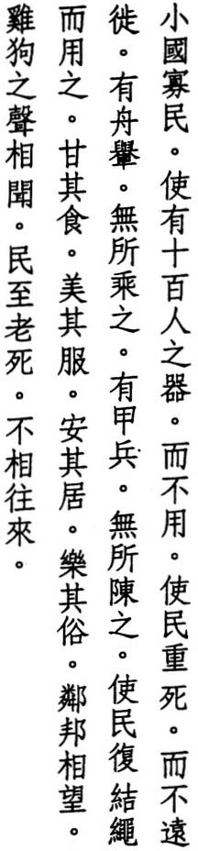Imagine a small state with a small population let there be labor-saving tools
that aren't used
let people consider death and not move far
let there be boats and carts
but no reason to ride them
let there be armor and weapons but no reason to employ them
let people return to the use of knots and be satisfied with their food
and pleased with their clothing and content with their homes and happy with their customs let there be a state so near
people hear its dogs and chickens and live out their lives
without making a visit

HUANG-TJ says, 'f\. great state is yang. A small state is yin."
SU CH' E says. "Lao-tzu lived during the decline of the Chou. when artifice flourished and customs suffered. and he wished to restore its virtue through doing nothing. Hence at the end of his book he wishes he had a small state to try rhis on. Bur he never got his wish."
YAO NAI says, "In ancient rimes. states were many and small. In later times. they were few and great. But even if a grear srate wanted ro return to the ancient ways. how could it?"
HO-SHANG KUNG says, 't\ithough the sage governs a great state. he rhinks of ir as a small state and is frugal in the use of irs resources. Alrhough rhe people are many, he rhinks of rhem as few and is careful not to exhaust them."

160


H U SHIH says, "With the advance of civilization, the power of technology is used to replace human labor. A cart can carry a thousand kilos, and a boat can carry hundreds of passengers. This is the meaning of 'labor-saving tools' " (p. 64).
WANG AN-SHIH says, "When the people are content with their lot, they don't concern themselves with moving far away or going to war."
THE YICHING CHITZU says, "The earliest rulers used knots in their govern­ ment. Later sages introduced the use of books" (B.2).
WU CH' ENG says, "People who are satisfied with their food and pleased with their clothes cherish their lives and don't tempt death. People who are content with their homes and happy with their customs don't move far away. They grow old and die where they were born."
CH'ENG HSUAN-YING says, "They are satisfied with their food because they taste the Tao. They are pleased with their clothing because they are adorned with virtue. They are content with their homes because they are content everywhere. And they are happy with their customs because they soften the glare of the world."
' TAO-CH'U NG says, "Those who do their own farming and weaving don't lack food or clothes. They have nothing to give and nothing to seek. Why should they visit others?"
TS AO
In line two, some editions delete jen:man in the compound shih-po-jen:labor­ saving. I have followed Yen Tsun, Ho-shang Kung, and the Suotan and Mawangrui texts, all of which include it. This phrase can also be interpreted, with or without jen, to mean "tools of war." But Hu .shih's reading, seconded by Cheng Liang-shu, is, I think, more profound. After line ten, Ssu-ma Ch'ien and the Fuyi edition add: "the goal of perfect rule / and everyone is . . ." But this appears to be an interpolation. Finally; some editions reverse the order of lines thirteen and fourteen but thereby abandon the rhyme.

161

- 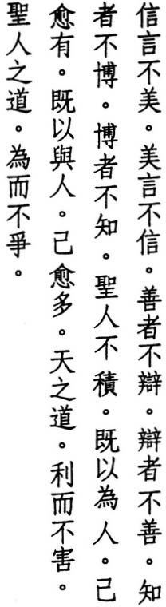True words aren't beautiful beautiful words aren't true
the good aren't eloquent the eloquent aren't good the wise aren't learned the learned aren't wise
the sage accumulates nothing but the more he does for others the greater his existence
the more he gives to others the greater his abundance the Way of Heaven
is to help without harming the Way of the sage
is to act without struggling

HUANG-TI says, "There is a word for everything. Words that are harmful we say are not true" (Chingfa: 2).
TE-CH'ING says, '�t the beginning of this book, Lao-tzu says the Tao can't be put into words. But are its 5,ooo-odd characters not words? Lao-tzu waits until the last verse to explain this. He tells us that though the Tao itself includes no words, by means of words it can be revealed-but only by words that come from the heart."
' E says, "What is true is real but nothing more. Hence it isn't beautiful. What is beautiful is pleasing to look at but nothing more. Hence it isn't true. Those who focus on goodness don't try to be eloquent, and those who focus on eloquence aren't good. Those who have one thing that links everything to­ gether have no need of learning. Those who keep learning don't understand the Tao. The sage holds onto the one and accumulates nothing."
SU CH
HO-SHANG KUNG says, "True words are simple and not beautiful. The good cultivate the Tao, not the arts. The wise know the Tao, not information. The

162

sage accumulates virtue, not wealth. He gives his wealth to the poor and uses his virtue to teach the unwise. And like the sun or moon, he never stops shining."
CHUANG-TZU says, "When Lao Tan and Yin Hsi heard of people who consid­ ered accumulation as deficiency; they were delighted" (33.5).
SUNG CH' ANG-HSING says, "People only worry that their own existence and abundance are insufficient. They don't realize that helping and giving to oth­ ers does them no harm but brings them benefit instead."
TS ' AO TAO-CH' UNG says, "The wealth from giving generously is inexhaustible. The power from not accumulating is boundless."

wu CH
'
ENG
says, "Help is the opposite of harm. Where there is help, there


must be harm. But when Heaven helps, it doesn't harm, because it helps with­ out helping. Action is the start of struggle. Where there is action, there must be struggle. But when the sage acts, he doesn't struggle, because he acts with-
out actm. g."

CHIAO HU NG says, "The past 5,000 words all explain 'the Tao of not accumu­ lating: what Buddhists call 'non-attachment.' Those who empty their minds on the last two lines will grasp most of Lao-tzu's book."
WANG CHEN says, "The last line summarizes the entire 5,000 words of the pre­ vious eighty verses. It doesn't focus on action or inaction but simply on action that doesn't involve struggle.
In lines three and four, the Fuyi edition adds yen:words. In the Mawangtui texts, lines three and four are inverted with lines five and six. I haven't used either of these variants, nor have I accepted the variation of the last line introduced by Mawangtui Text B and the Suotan edition, both of which havejen:man in place of sheng-jen:sage. This would result in "the Way of Man," which does appear in verse 77, but in a pejorative sense.

163

Glossary

In addition to proper names and Chinese terms, the following list includes the names and dates of all commentators quoted in the preceding pages along with the titles of texts from which I have quoted selected passages.
Chang Tao-ling !:Ji!l:t1\i (34-157 AD). Patriarch of the Way of Celestial Masters, the earliest-known Taoist movement, which emphasized physical and moral training as well as spiritual cultivation. His commentary was lost until a partial copy. including verses 3 through 37, was found in the Tunhuang Caves: s.6825. Lao-tzll hsiang-erh-chll.
Chankllotse �I!lilj:ft . Collection of narratives, some historical, some fictional, based on the events of the Warring States Period (403-221 BC). Compiled by Liu Hsiang (c. 79-6 BC) and re-edited by later scholars.
Chao Chih-chien I!e¥� (fl. 1270). Tao-te-chen-ching shll-Yi.
Ch'en Ku-ying ��m. (1935- ). Classical scholar and philosopher who has taught in Taipei and Peking and annoyed authorities in both places with his outspoken views. LaO-tZII chll-yi chi-p'ing-chieh.
Ch'eng Chu ffi1fJl, (I078-II44). Scholar-official and fearless critic of government policies with which he did not agree. Lao-tzlI-llln.
Ch' eng Hsuan-ying Jl�� (fl. 647-{i63). Taoist master and proponent of using an eclectic approach to explain the teachings of Lao-tzu. His commentary. re­ cently re-edited from portions in the Taoist Canon and Tunhuang manuscript S.2517, reflects the influence of Chuang-rzu along with Buddhist Sanlun and Tientai teachings. It was required reading for Taoists seeking ordination dur­ ing the T'ang dynasty Lao-tzlI-shll.
lotlIlltW
Cheng Liang-shu (1940- ). Classi'cal scholar and leading authority on the Mawangtui texts, His presentation of differences between the Mawangtui and other editions appears in Ta-lll tsa-chih vols. 54-59 (April 1977-0ctober 1979), His study of Tunhuang copies of the Taoteching is also excellent: LaO-tZII llln-chi.

165

Chiang Hsi-ch'ang ��� (pub!, 1937). Lao-tzu chiao-chieh.
5!J�,j!\'
Ch'iang Ssu-ch'i (fl. 920). Taoist master of the Former Shu dynasty (Szechuan province) during the Five Dynasties period. His edition is invaluable for its preservation of the comments of LiJung, Ch'eng Hsuan-ying, and Yen Tsun, as well as those of Hsuan-tsung and Ho-shang Kung. Tao-te-chen-ching hsuan-te-tsuan-shu.
Chiao Hung;\li\JI/i; (1541-1620). Noted compiler of bibliographic works. His 1587 edition of the Taoteching includes his own occasional comments as well as se­ lected commentaries of mostly Sung dynasty authors, especially Su Ch'e, Lu Hui-ch'ing, and Li Hsi-chai. It remains one of the most useful such compila­ tions. Lao-tzu-yi.
Chiehm (d. 1766 BC) and Chou M' (d. II22 BC). Tyrants whose reigns concluded the Hsia and Shang dynasties respectively.
Chingfu :!lt�Iil' Inscription of the Taoteching carved in the second year of the Chingfu period (893) at Lunghsing Temple in Yichou, southwest of Peking.
Chinglung :!ltilK. Inscription of the Taoteching carved in the second year of the Chinglung period (708) also at Yichou's Lunghsing Temple. Authorities in charge of the temple's former site have no idea what happened to these two stelae, though several elderly village women told me they were moved south to another county in the same province-. they didn't know which county or when the move took place. A third Taoteching stele, carved in 738, is the lone survivor of Lunghsing Temple's collection of ancient inscriptions.
Chinjenming �A�' An inscription that Confucius reports seeing on the back of a metal statue whose mouth was papered over. The statue, he says, was at the entrance to an early Chou dynasty shrine to Houchi, the God of Crops. (Kungtzu Chiayu: II). A copy of the inSCription now stands near the entrance to the Duke of Chou's shrine in Confucius' home town of Chufu.
Chu Ch'ien-chih *�Z (1899-1972). Classical scholar and teacher of philoso­ phy and history. His edition of the Taotechingpresents variants, rhymes, and us­ ages, along with his own comments. Lao-tzu chiao-shih.
Chu Ti-huang *'i:l.!il (1885-1941). Ch'ing dynasty official and early revolution­ ary. After fleeing the country. he returned to China to devote himself to Bud­ dhism and Chinese philosophy.
Ch'u Yuan Jim\ (340?-278 Be). China's first great poet and author of the Lisao.

166


His suicide in the Milo River is now celebrated on thefifth day of the fifth moon as Poet's Day and marked by dragon boat races to save his body from the fishes.
lIFf-
Chuang-tzu (369-286 Be). After Lao-tzu. the greatest of the early Taoist philosophers. The work that bears his name contains some of the most imagi­ native examples of early Chinese writing and includes numerous quotes from the Taoteching. The work was added to by later writers and edited into its present form by Kuo HSiang (d. 312).
cplJlf
Chungyung (Doctrine of the Mean). Attributed to Tzu-ssu. the grandson of Confucius. It forms part of a larger work known as the Lichi, or Book of Rites.
:rLxi'"
Confucius (551-479 Be). China's most revered teacher of doctrines em­ phasizing the harmony of human relations. His teachings. along with those of his disciples. were compiled into the Lunyu (Analects). the Chungyung (Doctrine of the Mean). and the Tahsueh (Great Learning) and until recently formed the basis of moral education in China.
Diamond Sutra ��m� (Vajracchedika Prajnaparamita Sutra). Along with the shorter Heart Sutra and the longer Lotus Sutra, this is one of the most popular of all Buddhist texts. It was first translated into Chinese by Kumarajiva around 400 AD.
Duke Ai �� (fl. fifth cent. Be). Ruler of the state of Lu and interlocutor of
Lunyu: 12.9.
Duke Wen of Chin tf>c� (fl. seventh cent. Be). Ruler of the state of Chin and hegemon of the central states.
Fan Ying-yuanm.l!7C (fl. 1240-1269). One of the first scholars to examine varia­ tions in pronunciation and wording in the Taoteching. Lao-tzu tao-te-ching ku­ pen-chi-chu.
Five Emperors 1iW. According to the lineage of Ssu-ma Ch'ien. they included Shao Hao (c. 2600-2500 Be), Chuan Hsu (c. 2500-2400 Be). Ti K'u (c. 2400-2350 Be). Yao (c. 2350-2250 Be). and Shun (c. 2250-2150 Be).
f:il
Fu Hsi (c. 3500 Be). Sage ruler of prehistoric times and the reputed inven­ tor of the system of hexagrams on which the Yiching is based.
1lJ�.
Fuyi Copy of the Taoteching that came to light in 574 near the town of Hsuchou in the grave of one of the concubines of Hsiang Yu. Although the date

167


of her death is unknown, HSiang Yu died in 202 BC. Along with the Mawangtui texts, which date from the same period, this constitutes one of the earliest known copies. Fu Yi (555-639) was a court astrologer and outspoken opponent of Buddhist monasticism who published the text along with his own commen­ tary. Subsequent editions of the text suggest he made some minor changes in­ volving grammatical particles. Fu-yi chiao-ting ku-pen-lao-tzu.
Han Fei"�F (d. 233 BC). Student of the Confucian philosopher, Hsun-tzu. His collection of rhetoric and antecdotes, known as the Hanfeitzu, is noted for its Legalist philosophy. Chapters 20 and 21 consist of numerous quotes from the Taoteching and include commentaries on verses 38, 46, 50, 53, 54, 58, 59, 60, and
67. Although Han Fei often misconstrues phrases to support his own ideas, his is the earliest-known commentary.
Hanku Passi?hi'l-iJaJ. A 17-kilometer-long defile through the loess plateau on the border between Honan and Shensi provinces. Lao-tzu reportedly conveyed to the Warden of the Pass the text that makes up the Taoteching.
BC?).
Ho-shang Kung7i..:l} (d. 159 Taoist master who lived in a hut beside the Yellow River-hence his name, which means "Master Riverside." His com­ mentary emphasizes Taoist yoga and was reportedly composed at the request of Emperor Wen (179-156 BC). It ranks next to that of Wang Pi in popularity. Some scholars think it originated in the third or fourth century AD from the Taoist lineage that included Ko Hung (283-343). There is at least one English translation: Eduard Erkes, Artibus Asiae (Switzerland), 1950. Lao-tzu-chu.
r&r1HI
Houhanshu (History of the Latter Han Dynasty). Compiled by Fan Yeh (398-445) for the period 25-220 AD.
�fll!l
Hsi T'ung (1876-1936). Official and classical scholar known for his com­ mentaries on the philosophical texts of the Warring States period (403-221 BC). Lao-tzu chi-chieh.
Hsin Tu-tzu {AlIl"r' Interlocutor in Liehtzu: 8.25.
Hsishengching i!§7T� (Book of the Western Ascension). Taoist work apparently composed during the first centuries AD. It is one of several texts that recount Lao-tzu's reappearance in India following his transmission of the Taoteching to Yin Hsi.
�1l<$
Hsu Yung-chang (pub!. 1992). Hsu's commentary, which took forty years to publish, is prefaced by a thorough and wide-ranging discussion of the Taoteching as poetry. Lao-tzu shih-hsueh yu-chou.

168


Hsuan-tsung 3l:* (Li Lung-chi $lIiIf) (r. 712-762). One of China's greatest emperors. He was also a skilled poet and calligrapher and deeply interested in Taoism as well as Buddhism. I have quoted from his own commentary; written in 732, as well as from another commentary compiled under his direction that expands on his earlier effort. Yu-chu tao-te-chen-ching and Yu-chih tao-te-chen­ ching-shu.
Hsueh Hui il¥iJ (1489-1541). Official, classical scholar, and student of the oc­ cult. His work on the Taoteching is notable for its critical review of previous commentaries. Lao-tzu chi-chieh and Lao-tzu k'ao-yi.
Hsun-tzu m'T (fl. 300-240 Be). Teacher of Han Fei as well as Li Ssu, the First Emperor's infamous prime minister. He is considered the third of the great Confucian philosophers, after Confucius and Mencius, though his rationalism is often at odds with their idealism. His teachings are contained in a book of essays that bears his name.
Hu Shih ;lj!j� (1891-1962). Student ofJohn Dewey and leader of the New Cul­ ture Movement that helped establish vernacular Chinese as a legitimate form of literary expression. Chung-kuo che-hsueh-shih ta-kang.
IlJ'5i:)
Huai-nan-tzu iitWi'T (Liu An (d. 122 Be). Grandson of Liu Pang, the first Han emperor. He was a devoted Taoist, although his search for the elixir of im­ mortality was prematurely interrupted when he was accused of plotting to succeed to the throne and forced to commit suicide. The book that bears his title is a collection of treatises on mostly Taoist themes written by a group of scholars at his court.
Huang Mao-ts'ai Jiatt (fl. II74-90). Scholar and military official. Lao­ tzu-chieh.
Huang Yuan-chi Ji:7G15' (fl. 1820-1874). Taoist master famous for his sermons and oral exposition of Taoist texts. His commentary; which he dictated to a disciple, focuses on internal yoga as well as on points in common between the teachings of Lao-tzu and Confucius. Tao-te-ching ching-yi.
Huang-ti JiW (Yellow Emperor) (c. 2700-2600 Be). The patriarch (some now say matriarch) of Chinese civilization and leader of the confederation of tribes that established themselves along the Yellow River. When excavators opened the Mawangtui tombs, they also found four previously unknown texts attrib­ uted to Huang-ti: Chingfa, Shihtaching, Cheng, and Taoyuan.
Huangti Neiching JiWpg� (Internal Treatise of the Yellow Emperor). Earliest

169



work that bears his name more likely incorporates the views of the Chi-hsia Academy that flourished in the Ch'i capital about the same time.
�.Hft
Kumarajiva (344-413). Native of the Silk Road kingdom of Kucha and greatest of all translators of Buddhist scriptures into Chinese. Lao-tzu-chu.
$1lJl
Kuo Yen (fl. seventh cent. Be). Chief minister of the state of Chin during the reign of Duke Wen.
liliiB
Kuoyu (Dialogues of the States). Like the Tsochuan, with which it overlaps and shares much material, this is a compilation of Chou dynasty history and fictional narrative focusing primarily on the period 770-464 Be. Traditionally, but erroneously. attributed to Tso Ch'iu-ming.
tl�jij{ .
Kushihyuan Anthology of pre-T'ang dynasty poetry compiled by Shen Te-ch'ien (1673-1769) and published in 1719.
*,�,m
Li Hsi-chai (fl. n67). Taoist master, practitioner of Taoist yoga, and noted Yiching scholar. His commentary extends Lao-tzu's teachings to the state as well as to the individual. Tao-te-chen-ching yi-chieh.
*5.Z:ii
Li Hung-fu (fl. 1574). His commentary can be found appended to a re­ issue of Su Ch'e's commentary. In his preface, he says the differences between Confucius and Lao-tzu are no more significant than the preference for wheat in North China and rice in the South. Lao-tzu-chieh.
*�
Li Jung (fl. 670). Taoist master and proponent of the Chunghsuan (Double-Darkness) approach to the truth that first uses darkness to break through the dialectic of darkness and light and then renounces darkness as well. His commentary has been recently re-edited from portions that sur­ vive in the Taoist canon as well as from several Tunhuang copies. Tao-te-chen­ ching-chu.
*k0
Li Yueh (fl. 683). Military official, accomplished poet, calligrapher, and painter of the plum tree. He viewed the Confucian classics as no more than leaves and branches and the Taoteching as the root. Tao-te-chen-ching hsin-chu.
iiI�c
Lichi (Book of Rites). Anthology of Confucian writings, including the Chungyung and the Tahsueh. It wasfirst put together around the second century Be and further edited by Tai Te and his cousin during the following century.
JUT
Lieh-tzu (fl. fourth century Be). Taoist master about whom nothing is known, other than that he could ride the wind. The book that bears his name was probably the work of his disciples and later generations of Taoists. The present version dates from the fifth century AD.

171

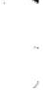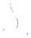Lin Hsi-yi:f*1!l-lf!l (fl. 1234--60). Scholar-official who produced commentaries to a number of classics. His commentary on the Taoteching is noted for its clarity. Lao-tzu k'ou-yi.
Liu Ch'en-weng �J�$ (1232-1297). Poet and essayist. He held several official posts but spent most of his life in obscurity. if not seclusion. Lao-tzu tao-te-ching p'ing-tien.
itlil!
Liu Ching (fl. 1074)· Recognized for his literary talent by Wang An-shih, he was given several minor posts but failed to advance due to his fondness for argument. Lao-tzu-chu.
Liu Chung-p'ing �j{<pSjZ (fl. 1060). Official and member of Wang An-shih's re­ form clique. Lao-tzu-chu.
Liu Pang �Jfj) (247-195 BC). Helped overthrow the Ch'in dynasty and became the first emperor of the Han dynasty.
Liu Shili-li itlW:l.Z: (fl. 1200). Lao-tzu-chieh-chieh.
Liu Shili-p'ei �JW!ff (1884-1919). Adds to the work of Wang Nien-sun and oth­ ers in locating ancient usages. Lao-tzu-chiao-pu.
Hi�:E
Lo Chen-yu (1866-1940). Archaeologist, educator, bibliographer, advisor to the last emperor, and among the first scholars to srudy the Tunhuang copies of the Taoteching. Tao-te-ching k'ao-yi and Tun-huang-pen laO-TZU yi-ts'an-chuan.
L'U Hsi-sheng IIi;fW (fl. 890). High official and scholar known for his wide learning. His commentary reflects the view that Lao-tzu and Confucius were the spirirual heirs of Fu Hsi (c. 3500 BC), with Lao-tzu emphasizing the yin and Confucius the yang aspects of the Way of Heaven. Tao-te-chen-ching-chuan.
Lu Hui-ch'ing §l!WIl (1031-1111). Chosen by Wang An-shih to help draft his reform proposals and later by Emperor Shen-tsung to replace Wang as prime minister. His commentary, presented to the emperor in 1078, is quoted at length by Chiao Hung. Tao-te-chen-ching-chuan.
Lu Nung-shili IIiRlW (1042-1102). High official and scholar known for his knowledge of rirual usage. His commentary makes extensive use of quotes from Liehtzu and Chuangtzu. Lao-tzu-chu.
Lu Tung-pin§jfllil: (fl. 845). Leader of the legendary Eight Immortals and au­ thor of a number of Taoist works, including Secret ofthe Golden Flower. Several commentaries have been attributed to him. I have used the Tao-te-chingshih-yi.
Lushih Chunchiu §.fJ;wt:k (The Spring and Autumn Annals of Mr. Lu). Commis-
1 72

sioned by Lu Pu-wei (d. 235 BC), this was probably the first Chinese text written with a unified plan. It purported to contain all that anyone needed to know of the world and was Taoist in conception. Not to be confused with The Spring and AutumnAnnals of Master Yen or The Spring and Autumn Annals written in the state of Lu and attributed to Confucius.
Ma Hsu-lun J.!',�fIjIj(1884-1970). Minister of Education, member of several leg­ islative bodies, and classical scholar. One of the first scholars to suggest re­ arranging passages of the Taoteching to remedy inconsistencies which he thought were the result of inadvertant shuffling of the wooden strips on which the text was first written. Lao-tzu chiao-ku.
Mawangtui J.!',:E�. Suburb of Changsha, capital of Hunan province, and the site of several Han dynasty graves that were excavated in 1973-4. Among the contents of one of the graves were two copies of the Taoteching written on silk. Although the grave was sealed in 168 BC, the presence or absence of certain characters proscribed after the onset of the Han dynasty suggest that Text A was copied before 206 BC and Text B was copied between 206 and 194 BC. Along with the Fuyi text, they constitute our earliest copies of the Taoteching. One noteworthy difference in the Mawangtui texts is the re-ordering of several verses and the placement of the second half of the text first.
Mencius:i!L.:r (390-305 BC). Ranked with Confucius and Hsun-tzu as one of the foremost teachers of the philosophy known as Confucianism. He studied with Confucius' grandson, Tzu-ssu. The work that bears his name records his con­ versations with his disciples and various rulers.
*7f;�)
Ming T'ai-tsu B)tiil (Chu Yuan-chang (1328-1398). Grew up in a family of destitute farmers, became a Buddhist monk, joined a rebellion against the Mongols (who had occupied the Chinese throne since 1278), and founded the Ming dynasty (1368-1644). His commentary. which he appar­ ently wrote without the help of tutors, was completed in 1374. Tao-te-chen­ ching yu-chu.
Be).
Mo-tzu !l\.:r (fl. fifth cent. Philosopher whose arguments in favor of uni­ versal love and against costly funerals put him at odds with the Confucian school, especially Mencius and Hsun-tzu. The work that bears his name was apparently composed after his death by his disciples, who themselves betray differences of opinion concerning their master's views.
,

Mou-tzu tp.:r (MouJungtpM!l!) (fl. third cent.). High official and author of the Lihuolun, the earliest-known work that addresses the problems ariSing from Buddhist practice and Chinese tradition.

1 73


Pao-ting I@T. Knife-wielding cook of Chuangtzu: 3 .2.
J:t-'f
Pi Kan (fl. 1I50 BC). Advisor to the last emperor of the Shang dynasty; who had Pi killed for his frank counsel.
-$i:it
Pi Yuan (1730-1797). Prominent scholar-official with interests in history. philology. and geography. Lao-tzu tao-te-ching k'ao-yi.
Po-tsung m* (fl. eighth cent. BC). Minister at the court of Chin. His views are reported in the Tsochuan: Hsuan.15.
Shanhaiching il.J#if� (Book of Mountains and Seas). Shaman's guide to China's mountains and waterways. Attributed to Yu the Great (fl. 2200 BC), it was ed­ ited into its present form by Liu Hsin (c. 50 BC-23 AD). A reliable English trans­ lation was published by Taiwan's National Institute for Compilation and Translation in 1985.
Shao Juo-yu B�;ti� (fl. 1I35-70). Tao-te-chen-ching chih-chieh.
iil$�
Shen Nung (c. 2800-2700 BC). Legendary ruler of China's prehistoric pe­ riod. He is venerated as the father of agriculture and herbal medicine in China.
Shihching if�. Collection of some 300 poems from China's earliest historical period, between the twelfth and seventh century BC. Arranged by style and re­ gion, it was reportedly compiled by Confucius from a larger corpus of over 3,000 poems. It remained an essential part of traditional education until the twentieth century.
Shuching .�. Collection of memorials from China's earliest historical period: the Hsia, Shang, and Chou dynasties. Reputedly edited by Confucius, there are two versions, one of which contains 28 chapters and which most scholars think is genuine and another with an additional 22 chapters of debatable authenticity.
Shun � (c. 2250-2150 BC). Early sage ruler noted for his filial piety and non-in­ terference in public affairs.
iti/;:)l:
Shuowen Greatest of China's early etymological dictionaries. It was com­ piled and first published by Hsu Shen in 121 AD and revised and updated with new materials in the T'ang, Sung, and Ch'ing dynasties.
Shuoyuan iti/;:f Collection of moral tales and political discourses. Attributed to Liu Hsiang (c. 79-{5 BC), who also compiled the Chankuotse.
i'i]Ji!l,i(
Ssu-ma Ch'ien (45-85 BC). Together with his father, Ssu-ma T'an, author of the first comprehensive history of China. His biography of Lao-tzu

1 74

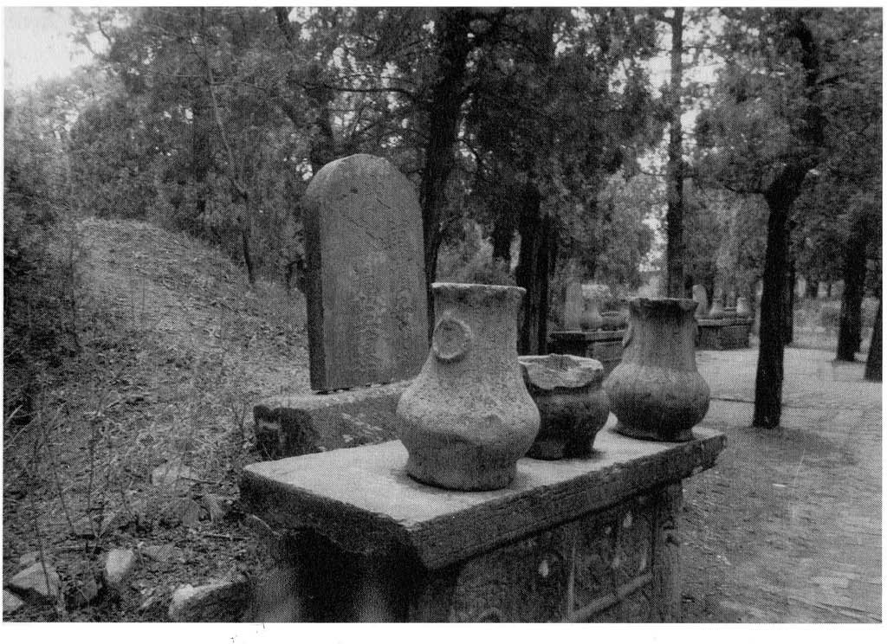

Tomb ofSu Ch'e (Su Tzu-yu). Located in Honan province near the town ofJuchou. Beyond Su's grave are the graves ofhisfather and his
morefamous brother, Su Tung-p'o. Photo by Bill Porter.

constitutes the earliest known record of the Taoist patriarch. Shih-chi (Records ofthe Historian): 63.
l'1]�*
Ssu-ma Kuang (roI9-ro86). One of the most famous writers and political figures of the Sung dynasty and adversary of Wang An-shih. His multi-volume history of China remains one of the most thorough treatments of China's past through the Tang dynasty. His commentary interprets Lao-tzu's text using Confucian terminology and Neo-Confucian concepts. Tao-te-chen-ching-lun.
�fRI:
Su Ch'e (ro39-III2). Along with his father and brother, he was one of the eight great prose writers of the T'ang and Sung dynasties. Although his com­ mentary reflects his own Neo-Confucian sympathies, it is treasured by Bud­ dhists and Taoists alike. Tao-te-chen-ching-chu.
�1H
Suichou . Inscription of the Taoteching carved during the T'ang dynasty at Suichou's Lunghsing T<zmple. Not dated.

1 75



mythology and a proponent of the view that Taoism had its origin in the wor­ ship of the moon. Lao-tzu-te yueh-shen tsung-chiao.
1\1 Tao-chien tf:ii� (fl. 1264-1306). Taoist master and author of commentar­ ies to a number of Taoist classics. His Taoteching commentary makes extensive use of quotes from the Confucian classics. Tao-te-hsuan-chingyuan-chih.
Tung Ssu-ching jVi!� (fl. 1246-1257). Taoist master and compiler of Taoist texts in the Ling-pao tradition. His commentary includes extensive quotes from T'ang and Sung dynasty commentators as well as his own comments. Tao-te-chen-ching chi-chieh.
Tunhuang�i1i!. China's westernmost outpost on the Silk Road as early as the Han dynasty and the location of dozens of Buddhist devotional caves carved into a hillside from the fourth through the fourteenth centuries. At the end of the nineteenth century; a Taoist caretaker opened a sealed side-room in one of the caves and found more than 30,000 manuscripts, most of which dated from the eighth through the eleventh century. From 1907 onward, he began selling these manuscripts to collectors, and the majority ended up in the national ar­ chives of France and England. Although most were Buddhist sutras, they in­ cluded at least 60 copies of various portions of the Taoteching.
.
Tzu-ssui"Ji!, (d. 483 Be). Grandson of Confucius and author of the Chungyung.
Wang An-shih :E3(E (1021-1086). One of China's most famous prime minis­ ters. His attempt to introduce sweeping reforms directed against merchants and landowners galvanized Chinese intellectuals into a debate that continues to this day. He was also one of the great poets and prose writers of his day. His commentary has been re-edited from scattered sources by Yen Ling-feng. Lao-tzu-chu.
(fl.
Wang Chen:EJi 809). T'ang dynasty general and student of the Taoteching. His commentary; which he presented to Emperor Hsiuan Tsung, remains unique for its display of pacificist sympathies by a military official. Tao-te-ching lun-ping yao-yi-shu
Wang Nien-sun :E�l* (1744-1832). Distinguished philologist whose analysis of grammatical particles used in ancient texts is unrivalled. His approachis also unique in not taking characters at their face value but in viewing them as pos­ sible homophones. Lao-tzu tsa-chih.
Wang P'ang :E3lf (1044-1076). Brilliant scholar, writer, and son of Wang An­ shih. His commentary. written in 1070, was "lost" until Yen Ling-feng re-edited it from scattered sources. Lao-tzu-chu.

1 77


Wang Pi:El!fJ (226-249 AD). Famous for the quickness of his mind as well as the breadth of his learning, he grew up with one of the best private libraries of his time. Although he died of a sudden illness at the age of twenty-four, he was among the first to discuss Taoism as metaphysics rather than religion. As a re­ sult, his commentary has been preferred over that of Ho-shang Kung by Con­ fucian scholars. At least two English translations exist: Paul Lin, University of Michigan Center for Chinese Studies, 1977; Ariane Rump, University of Hawaii Press, 1979. Lao-tzu-chu.
:El]!
Wang Tao (1476-1532). Incorporates Confucian interpretations in his commentary. Lao-tzu-yi.
:E1!\Ii�
Wang Wu-chiu (fl. 1056). Scholar-official. He gave up a promising offi­ cial career in order to devote himself to studying and teaching. Lao-tzu-yi.
�ii
Wei Yuan (1794-1856). Classicist, historian, geographer, and admired ad­ ministrator. While his own views are insightful, his commentary consists largely in selections from Chiao Hung's edition. Lao-tzu pen-yi.
)l:T
Wen-tzu (fl. fifth cent. Be). Taoist recluse and teacher of Fan Li, prime minister of the state of Yueh. According to theHanshu, he was a disciple of Lao­ tzu and a contemporary of Confucius. The book that bears his name is attrib­ uted to his disciples.
Wu Ch'eng �m (1249-1333). One of the great prose writers of the Yuan dy­ nasty. surpassea only by his student, Yu Chi (1272-1348). His commentary re­ veals unique insight and provides essential background information. It is also noted for its division of the text into 68 verses. Tao-te-chen-ching-chu.
Yang 1l! . The bright side, the male, the strong.

Yang Hsiungm� (53 Be-18 AD). Gifted writer of courtly odes and philosopher. Known for his view that man is neither good nor bad by nature but wholly subject to his environment. A number of his odes are preserved in the Wenhsuan. The Fayen contains his philosophical maxims.
Yao Nai!!Jliili (1732-1815). One of the most famous literary figures of the Ch'ing dynasty and advocate of writing in the style of ancient prose. His anthology of ancient literary models, Kuwentzu Leitsuan, has had a great influence on writ­ ers and remainsin use. Lao-tzu chang-chu.
Yellow Emperor (Huang-ti j[W) (c. 2700-2600 Be). Patriarch of Chinese cul­ ture. He was also among the earliest known practitioners of Taoist yoga and other hygienic arts.

1 78


Yen Fu (1853-1921). Naval officer, scholar, and the first Chinese commen­ tator to use Western philosophical concepts in interpreting Lao-tzu. Lao-tzu tao-te-ching p'ing-tien.
Mm.
Yen Ling-feng IUIlIf$ (1910- ). Classical scholar and specialist in Taoteching studies. In addition to his own books on the subject, he re-published most of the surviving commentaries in his monumental Wu-ch'iu-pei-chai lao-tzu chi­ ch'eng, including a number of "lost" commentaries which he re-edited from scattered sources. Lao-tzu chang-chu hsin-pien.
Yen Tsun Mli. (Chun-p'ing �SjZ) (fl. 53-24 Be). Urban recluse of Chengtu. He supported himself as a fortune-teller and spent his remaining time reading and pondering the Taoteching. The lengthy commentaries that he produced are sometimes quite profound but more often obscure, and those that survive are incomplete. He divides the text into 72 verses. Tao-te-ching chih-kuei.
Yentiehlun ••IDili (Discource on Salt and Iron). Record of debates on govern­ ment policies and other problems of the day compiled by Huan K'uan (fl. 73 Be).
Yiching Jlb� (Book of Changes). Ancient manual of divination based on a system of hexagrams invented by Fu Hsi (c. 3500 Be) with judgments attributed to Duke Wen and the Duke of Chou (c. 1200-1100 Be), and commentaries added some 600 years later, ostensibly by Confucius.
Yiching Chitzu. Jlb��1$ (Appended Judgments on the Yiching). Attributed to Duke Wen.
Yin �. The dark side, the female, the weak.
Yin Hsi jOt# (fl. sixth cent. Be). Taoist astronomer who met Lao-tzu at Hanku Pass and to whom Lao-tzu subsequently conveyed the Taoteching. Several works have been attributed to him, though those that survive are probably by later Taoists.
Yin Wen jOtX (350-284 Be). Eclectic philosopher of the state of Ch'i and author of a book of discourses that bears his name.
YuJuo�;s (fl. fifth cent. Be). Disciple of Confucius known for his resemblence to the sage as well as for his love of antiquity After Confucius' death, many of his disciples wanted to render to Yu Juo the same observances they had con­ ferred on Confucius. But this was opposed by Tseng-tzu.
��t;ji.
Yunchi Chichien Anthology of Taoist writings edited by Chang Chun-fang (fl. 1017-21). One of the most influential such compilations, it is also called the Shorter Taoist Canon.

1 79

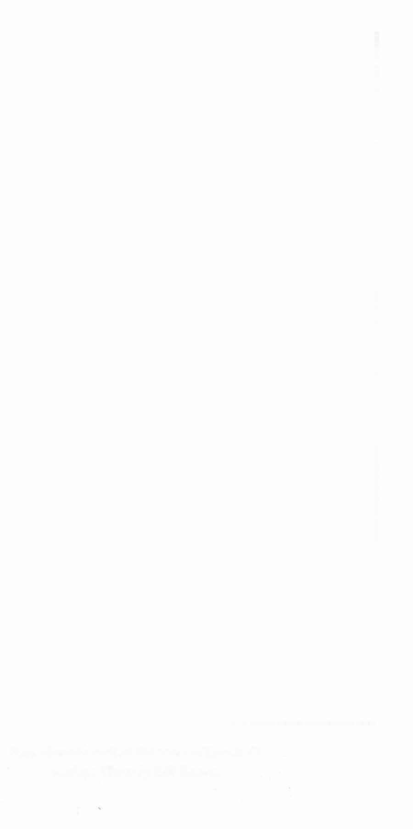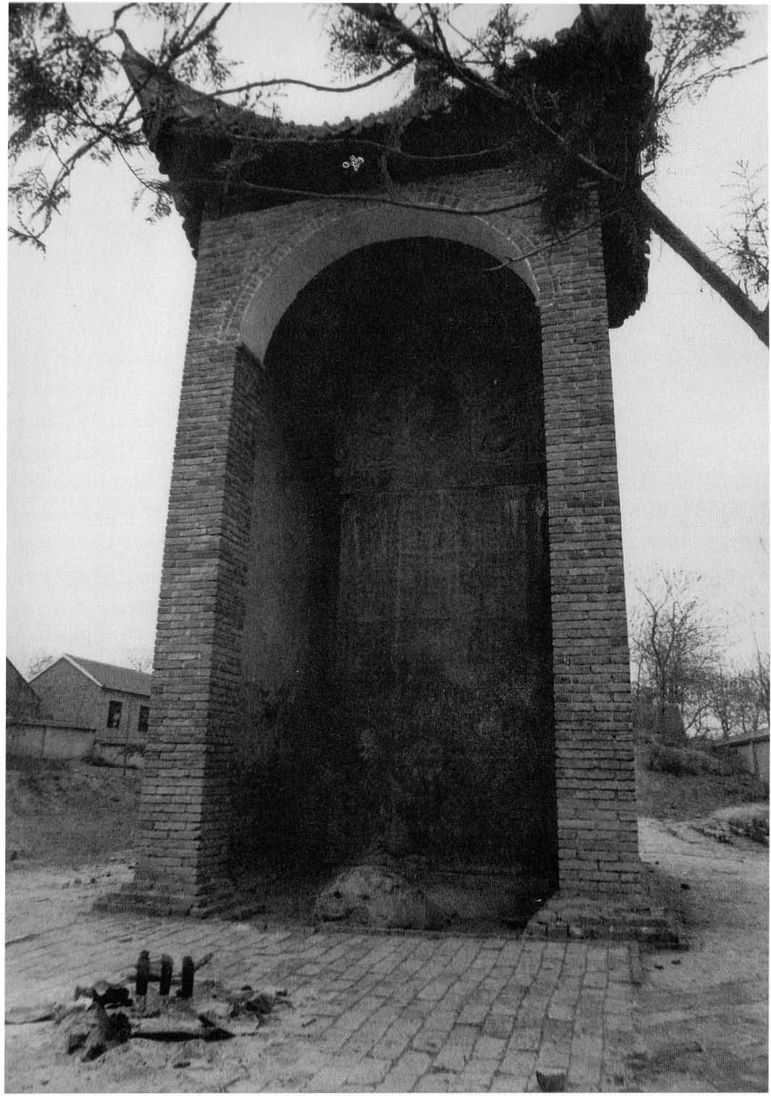

Sung dynasty stele at the grave oJLao-tzu's mother. Photo by Bill Porter.



On the Spelling af Chinese Names

A modified Wade-Giles system, in which umlauts have been omitted, is used throughout. According to this system, aspirated consonants are unvoiced Ct'" is pronounced "t" as in "toy," and "ch'" is pronounced "ch" as in "church"). Unaspirated consonants are voiced Ct" is pronounced "d" as in "dog" and "ch" is pronounced "j" as in "jam"). The only unusual pronunciation is "j," which is pronounced "r" as "row." And the only vowel that is pronounced differently from what one might expect in English is the final "e" or "u," which is given little or no emphasis. Thus the "tzu" in "Lao-tzu" is pronounced the same as the final part of the word "adze." For the names of places and books, I have omitted the apostrophes and hyphens and run words together. Thus Tao-te­ ching becomes Taoteching, and Lao-tzu the person becomes Laotzu the book. I have also retained commonly used spellings based on other romanization sys­ tems. Thus, Yangtze instead of Changchiang.


Acknowledgments

The translator is indebted to Michael O'Connor and Christina McLennan for critical readings of the English text, to Paul Hansen for his fine map, to Steven
R. Johnson for his photo of the Mawangtui texts. to Martin Merz for help in China. and to Paul Hansen. Jack Estes. Fred Goforth. Nicholas Gould. and the
U. S. Department of Agriculture's Food Stamp program for various forms of financial assistance.

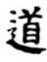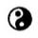

Cover, interior design in Dante and Columbus, and typesetting by Thomas Christensen. Chinese characters typeset by Katherine Loh Design.
Map on p. viii by Paul Hansen. Edited by Thomas Christensen and Kirsten Janene-Nelson, with assistance from Victoria Bullman, Sarah Fallon, andJiirgen Mollers;
proofread by Catherine Park. Printing and binding by Data Reproductions, using sixty-pound Springhill
vellum paper.

The cover and title page calligraphy
ltl:
of the character Tao is by one of China's greatest calligraphers, Yen Chen-ch'ing
MJ{WP
(709-785). It is part of a longer inscription written circa
'*0.
775 at the Taoist center of Maoshan while Yen was Military Commissioner of
the Huchou area.

$12.95 u.s.
Eastern SpirituaUty / Asia11 Studies

"Here is an honest, fresh renditio11 of the Taoteching that has much to recom­ n1cnd it. The language, tl1ough simple, aptly captures the austere and mystical poetry of the original. Red Pine, because he hin1se]f has experienced the life of a true Taoist ascetic, possesses an almost unique ability to convey the nuance and sense of this elusive text. . . . One feature chat sets it apart from virtually all others is the illuminating, eclectic commentaries following each chapter that have been judic.iously assen1bled by Red Pine. These are extraordinar­ ily valuable for those who want to understand l1ow the Chinese have tra­ ditionally interpreted the thoughr embodied in the Taoteching. I
wholeheartedly endorse Red Pine's sensitive translation of the classic and enthusiastically e11courage anyone with an interest in early Taoism
to read it in confider1ce that it cornes as close as possible
to expressing the Chinese text in English."

- Victo r H. Mair, Professer of Asian and Middle Eastern Studies.
University of Pennsylvania

Award-w mning translator Red Pine, whose.. previous books from Mercury House inc]ude Road to Heaven: Encounters i.:vith Chincse Hennits and his tr ans ­ lation of Su11g Po -jen's Guide to Capturing a Plurn Blossom, renders the class1c Chinese text into exquisite English in a breakthrough translation that includes for the first time essential commentanes, considered by Chinese scholars to be vital to understanding the w1sdom of Taoism.

MERCURY HousE
San Fra11cisco, Califor111a

ISBN 1 - 5 6 2 7 9 - 0 8 5 - 4

5
11111 1 11 111 ,
2 9 5
>

9 781562 790851 111111

